Catholic School Council
Our next Catholic School Council meeting will take place VIRTUALLY on May 16 at 6:00pm. Please let Mrs. Cuthbert-Brown know if you would like an e-vite.
See Me In ALCDSB Survey
The first-ever See Me in ALCDSB Survey, a confidential student census, takes place May 9 to 20. We hope all students and families will participate.
1) The survey will collect student demographic and identity data, including information about language, gender, sexual orientation, race, ethnicity and more. It also includes questions about school experience.
2) The information students and families share will impact program and support design and evaluation. Your contribution will help our school and school board build on the work we are already doing to support equity, well-being and success for all students and provide a way to measure the impact of that work.
3) School staff won’t ever see individual responses to the survey. The data will be reviewed from a population level alongside other student data already collected under the Education Act to identify ways to improve equity and well-being for all students.

4) The more responses, the better! Participating in the survey is a simple thing you can do that could significantly impact the well-being of other children and families in our school community and beyond.
5) You can help spread the word. By better understanding our students, we can make sure programs, supports, and opportunities best suit their needs. Help encourage other families to participate in the survey. You can share the ALCDSB’s social media posts, or just mention the survey to friends. Every little bit helps!
The survey is for all Algonquin and Lakeshore Catholic District School Board students from Kindergarten to Grade 12. Elementary parents/guardians will receive the survey by email on behalf of their children. Students in Grades 9 to 12 will have time to complete the survey at school. Please have your voice heard. Learn more about the survey at alcdsb.on.ca.
Important Dates
Dental Screening May 17
Cross Country Meet May 9
Cross Country Rain Date May 10
Gr 7/8 Immunizations May 12
EQAO Gr 3 and 6 to be completed between May 16 to June 24

Upcoming Community Sessions
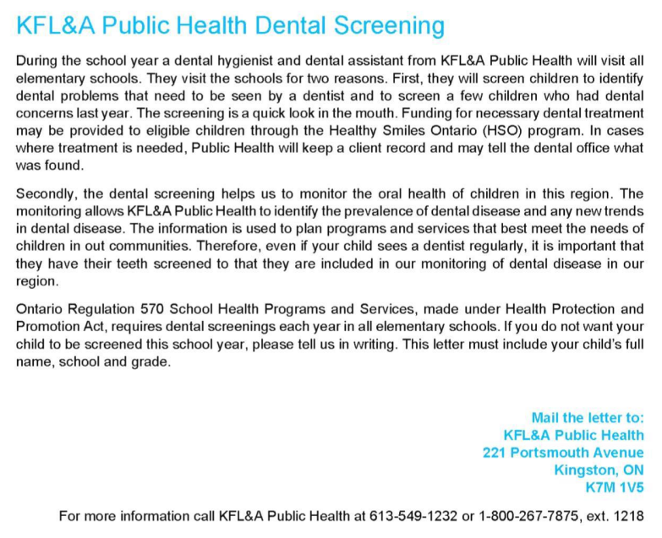
Water Walk
Thank you to Mrs. LaPrairie and t our Knowledge Keeper, Judi Montgomery, for leading our school community in our water walk this year!
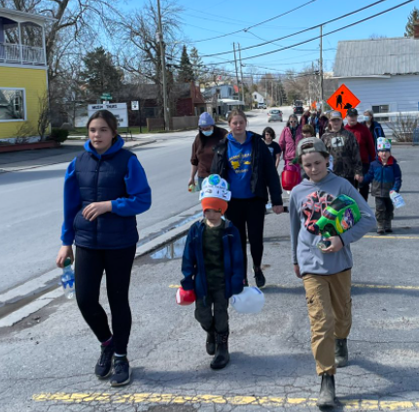
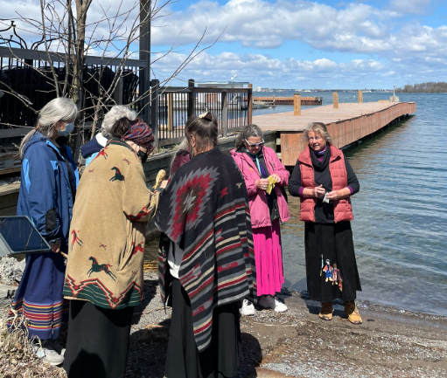
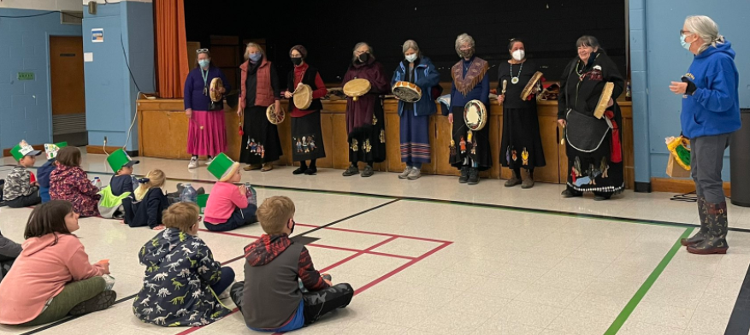
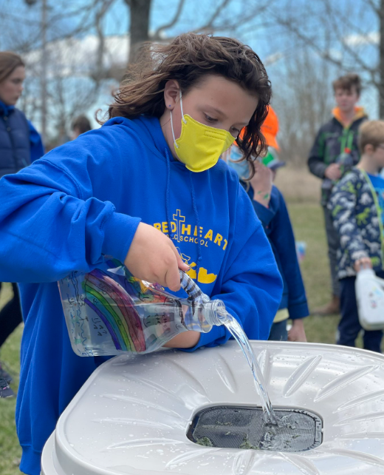
Lent
JK-1 students were washing one another’s feet. If Jesus--God incarnate--is willing to serve, we should follow that example as well. Students took part in many Lenten activities during the past few weeks.
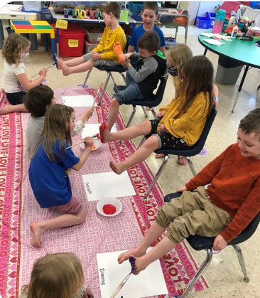
Hot Lunch and Milk
If you are paying by cash, please make sure money comes in with forms at the same time and not at a later date. We will not process any orders until we receive the money. We prefer School Cash Online though. If you child is away on a hot lunch or milk day, we will hold the food and milk for 1 day after. We will not be issuing refunds. Feel free to pop by the school that day to pick up food and milk. Thank you for understanding.

Catholic Education Week
This year, Catholic Education Week is from May 2 to May 6. Our school community will take part in many activities and events to celebrate this important week!
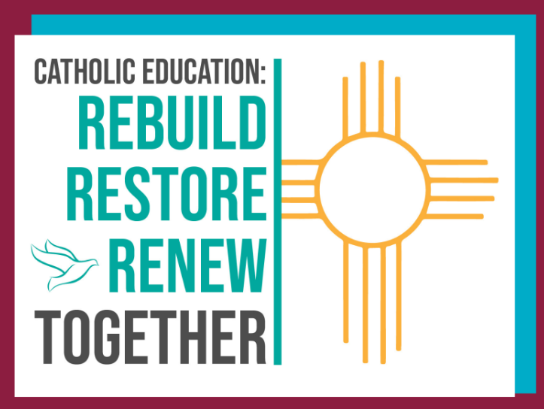

Welcome Ms. De Sasio!
We would like to give a warm welcome to Ms. Megan De Sasio who will be replacing Mrs. Sherriff until she returns.

