Thank you for your patience and flexibility during this last round of remote learning. Hopefully we are back to school to stay!
Loaned Devices
Please return loaned devices and cords ASAP. Students have upgraded software training and refresher sessions with our board’s Learning Technology Service staff member this month. Thank you.
Covid Screener
Please continue to use the daily screener before your child gets on the bus or arrives at school. Staff will review the screener daily as part of the morning routine.
https://covid-19.ontario.ca/school-screening/
Indigenous Teaching
We are delighted to have Magan’s grandma, Judi Montgomery, as our cultural advisor again this year! She will virtually visit our classes in order to help build student capacity in Indigenous programming.
Meat Stix Fundraiser
The school will be running the Meat Stix fundraiser again this year. Forms will go home at the beginning of March.

Term One Report Cards
Report cards and Individual Education Plans go home February 16th.
December and January Fun
The last few months were busy at Sacred Heart! Weekly Advent services and various activities were completed. Students decorated the float and took part in the Santa Claus Parade! We won $100 gift card from the WIPP! We also had the first annual Christmas Sale! Approximately $200 was raised and donated to the Food Bank and St Vincent de Paul Society. Start collecting your gently used items (does not have to be Christmas related) for next year’s sale!
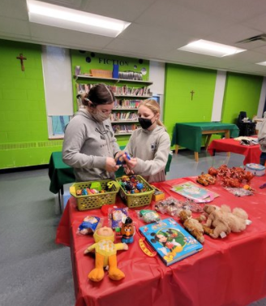

Valentine’s Day
The school will provide each student with a pizza lunch and drink on February 14th! It is also red/white/pink day that day! We will stick to regular valentines this year, without any home baked treats please.

Isolation Situations
If your child or a family member is sick and isolation is required, teachers will continue to post daily work on D2L that can be completed asynchronously. Please contact the office, as usual, if your child will be absent.
Catholic School Council
The Sacred Heart Catholic School Council is a dynamic and integral part of this school community. Our next Catholic School Council meeting will take place VIRTUALLY on Monday March 21 at 6:00. All are invited and welcome to attend! Please let Mrs. Cuthbert-Brown know if you would like her to send you an e-vite.
