Wolfe Island T-Shirt Contest
Check out some of these amazing artists who designed their own t-shirt for the Wolf Island Heritage Society’s contest. The goal was to show how we ‘Protect, Preserve and Promote the Culture and Heritage of Wolfe Island’
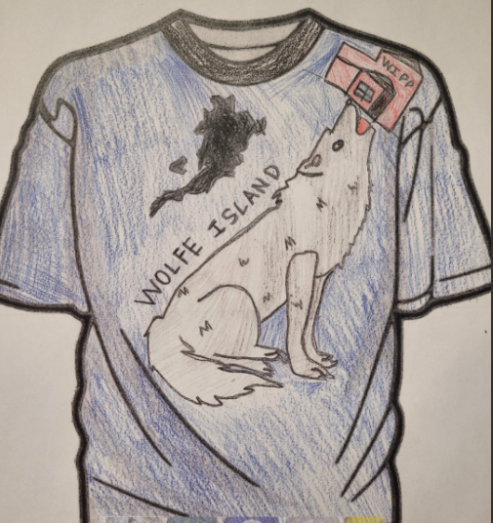
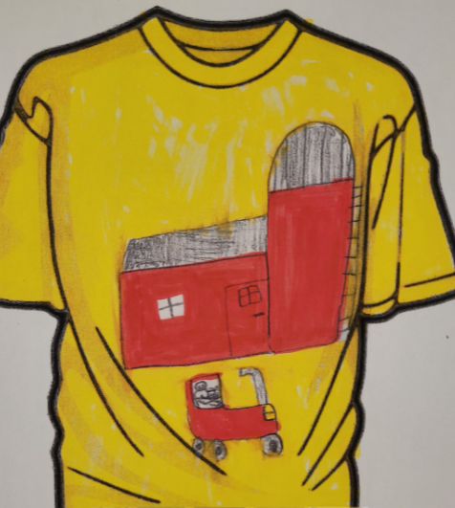
Catholic School Council
Our next Catholic School Council meeting will take place VIRTUALLY on May 16 at 6:00pm. Please let Mrs. Cuthbert-Brown know if you would like an e-vite.
Ticks
Now the the warmer weather is coming, so will the bugs! We will remind students to check for ticks after each recess. Please do a thorough check once students come home.

Outdoor Mud Kitchen
If you have any old utensils (large spoons, spatulas, bowls, pots, pans, tins, measuring cups and spoons, etc., please consider donating them for our ‘Mud Kitchen’. Students are having a blast playing with it and we are finding there are loads of links to math in their play! Thanks!
See Me In ALCDSB Survey
The first-ever See Me in ALCDSB Survey, a confidential student census, takes place May 9 to 20. We hope all students and families will participate.
1) The survey will collect student demographic and identity data, including information about language, gender, sexual orientation, race, ethnicity and more. It also includes questions about school experience.
2) The information students and families share will impact program and support design and evaluation. Your contribution will help our school and school board build on the work we are already doing to support equity, well-being and success for all students and provide a way to measure the impact of that work.
3) School staff won’t ever see individual responses to the survey. The data will be reviewed from a population level alongside other student data already collected under the Education Act to

identify ways to improve equity and well-being for all students.
4) The more responses, the better! Participating in the survey is a simple thing you can do that could significantly impact the well-being of other children and families in our school community and beyond.
5) You can help spread the word. By better understanding our students, we can make sure programs, supports, and opportunities best suit their needs. Help encourage other families to participate in the survey. You can share the ALCDSB’s social media posts, or just mention the survey to friends. Every little bit helps!
The survey is for all Algonquin and Lakeshore Catholic District School Board students from Kindergarten to Grade 12. Elementary parents/guardians will receive the survey by email on behalf of their children. Students in Grades 9 to 12 will have time to complete the survey at school.
Please have your voice heard. Learn more about the survey at alcdsb.on.ca.

