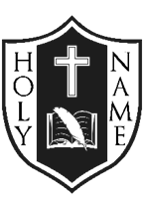

**JUNE NEWSLETTER**

** **

**Greetings:** It amazes me how fast this “first year” has gone. “Firsts” are always extra special. I have enjoyed being part of Holy Name Catholic School community, and look forward to being here again next year. Faith in Action has been practised throughout the year and are words students and staff have been encouraged to follow. Student achievement in the areas of Discipleship, Scholarship and Stewardship keep our goals focused and purposeful. Together, home, school and parish best meet the needs of our young people. Thank you for welcoming me into your community, and sharing in my passion and belief that children are first.

*God Bless, Mrs. McDonald*

[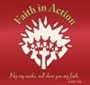](javascript:ClickThumbnail(2))

**Caring and Safe Schools:**

Several Grade 2 students received the Sacrament of First Holy Communion on Sunday on May 5, 2019. 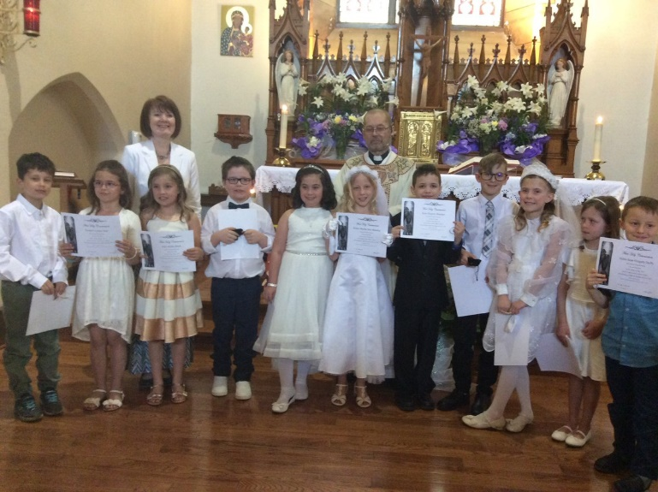On Monday May 6, 2019, crosses purchased by the School Council were presented to these students by CSC Representatives. Confirmation keepsakes were also presented to Gr. 8s by Catholic School Council members. Thank you! 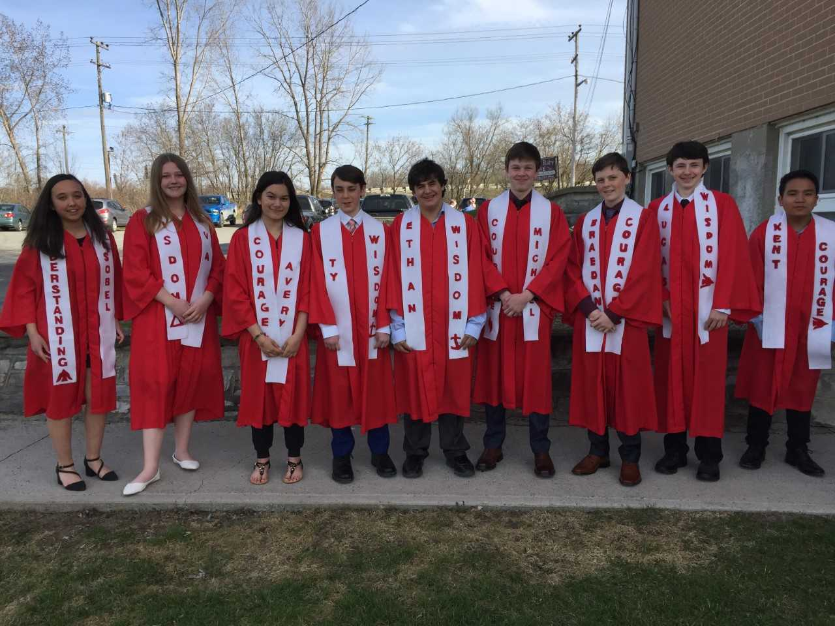

**Jump Rope and Hoops Event**: Students raised over **$2459.00** for the Heart & Stroke Foundation. Faith In Action was very evident.

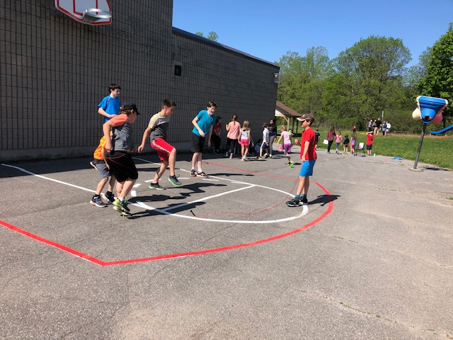

**Flag Football** – Samer and several 7/8 students will take part in a Flag Football Tournament on Tues. June 4, 2019 at Regi. Good luck!

**System Track & Field Days**: Tykes & Peewees will compete on Mon. June 17 and Bantams will compete on Tues. June 18th, at Invista Centre.

**Faith in Action** is dressing appropriately. Personal modesty, weather, and our Catholic academic setting help to determine the types of clothing acceptable for school. Appropriate school dress is essential for maintaining a positive and stimulating learning environment. We ask for your support in enforcing our dress policy. Shorts should be appropriate in length and not cut-offs. Spaghetti strap tops are not acceptable unless they are under a cover (E.g., sweater). Backs and midriffs should be covered.

**Safety** is always a priority. Sun safety means wearing a hat, sunscreen and sunglasses.

**ECO School Update:**

Holy Name Catholic School submitted an application to be certified as an ECO School by the Ministry of the Environment. We will know by September if Holy Name is successful.

Monthly School Newsletters posted on the school webpage can be emailed directly. If you have not registered for Newsletters to be sent, please do so in order to keep current and up to date.

**UPCOMING EVENTS:**

**School Mass** is scheduled for 9:30 AM on Thursday June 06, 2019 at Holy Name of Jesus Church**. Please join us.**

**Grade 8 Graduation** Mass takes place on Thursday, June 20, beginning at 5:00 PM at Holy Name of Jesus Church followed by a social family time at the school and then a boat cruise dance for the graduates and Gr. 7 students. Mr. Archer, students and parents have been working collaboratively on this special event.

**Report Cards** will go home on the last day of school for students – Thurs. June 27, 2019. Reports will not be sent out earlier. Students absent on the last day will have their reports mailed.

**FUN FRENCH FACT**

**DID YOU KNOW?**

“The learning of a second language is in itself an excellent pursuit, not least because it develops an appreciation of the act of communicating with others, the subtleties that must be expressed in words, the importance of listening.”

*Dr. André Obadia*

**PA Day** takes place on Friday June 28, 2019, and there is no school for students.

**Catholic School Council Update**

Many thanks to the Catholic School Council for their time, dedication, support of student learning. Notice of the first School Council meeting for 2019 – 2020 school year will be made in early September. There was consistent attendance and participation from parents this year. Hoping for continued success, moving forward.

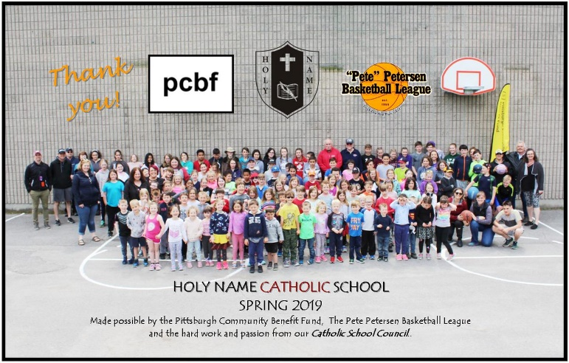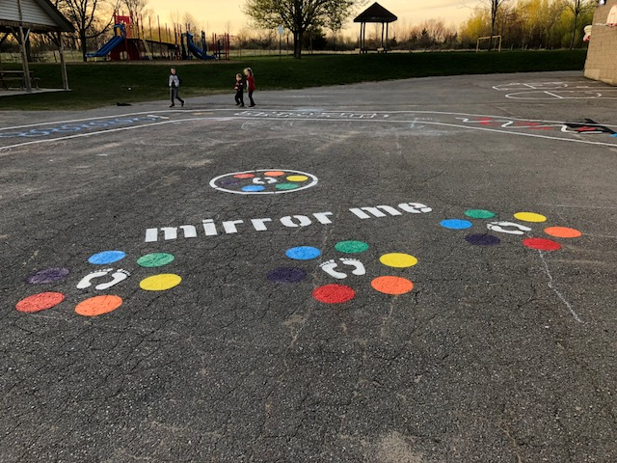

**UPCOMING 2019-2020 SCHOOL YEAR:**

Class arrangements are not expected to be completely organized before the end of June. Students will be assigned to next year’s classroom groups based primarily on feeedback from their current teachers. They have worked with your children throughout the year and are well aware of individual strengths and needs.

Many factors are considered when establishing balanced classroom groups, for example: the range of academic abilities, social factors, gender balance, learning styles, behaviour, class size and the special needs of exceptional students. The objective of this process is to produce a workable, balanced, and cohesive combination of students within a given classroom which will create a positive class environment. Regardless of where a particular student is placed, they can look forward to a very successful Catholic education, at Holy Name Catholic School.

**Staffing:** We will be saying farewell to the Long- Term Occasional Staff members: Madame Summers, Samer Saade, Ms. Desrochers, and Ms. Kish. Mr. Archer is retiring. Mr. Gaudet is moving to Archbishop O’Sullivan. Mrs. Selkirk is transferring to St. Martha. Holy Name has been blessed to have had their dedication and we wish them the very best in their future endeavours. We welcome Cynthia St. Jacques and Mr. Dave Rooney to the Holy Name community. Further welcomes will come as staffing is completed by September!

**Paid Yard Supervisors**: If you are interested in this position, please contact Mrs. Guindon for application information before the end of June.

**Go With God – A Summer Blessing**

Go with God!

This is my summer prayer for you.

Take it with you and keep it in your mind and heart.

As you leave school for the summer,

As you lay aside textbooks and notebooks

And pencils and pens,

Go with God, for God goes with you.

As you begin new projects or a summer job,

As you meet and make new friends,

Go with God, for God will guide you. As you make choices about places to go, Or about whom to hang around with, Never compromise your values,

Never compromise yourself,

And go with God, for God knows your value.

As you enjoy the summer sun

And the summer’s cool blue waters,   
Be wise and be safe.

Respect the beauty of private space and time.

Go with God, for God always goes with you.

Amen.

