STATIONS OF THE CROSS
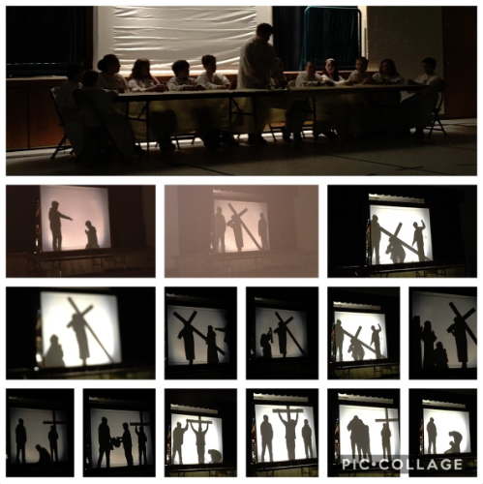
Thank you to everyone who joined us from the community for our presentation of the Stations of the Cross. The Students and Staff work hard to make this a beautiful representation on Holy Thursday.

EQAO
EQAO assessments for Grades 3 and 6, begin Tuesday, May 21st until May 23rd. Please ensure your children in these grades are in full attendance for these three days. Thank you.

ROBOTICS CLUB
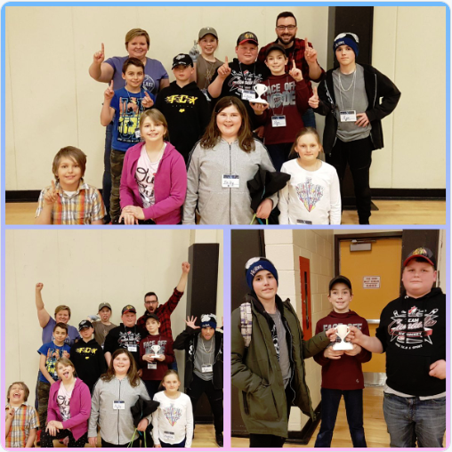

Congratulations to the Robotic Club on your Championship win in the Robot Rumble! Thank you to Whitney Public School for the invite to join you!

PA Day

Friday May 17th


CATHOLIC EDUCATION WEEK
Living as Joyful Disciples
May 5th To 10th, 2019


“Our Catholic schools help to form joyful disciples as hearts and minds are opened to the transforming love of God and to the flame of faith in action. On a daily basis, Catholic schools demonstrate the joy of believing and witness the Good News to the communities that they serve.”

Day 1: Rooted in Prayer
Day 2: Living in Community
Day 3: Doing Justice & Creating Hope
Day 4: Journeying Together in Faith
Day 5: Sharing the Good News

Please see the May calendar for more information on the special activities that are planned for Catholic Education & Mental Health Week.

FOR 2019-2020 KINDERGARTEN PROGRAM


ALCDSB is now able to accept online registration for Kindergarten students for the fall of 2019-2020. To be eligible the child must be 4 years of age on or before December 31st, 2019. Please see our website for more details. Please note that forms for busing are not currently available online. Forms will have to be picked up at the school for submission to Tri-Board.

TIME IS RUNNING OUT TO SECURE A VOLUNTEER CRIMINAL BACKGROUND CHECK

If you anticipate that you would like to serve as a volunteer in our school, or be a chaperone for a school activity/class trip, you are encouraged to initiate the process NOW in anticipation of a possible delay. The Board requires that parent volunteers produce Criminal Background Checks every two years. Do no wait until just before an event to request screening



TRACK & FIELD


Permission forms will be coming home soon for our Track & Field Meet. We will be competing at York River PS on Tuesday, May 28th (rain date May 29th)

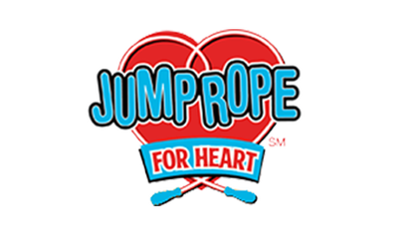
JUMP ROPE FOR HEART – MAY 10TH

Please bring in all fundraising forms by May 9th, 2019
EARTH DAY
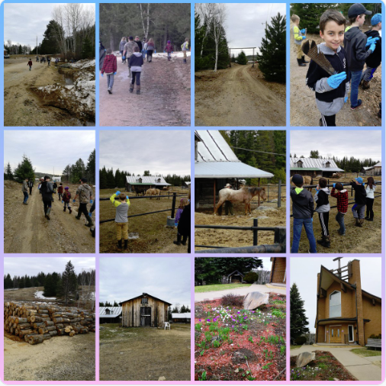

St. Martin of Tours Students picked up garbage and learned about the environment on Earth Day April 23rd.

World’s Finest Chocolate Fundraiser


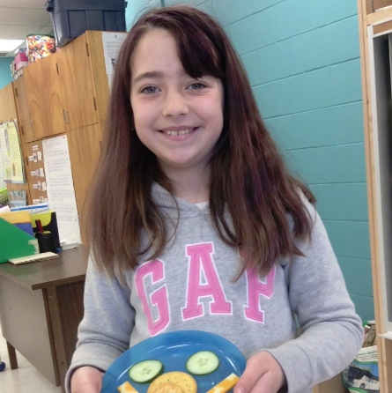

Thank you to everyone for their hard work selling chocolates to fundraise for our healthy snack program. We ask to have all fundraising envelopes back at the school by Monday May 8th. If you have any chocolate left over that you cannot sell please bring it back to the school as there are some families looking to sell more.

Spirit Days

May 23 – Pajama/ Twin Day
May 31 – Hawaiian Day

