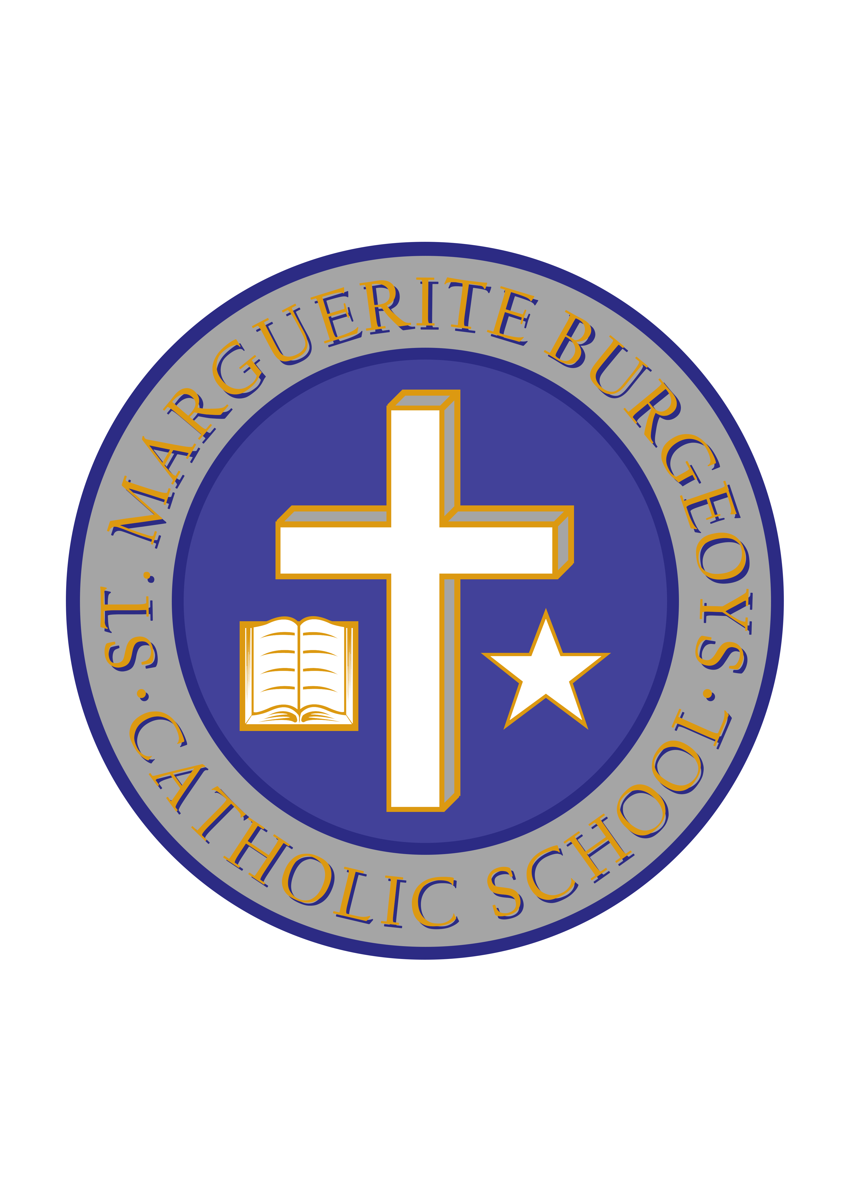

100 years of Remembrance 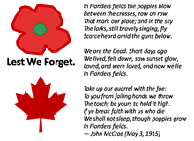

Dear Parent/Guardian:

2018 is a special year for our Remembrance Day ceremony.

This year marks the 100th anniversary of the first: 11th hour of the 11th day of the 11th month. In 1918, Armistice was declared. From that day forward we have always stopped on this day to reflect on the many thousands of military service personnel who have put their lives on the line for us at home. We are grateful and we pause to honour their sacrifices, both past and present. The St. Marguerite Bourgeoys Catholic School community is representative of many communities across our great nation. So many of our own families have been impacted by a wartime call to arms or the peace-keeping efforts around the globe. We have families who mourn the loss of grandparents, great-grandparents, aunts, uncles and cousins, who may have died overseas in past wars or who have given their lives in modern day peace-keeping missions or other military activities. We also acknowledge the men and women who are parents of our students who are currently serving our country in the Canadian Armed Forces, Navy and Airforce. Often, many of our families face time separated by oceans and months of duty outside of Kingston. We remember and honour them this month.

Our school community would like to turn the front foyer into a “Hall of Remembrance” this November and we need your help. We plan to make a visual commemoration of our community’s past and current serving military personnel to help students, staff and families visualize the impact our own community has had on our country’s military presence, both past and present. This commemoration will be a very powerful reminder for our community of the debt we must honour to those who have fought for our rights and freedoms as Canadians.

We are asking families to lend us pictures, mementos and memorabilia that you might have at home, for a public display, through the month of November in the front foyer of the school. Memorabilia might include medals, cards, letters, flags, etc., that would have belonged to a loved one who has served, or is currently serving, in our Canadian military. Photos and mementos will be displayed, with dignity. A card indicating family details or connections to our community will be placed with the artifact.

Do you have something that you would like to be included in our “Hall of Remembrance” this November? Please send your artifacts into the school, clearly labeled, and any special instructions that you might have for their care. Your item(s) will be carefully displayed and a card will be placed indicating your family details and the connection to our school community (ie: Aunt of Bobby Smith in Grade 5).

Thank you for your support of this initiative. All artifacts will be returned to families following a display of approximately 2-3 weeks beginning this week (November 5).

