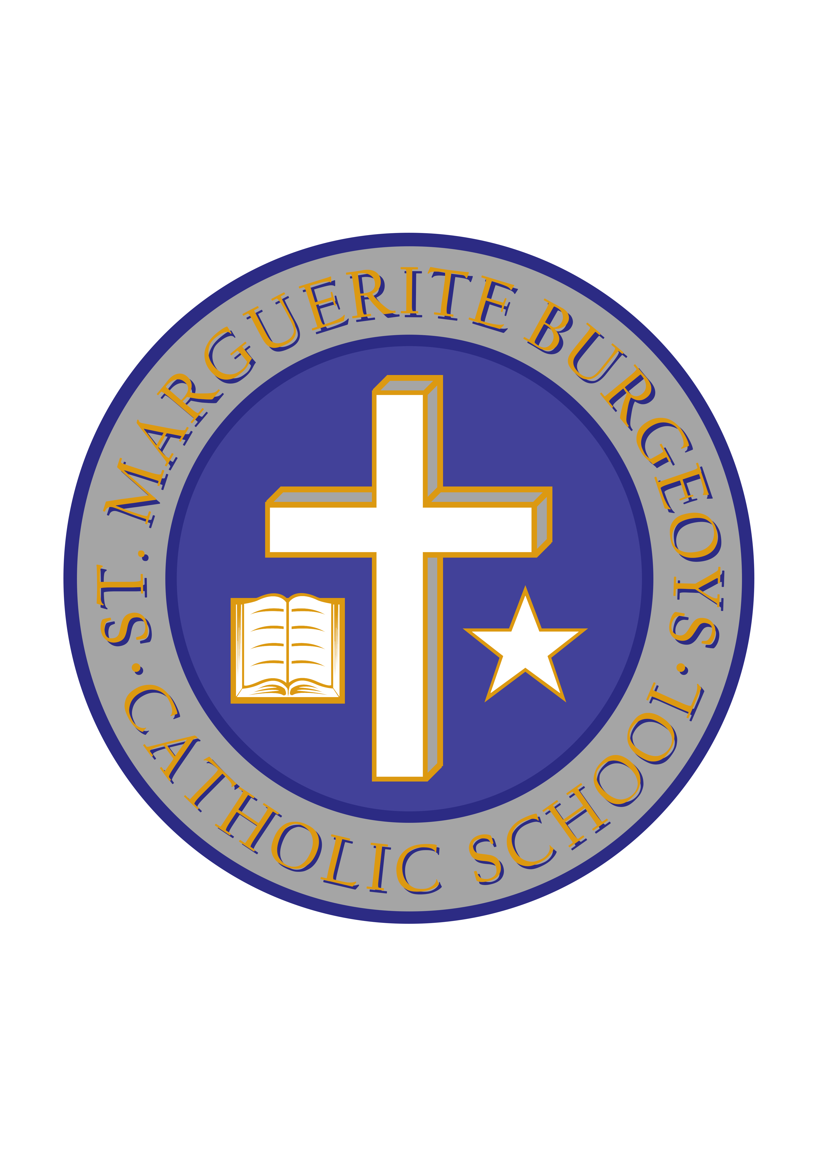

Dear Families,

Miss Alderson, a parent in our school community, has offered to provide complimentary tickets to families in our school community to attend the Our Nation’s Heroes Hockey Game vs Montreal Canadians Alumni on October 28th at 2:00pm taking place at the Leons Centre. This is a Remembrance Game to pay our respect to those who wear a uniform in protection of our community and our country.
The two links below provide information about the game:
https://www.thewhig.com/news/local-news/hockey-game-to-benefit-soldiers-veterans-first-responding/amp

http://www.leonscentre.com/event/our-natioins-hockey-night/

If your family is interested in receiving complimentary tickets to attend Our Nation’s Heroes Hockey Game, please complete and return the bottom section by Friday, October 19th, 2018.
Tickets will be sent home with your child the week of October 23rd, 2018.
Please take this opportunity to come out and show your support.

Please return the following information by Friday, October 23rd, 2018

Our family would like complimentary tickets to attend Our Nation’s Heroes Hockey Game on October 28th, 2018 at the Leons Centre at 2:00pm

STUDENT NAME: _______________________________________________

CLASSROOM TEACHER: _________________________________________ GRADE: _______________

NUMBER OF TICKETS: ___________

