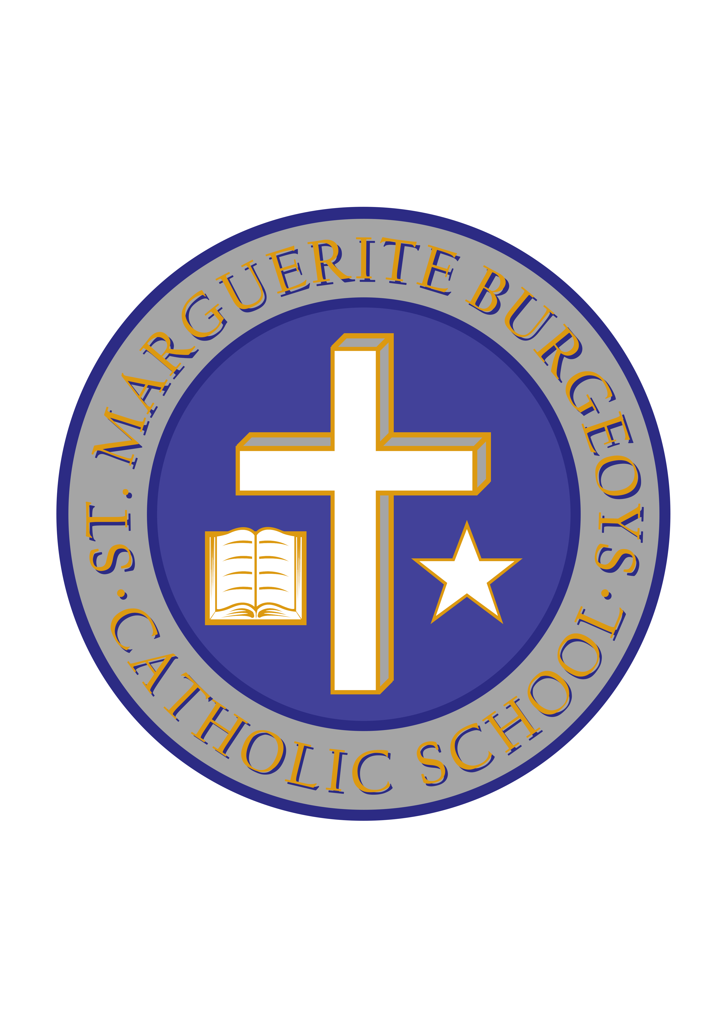

School Council Message– September 2018

Welcome parents and guardians to the 2018-19 school year at St. Marguerite Bourgeoys Catholic School. We are excited to launch a new School Council year with hope and inspiration from our school community.

Being a part of your child’s school council is an amazing way to create a sense of ownership and confidence in our educational system. Parents and guardians play a pivotal part in the school community and families thrive when everyone contributes to the development of the lifelong learner.

We hope you will consider joining us for our meetings held in the Learning Commons. The meetings run from 6:30pm -8pm and are typically scheduled on the third Monday or Tuesday of designated months.

As always, there are many opportunities for parents and guardians to get involved in the St. Marguerite Bourgeoys community. Our first event will be held on September 27th for our Annual Open House and Welcome Back BBQ. This is a great evening to get to know each other. The Knights of Columbus will be hard at work grilling hotdogs. Our parents and guardians will be helping to serve the hotdogs, nut-free cake, and provided refreshments. Special thanks to the KFL&A Health Unit who lend us the water dispensers that we use to fill with fresh fruit and vegetables, which helps create the delicious, healthful, infused water refreshments. Volunteers will be needed to setup tables, serve hotdogs and cake, fill water dispensers, and clean-up. Please consider donating your time.

In years past, parents and guardians have helped with many student events, wellness activities, and parent/student engagement evenings. In 2017- 18, our School Council launched various initiatives, which included, school yard painting, a Snowsuit Donation week, welcoming the Maltby Centre and Kingston Police for two Mental Health and Wellness Evenings, hosting an amazing Paint Night, fundraising for our new Kindergarten play structure, and of course, planning our amazing Annual Family Funfair, SMB’s main fundraising initiative.

The 2018-19 school year we will continue our commitment to school and community.
Please feel free to contact me at smbschoolcouncilchair@hotmail.com if you have any questions.

“Parent involvement in education is like the frosting on a cupcake, it makes it complete and oh so sweet.”

Blessings,

Ana Rand
St. Marguerite Bourgeoys Catholic School Chair

Mr. C. Minutillo Ms. L. Bryden
Principal Vice-Principal

September 07, 2018

Catholic School Council Elections

Dear parents/guardians,

Each year, our Catholic School Council helps the school in many ways, including special events, fundraising, and supporting school-wide initiatives. We have been incredibly fortunate to have a School Council with many volunteers who have contributed much of their time and talents for the betterment of the educational experience for our students over the years.

As part of the mandate of Catholic School Councils, elections are held near the beginning of each school year. Our first School Council meeting has been scheduled for Tuesday, September 25th at 6:30. At our next meeting, we will look to elect our School Council for the current school year. The positions that are open for nominations include:

- Chair
- Vice-chair
- Secretary
- Treasurer

If you are interested in serving in one of the above positions, you are welcome to let the school know or to attend the next meeting and express your interest in nomination. Likewise, you are able to nominate someone else who you feel would be able to serve on School Council as well.

We look forward to another great turnout for School Council on September 25th.

Mr. Minutillo Ms. Bryden
Principal Vice-Principal

