Weekly Wellness Plan
TIPS FOR FAMILIES

1. Reach out to others, you guessed it, at least once daily for thirty minutes. Try to do FaceTime, Skype, phone calls, texting—
connect with other people to seek and provide support. Do not forget to do this for your children as well. Set up virtual
playdates with friends daily. We are sure your kids miss their friends, too!
2. Stay hydrated and eat well. This one may seem obvious, but stress and eating often don’t mix well, and we find ourselves
over-indulging, forgetting to eat, and avoiding food. Drink plenty of water, eat some good and nutritious foods, and challenge yourself to learn how to cook something new!
3. Develop a self-care toolkit. This can look different for everyone. A lot of successful self-care strategies involve a sensory component (seven senses: touch, taste, sight, hearing, smell, vestibular (movement) and proprioceptive (comforting pressure).
An idea for each: a soft blanket or stuffed animal, a hot chocolate, photos of vacations, comforting music, lavender or
eucalyptus oil, a small swing or rocking chair, a weighted blanket. A journal, an inspirational book, or a mandala coloring
book is wonderful, bubbles to blow or blowing watercolor on paper through a straw are visually appealing as well as work on
controlled breath. Mint gum, Listerine strips, ginger ale, frozen Starburst, ice packs, and cold are also good for anxiety
regulation. For children, it is great to help them create a self-regulation comfort box (often a shoebox or bin they can decorate)
that they can use on the ready for first-aid when overwhelmed.

Spiritual Wellness Activities

Do Unto Otters - Do Unto Otters a story about the Golden Rule
https://youtu.be/-ZhcdyJ_Oq4

Spiritual Crafts for kids- pick the ones that are best for you to do at home. There are so many to choose from. Enjoy!
https://www.freekidscrafts.com/religious-crafts/

Physical Wellness Activities

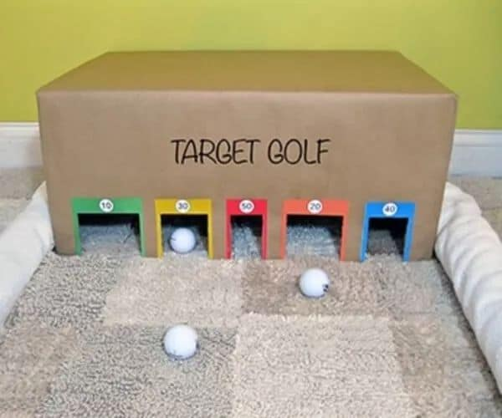
From <https://www.facebook.com/photo.php?fbid=10158441768986209&set=pcb.10158441786486209&type=3&theater>

Sardines
Similar to Hide and Seek. Pick one person to hide. Everyone else has to find them. Once they do they hide with them until everyone is together in the hiding spot.

Materials
None

Emotional Wellness Activities

Wellness Bingo
Fill up half your dinner plate with vegetables | Get over 5k steps in for one day | Limit weekend and screen time to 2 hrs. a day | Watch or listen to something that makes you laugh | Ask for help when you need it
Wear your favorite outfit once this week | Put on some music and dance around while doing chores | Enjoy a treat of your choice | Drink six cups of water today | Keep a gratitude journal for one day
Take some time for you; do what you need to re-energize | Call a friend you haven’t spoken to in awhile | No screens for one hour before bed | Treat yourself to something delicious | Tell someone you appreciate them
Spend time with an animal | Relax for at-least 15 min today | Be outside for a minimum of 30 min a day | De-clutter your work space/room | Sit in stillness for 5 minutes
Put your phone in a drawer at meal time for the whole week | Go for a half hour walk | Read a new book or an old favorite | Go to bed 30 min early | Try a new type of fitness routine

____________________________________________________________________________________________________________________________________________

Family Activities
Block Stack
Have each player balance a plate on his/her head and try to stack five blocks on top of the plate.
5 blocks &
1 plate per player

Breakfast Scramble
Cut the front of popular cereal boxes into 16 pieces and scramble them. Have the kids (either in groups or individually) try to put one of the cereal box puzzles back together. This is a pretty easy challenge, so it’s great to do in the beginning to build confidence!
Front of different types of breakfast cereal boxes

Don ’t Blow the Joker
Place a deck of cards (with the Joker on the bottom) on top of a glass container. When the minute starts, have the player gently blow the cards off of the bottle until he/she gets to the Joker. The player that blows all of the cards off of the bottle except for the Joker in under a minute wins!
Deck of cards
Glass container

Cooperative Drawing
Draw a picture together. Start with one piece of paper. The first person draws ONE thing then passes it to the next person who then draws ONE thing. Continue this until each person has had three turns to draw. Share the picture with everyone and talk about what is happening in the picture and why everyone drew the items they did.

Materials
Blank Paper
Pencil

