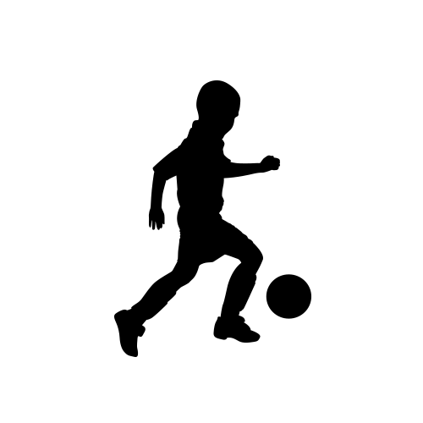
Athletic Association West

Soccer Rules (Revised 2018)

All Divisions:
- No time outs
- Off-sides will be called
- No slide tackling is allowed
- Substitution to be done: on throw ins, goal kicks or after a goal only and
must be done with the approval of the referee
- Referee will warn a player once about rough play or inappropriate language and then inform the coach. A second offence by the same player will result in removal from the game
- It is strongly recommended that shin pads and cleats (non-metal) be worn
- Each player must have a team sweater. Goalie should have different coloured jersey or not wear a team shirt. There should be no changing of shirts on the field
- All other soccer rules apply (according to Ontario Soccer Association)

** Junior Teams will now be playing 8 players on the field plus their Keeper.

Mixed Teams (Junior B and Grade 3/4):
- Teams must have a minimum 4 girls on the field at all times

Please note the following:
- Coach should check in with the convener when they arrive to pick up information on scoring system and tie breaking rules.
- Coaches should ensure that their team is ready to start games on time to help keep the schedule running smoothly.
- There will be a brief Coaches Meeting at 9:15 a.m. at the registration area.
- Emergency shelter (ie. Thunder and lightning) will be determined, and information will be given to coaches the day of the tournament. (Please refer to convenor for instructions and updates as necessary)

** Tie Breaking Rules
No game will end in a tie. If a game is tied at the end of regulation time a sudden death shoot out will decide the winner. One player from each team will shoot. If they both score or both miss, there will be a new round with two new players. This continues until one team scores over their opponent.

COACHING and REFEREES GUIDELINES

Direct Kick Indirect Kick
- 10 yards away - from infraction point
- not back to goalie - results from:
- called when following happens: dangerous play
charging from behind offside
handling the ball
holding/jumping opponent
kicking an opponent
kicking ball held by goalie
pushing
striking
tripping
violent charging

Goal Kick - offensive player kicks ball across end line

Kick-off - opposing team 10 yards away
- ball must go to other player before kicker touches again

Corner Kick - defensive play puts ball across end line
- players 10 yards away

