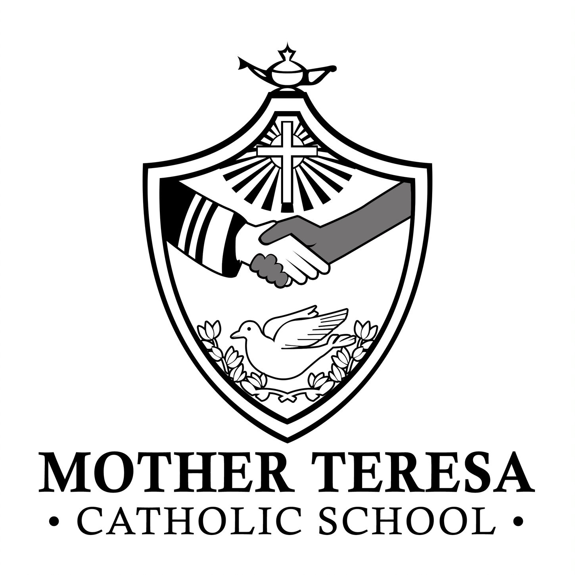

School Council-Principal’s Report
Wednesday, December 6th 7:00-8:00 p.m.

- Thank you so much to our Catholic School Council for organizing our milkshakes last Friday.
- Thank you for your generous support with non-perishable food for the Partners and Mission Food Bank. Your donations are greatly appreciated! Our Jingle Bell walk was held on Monday.
- We are still collecting hats, mitts, gloves and scarves for the St. Rita Drop in Centre until December 15th.
- We will be gathering as a school community for our Advent Prayer services:
    - Tuesday, December 5th @ 9:15
    - Wednesday, December 13th @ 10:30 with Fr. Michael
    - Tuesday, December 19th @ 9:15
- EQAO overview-
Gr. 3 Reading:
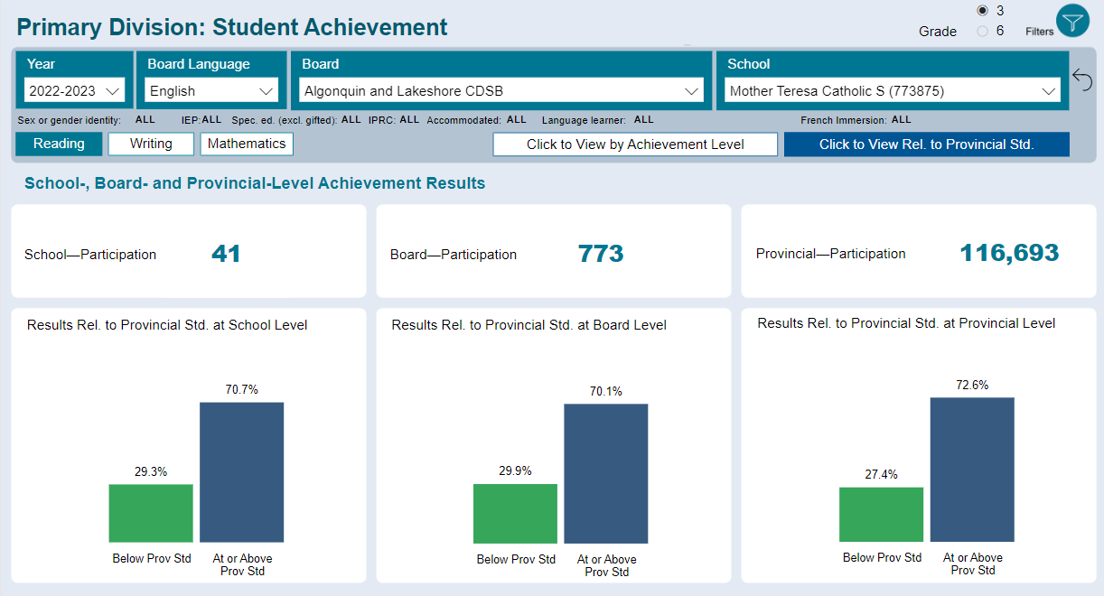
-70.7% of students at or above the provincial standard in reading
-Similar to board and slightly below provincial averages
-Reading continues to be a focus (SIPSAW goal) in all primary classes (Science of Reading)

Gr. 3 Writing:
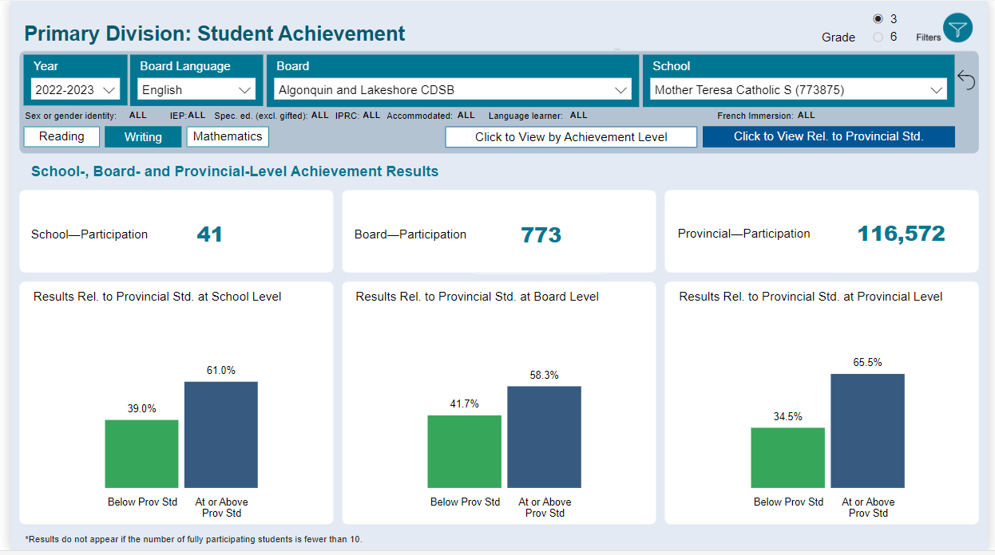
-61% at or above the provincial standard. Majority of students at level 3.
-On par with the board average, but below the provincial average (65.5%)
-Focus for PLC work in the new year (writing instruction for gr. 3’s)

Gr. 3 Mathematics
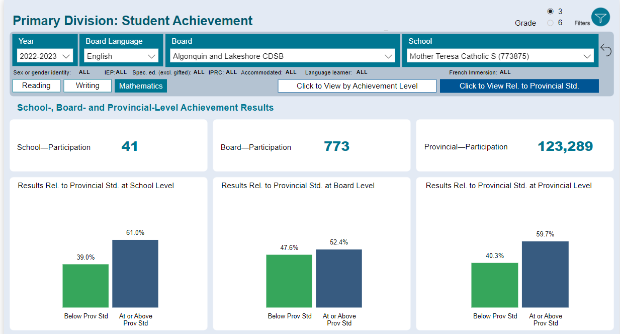
-61% at or above the provincial standard
-Above the board and slightly above the provincial average
-Continued focus on Effective Math Framework in all grades (focus on Thinking style questions)

Gr. 6 Reading
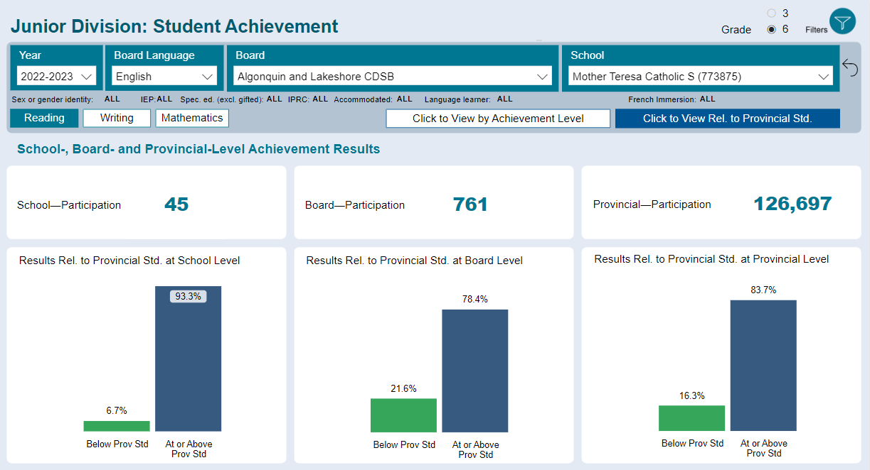
-Strong reading results for grade 6. 93.3% of students were at or above the provincial standard (Similar trend to last year)
-Significantly above both the board and provincial average

Gr. 6 Writing
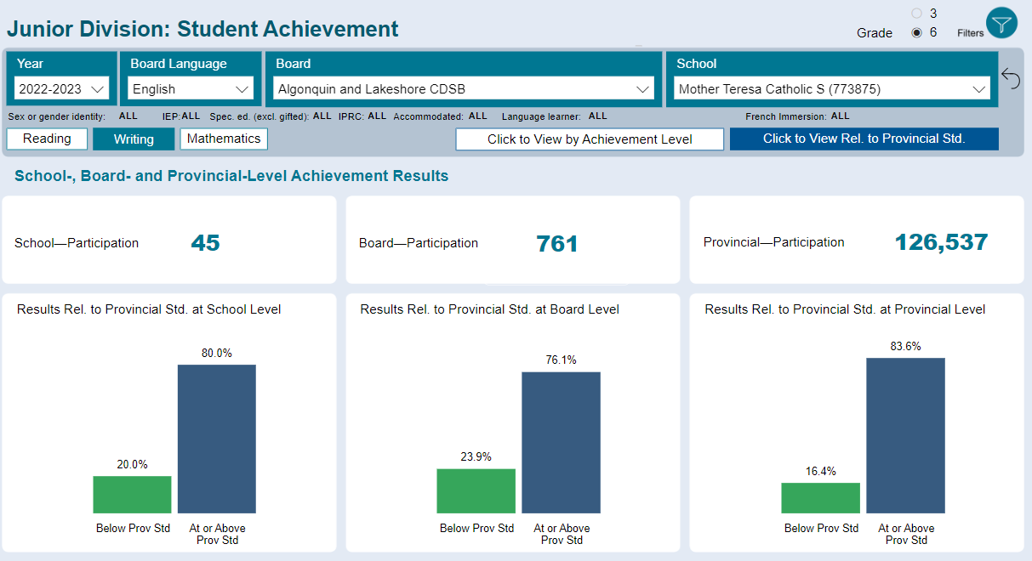
-80% of students were at or above the provincial standard
-Above the board average and slightly below the provincial average

Gr. 6 Mathematics
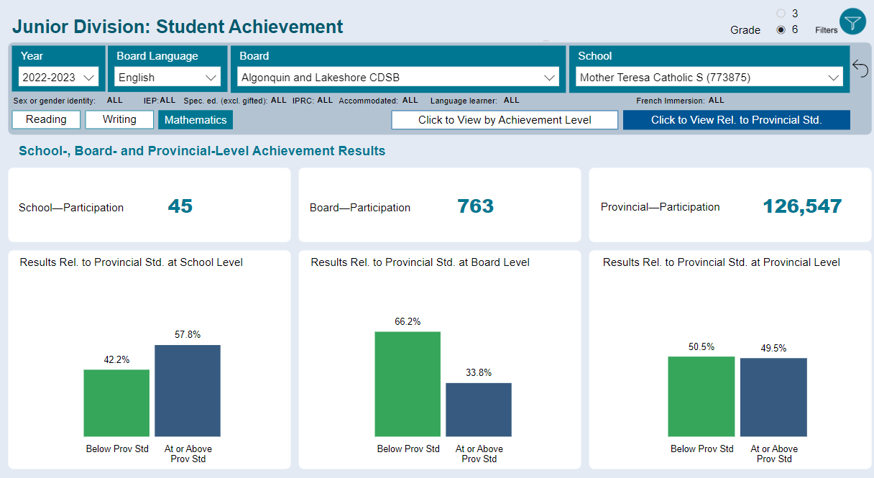
-57.8% of students were at or above the provincial standard (up slightly from last year)
-Significantly above the board and above the provincial average
-Junior math continues to be a focus of teacher PD (October PA Day) and PLC activities

Overall notes:
- This was the 2nd year that the testing was done on-line. We are very proud of the results! ☺
- Students continue to get more comfortable with the on-line format, but they need a lot of encouragement to think through the problems and ‘do the work’ instead of just guessing. Lots of practice for this!
- EQAO has release more unreleased questions, practice tests and other resources to help support students.
- The providence allowed for more students to be exempt from testing then in the past related to their learning profile. Our approach was that if students wished to participate with their peers, then we welcomed them to so. Limited accommodates are allowed.
- Individual student results were sent home last week.
- This data will be used to support PD opportunities for teachers and OFIP programming for students (focus on Math and Literacy)

