We Survived the First Month Back!
Thank you so much for being so patient and flexible with our return to school plan! Students are doing a great job wearing masks and keeping their distance from others. Please remember to complete the Covid-19 Screening Tool before your child attends school each day.
https://covid-19.ontario.ca/school-screening/
If staff members notice a student showing or complaining about any of the symptoms, and they are unrelated to other chronic medical conditions, you will be called and asked to pick up your child. The flow chart below is to be used if your child did not pass the Covid-19 screening.
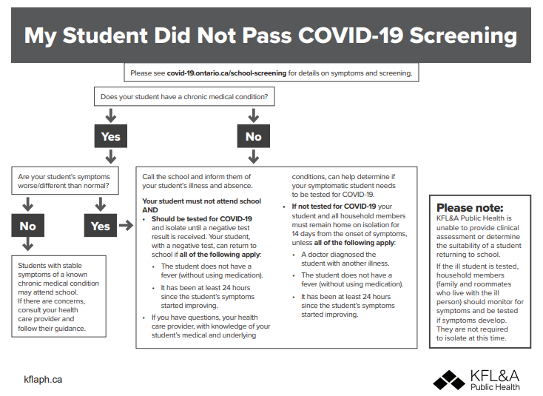

Student Accident Insurance
There are no pamphlets for Student Accident Insurance this year. Use the link: http://www.insuremykids.com/en/Default.aspx in the drop-down list under the Parents/Community tab on the Board website.

Bus Cancellation App
There are some days when there might be a bus driver shortage and some routes may need to be cancelled. This will not be announced on the radio. The board is urging you to visit the Tri-Board site and download their Bus Cancellation App. Please ensure your child only uses the primary and secondary drop off and pick up locations during this time.
Catholic School Council
The Sacred Heart Catholic School Council is a dynamic and integral part of this school community. The Catholic School Council will meet on a regular basis and all meetings are open to parents/guardians from our school community. All meeting dates will be announced in our monthly newsletter. Our second Catholic School Council meeting of the year will be taking place VIRTUALLY on Monday, November 23 at 6:00. All are invited and welcome to attend! Please let Mrs. Cuthbert-Brown know if you would like to attend so she can send you an invite virtually!
2020-21 Board’s Pastoral Theme
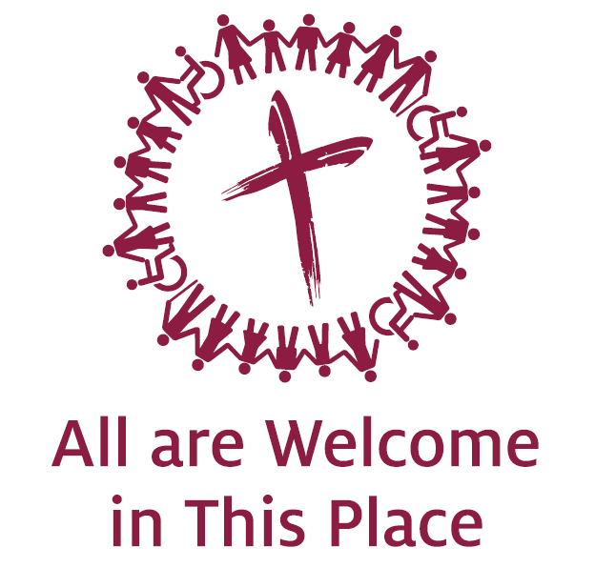

School Website
Families are encouraged to access our school website at https://www.alcdsb.on.ca/School/shrt to learn about what is happening at Sacred Heart. We will refresh feature stories regularly and include notices about upcoming events.
Interviews
Interviews after the progress reports are not mandatory and will not be in-person this year. If you would like to have a virtual interview or a phone call with your child’s teacher, we will arrange a schedule for November 3, 4 and 5th.
Other Upcoming Events:
Thanksgiving Day October 12
Progress Reports and IEPs go home November 3

Follow us on Twitter: @alcdsb_shrt

“Jesus teaches us another way: Go out. Go out and share your testimony, go out and interact with your brothers, go out and share, go out and ask. Become the Word in body as well as spirit.”
- Pope Francis

