Covid Screening Tool
Message from Health Unit:
Thank you so much for remembering to complete the Covid-19 Screening Tool before your child attends school each day. As of October 1, we’ve made a few updates to our testing guidelines for children. The main update is adjusting the type and number of symptoms needed for a child to stay home for a period of time and seek medical advice. Our guidelines continue to evolve as we learn more about COVID-19, how it spreads, and how it affects children and adults in different ways.
https://covid-19.ontario.ca/school-screening/
Progress Reports/Interviews
Progress Reports will be sent home on November 3. Interviews will take place November 3, 4 and 5. These are not mandatory. A teacher or parent can request one. Your options this year are to have a virtual interview or a phone call with your child’s teacher. A note was sent home regarding setting up an appointment.

School Photos
Unfortunately, there will not be any photo re-takes happening at the school this year. If you require them, please contact Life Touch at 613-634-1424 and arrange a studio appointment.

Community Garden
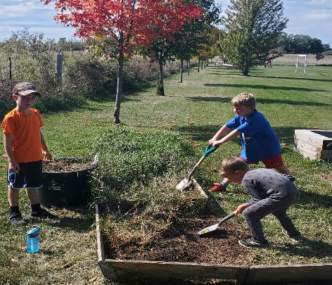
It has definitely been a community event to get these school yard gardens spruced up! Thanks to Nick Hogan Trucking and Topsoil and Isaac Orr for the soil and delivery. Kate Slagle came to facilitate the garden box building. Haley and Glen Hulton fixed the sandbox and are taking care of sand delivery! We all appreciate everyone taking the time to make our school yard look so great!
Catholic School Council
The Sacred Heart Catholic School Council is a dynamic and integral part of this school community.
Our second Catholic School Council meeting of the year will be taking place VIRTUALLY on Monday November 23 at 6:00. All are invited and welcome to attend! Please let Mrs. Cuthbert-Brown know if you would like her to send you an e-vite!
Fundraisers
The school is hosting the Halenda’s meat stix fundraiser to help raise money for student supplies, agendas, etc. Order

forms and School Cash Online payments are due November 9th.
Our Catholic School Council is selling Wilton Cheese. This fundraiser runs from October 19-November 24th. The gift card fundraiser and forms are due November 20th.
We will try to make 1 pick up night for all orders during the first week of December and will let you know, closer to that date, what the exact date and time will be.
School Website
Families are encouraged to access our school website at https://www.alcdsb.on.ca/School/shrt to learn about what is happening at Sacred Heart. We will refresh feature stories regularly and include notices about upcoming events.
Other Upcoming Events:
*Spirit Week Nov 2-6 for United Way
Monday-School Clothing Day (blue and yellow)
Tuesday-Crazy Socks Day
Wednesday-Sports Day
Thursday-Country Day
Friday-Favourite Character Day
*Remembrance Day November 11

Follow us on Twitter: @alcdsb_shrt

