March Break
March Break has been postponed until April 12th. Easter weekend is April 2nd.
Lent
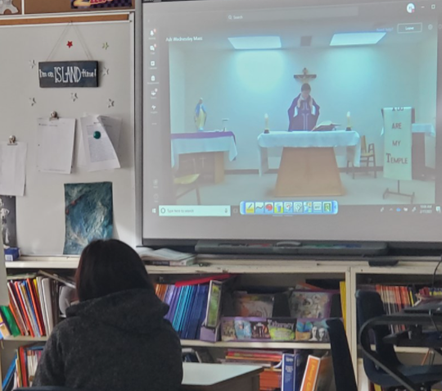
Ash Wednesday looked a little different this year, since we took part in a virtual service. Students continue to follow their Lenten promises, help others, and pray often.
Thank You W.I. Essential Workers
As a thank you to Wolfe Island’s essential workers, students made some beautiful Valentines to brighten the day at some local businesses!
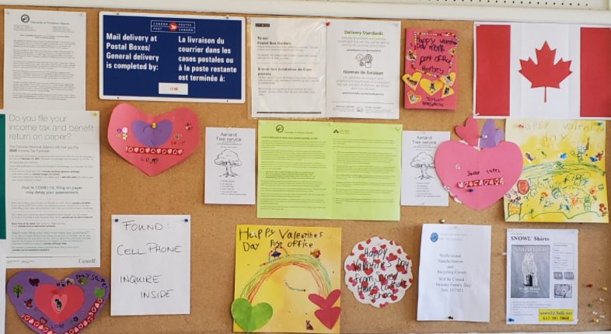

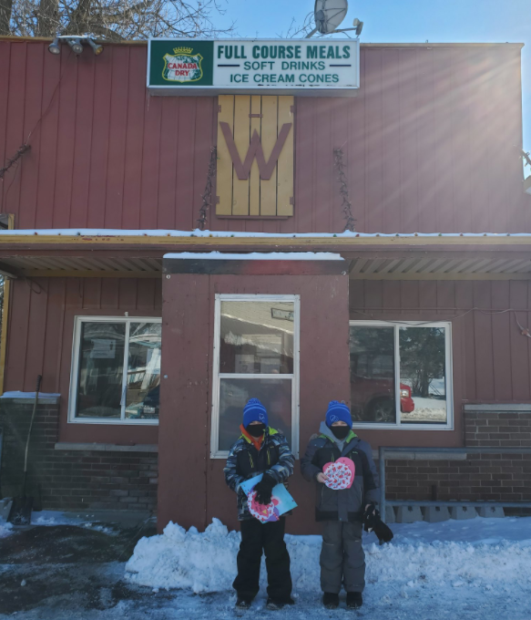
Black History Month
This past month, we celebrated, learned, shared and honoured the tremendous legacy of Black Canadians of the past and present.
Pink Shirt Day
There was a wave of pink at Sacred Heart for Pink Shirt Day. Students completed various activities and had discussions about anti-bullying.
ALCDSB Foundation Request for Silent Auction Basket Items
Thank you so much for the amazing donations to the ‘All Things Wolfe Island’ silent auction basket to help raise money for the ALCDSB foundation! This basket, along with many other great items, will be up for auction in the spring! More information to come at a later date!

Hot Lunch/Milk Orders
Please check your child’s agenda regularly for various forms we send home. If your hot lunch and milk orders (forms/online payments) are not submitted on or before the due dates, we are sorry, but we cannot process your order for that session.
Catholic School Council
The Sacred Heart Catholic School Council is a dynamic and integral part of this school community.
Our next Catholic School Council meeting will take place VIRTUALLY on April 19th at 6:00pm. All are invited and welcome to attend! Please let Mrs. Cuthbert-Brown know if you would like her to send you an e-vite.
Covid Update
Thank you for using the updated Covid Screening Tool before sending your child/ren to school.
Please ensure your child has a few extra masks in his/her bag and please check the stock regularly, especially since they are worn outside, during recesses, and get quite wet!

