We would like to sincerely thank you all for your patience and hard work during our remote learning block! It was not easy, but we all survived and learned a lot about technology at the same time!
Welcome
We would like to welcome Sarah Taggart to the K-1 class! She will be completing her Early Childhood Education placement with us until April.
Catholic School Council
The Sacred Heart Catholic School Council is a dynamic and integral part of this school community.
Our next Catholic School Council meeting will take place VIRTUALLY on Monday February 22 at 6:00. All are invited and welcome to attend! Please let Mrs. Cuthbert-Brown know if you would like her to send you an e-vite.
Black History Month is celebrated across Canada every February. This month is an opportunity to celebrate, learn, share and honour the tremendous legacy of Black Canadians of the past and present. One month is never enough time to fully commemorate and celebrate the often-neglected accomplishments, contributions and history of people of African descent. We are called to honour this legacy each day in the texts we choose, the perspectives we share and the narrative of hope and resilience that makes our country and world better.

Bell Let’s Talk Day
Students completed many activities and learned various strategies to help ensure we all stay mentally healthy! We wore blue on January 28th to show our support for this important event!
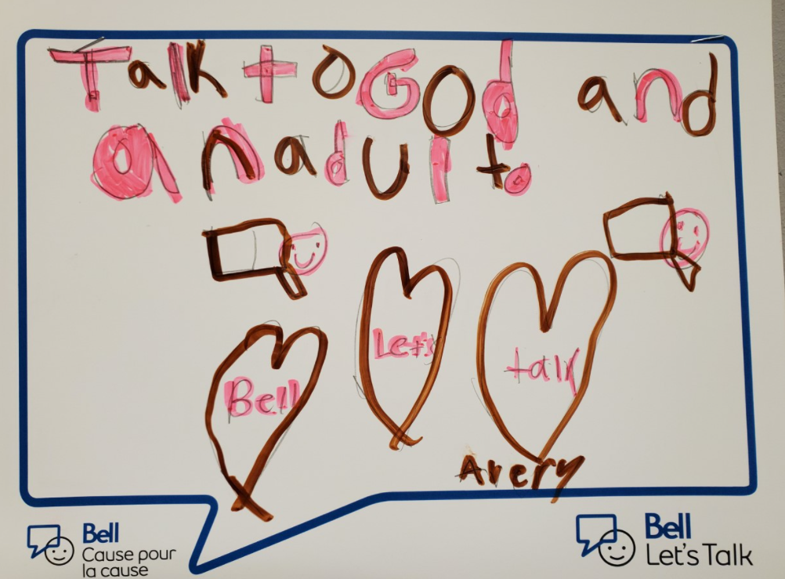
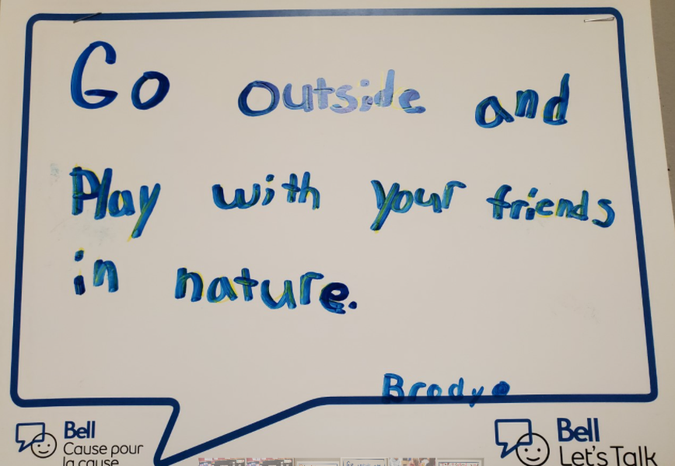
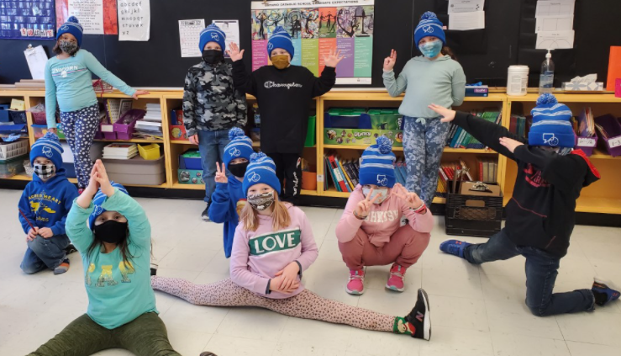

Term One Report Cards and IEPs
Report cards and IEPs will be sent home on February 17th. If you would like to talk to your child’s teacher about these reports, please contact the teacher directly using the agenda or email!

Sacraments
Father and Deacon Lindsey came to visit each class last week. He wanted us to know that we will continue to prepare for the Sacraments, as usual, but he won’t be able to give us any dates yet. Due to the changing maximum capacity of the church, we may have to have these ceremonies on a weeknight instead of a Sunday mass. We will share the information with you once he hears more.
ALCDSB Foundation Request for Silent Auction Basket Items
The school would like to donate Wolfe Island items (honey, coffee, clothing, gift cards, etc.) for a silent auction basket. Please consider helping with this important fundraiser for our board. Please send any donations to the school. Thank you!
Covid Update
Please ensure your child has a few extra masks in his/her bag and please check the stock regularly. All students and staff are now asked to wear masks when inside and outside. We sometimes need to switch, since they get wet. If students require a mask break, we get them to walk to a space away from others outside, to do so. Also, please see the attached link that includes a message from Dr. Moore about the Covid Variant strain and his recommendations.

