Asphalt Painting
Thank you to our Catholic School Council for purchasing these amazing games for students! They are loving them and are making good use of these new additions!
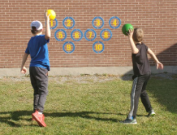
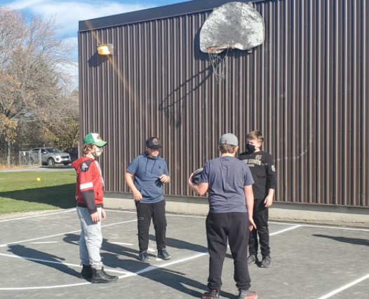
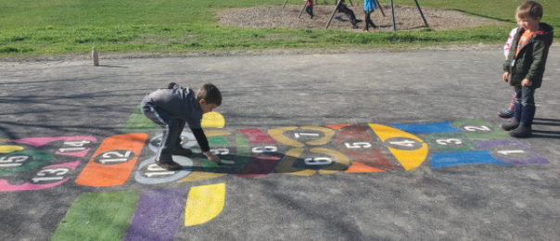
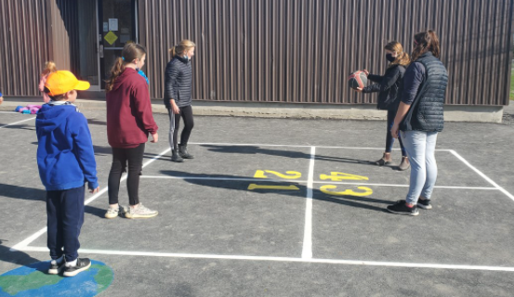

Catholic School Council
The Sacred Heart Catholic School Council is a dynamic and integral part of this school community.
Our next Catholic School Council meeting will take place VIRTUALLY on Monday February 22 at 6:00. All are invited and welcome to attend! Please let Mrs. Cuthbert-Brown know if you would like her to send you an e-vite!
Fundraisers
Thanks for helping out with our school’s pepperoni stix fundraiser. Alex Hulton was our V-P for the day! Way to go! Students enjoyed taking part in an extra-long recess and listening to music during their lunch.
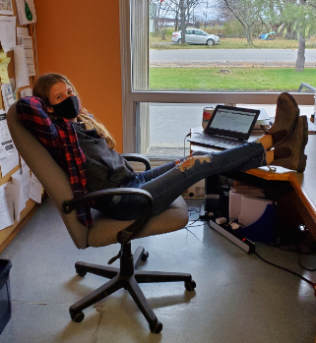
Remembrance Day
Students took part in a virtual ceremony and listened to some veterans speak on this important day. They also created some amazing works of art for our poster contest! Winners received a WIPP gift card donated by Mrs. LaPrairie!
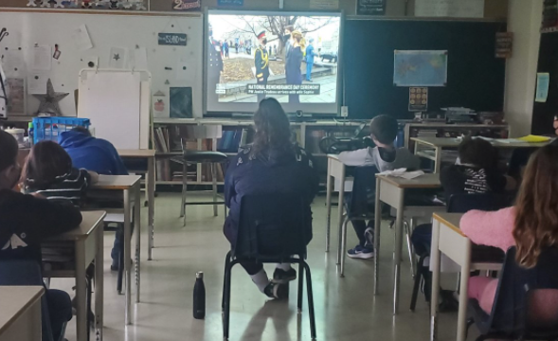
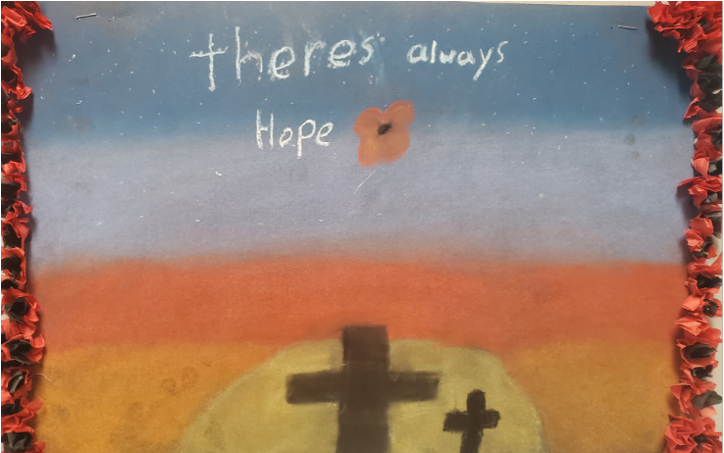
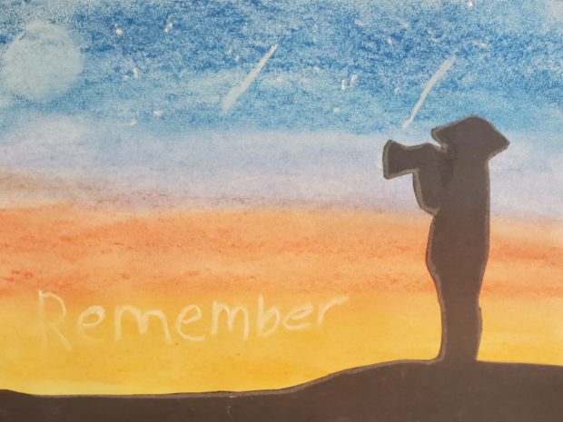

ALCDSB Foundation Request for Silent Auction Basket Items
The school would like to donate Wolfe Island items (honey, coffee, clothing, gift cards, etc) for a silent auction basket. Please consider helping out with this important fundraiser for our board. Please send any donations to the school. Thank you!
Covid
Please ensure your child’s backpack is stocked with a few extra masks each day. Thanks.
Upcoming events:
Science Fair December 15th

