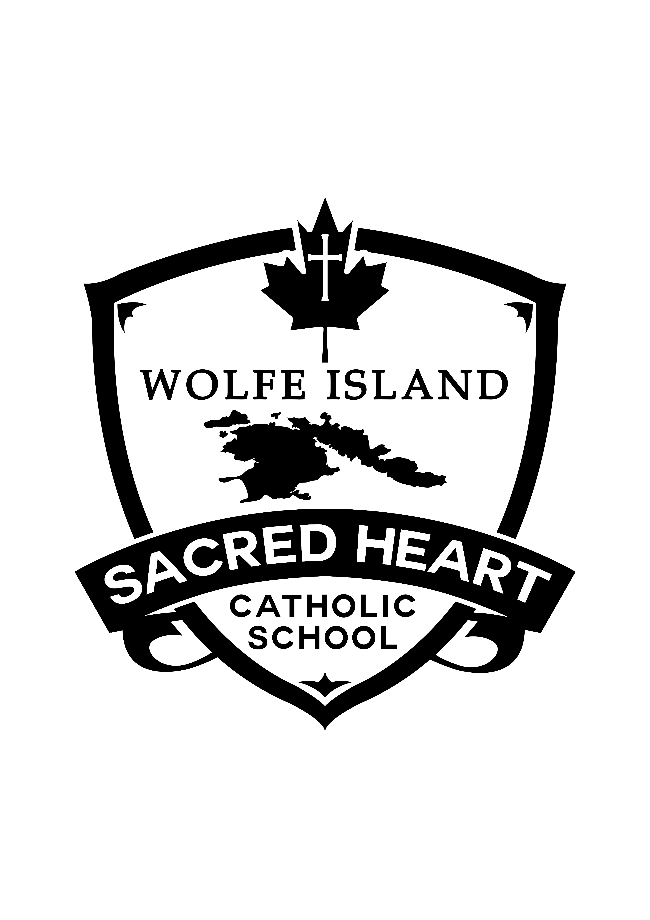

Dear Sacred Heart Catholic School Families,

As an unprecedented September is nearly upon us, I wanted to take a moment to reach out to each of you with some information in hopes that it will serve to answer the many questions you have. I want to begin by thanking each of you for the tireless effort you put in during the remote learning sessions in the latter part of last year. I think it is safe to say that we were all surprised by the length of time we were away from school, and how adept many of us became with distance learning. Our staff was thoroughly impressed with the work that was done, and encouraged by the growth our students made, despite the difficult situation.

As we get ready to open our doors in September, we have made every effort to ensure that our return to school is done so in a way that is safe, engaging, and in compliance with the Ministry of Education and the Local Public Health Unit. We will be teaching and instituting physical distancing practices, hand hygiene, requiring masks for all of our students (update as of today). So, what’s different? What is in place to ensure a safe and engaging re-opening of our school? While this is not an exhausted list, it will demonstrate some of the more glaring ways we are working hard to ensure things are safe.

Visitors and Parent(s)/Guardians: Visitors will not be permitted in the school. Parents/guardians will be required to remain outside the building if picking up or dropping their child off.

Staggered Entry: We will be staggering the entry of our students. Thursday September 3 and Friday September 4, 2020: Students in grades JK to 3 will come to school. Tuesday September 8, 2020: All students from Junior Kindergarten to grade 8 will be at school.

First Day: Upon arrival, the teacher will be there to take students to their designated entrance into the school once the bell rings. Walkers or students being dropped off should not arrive early.

Classes: Classes will be considered COHORTS. They will constitute their own bubble.

Recess: No masks will be worn. COHORTS will be assigned a specific area/zone of the yard and will be required to stay on that part of the yard. Different COHORTS will not be permitted to play with each other. The play structure is open. Students will sanitize hands before and after recesses.

**Update**Masks: All students from K through 8, and all staff are required to wear a mask while in the building. Masks will not be worn on the yard. Teachers will create time in their daily schedule to teach and talk with students about the proper way to wear a mask. PPE: All staff will be provided with and required to wear medical personal protective equipment that has been provided by the board.

Hand Hygiene: Teachers will teach and talk with students about proper hand hygiene. Teachers will create a schedule for opportunities throughout the day where students will wash hands.

Hand Sanitizer: Hand sanitizer will be available throughout the school and in each of the classes. Teachers will teach and talk with students about proper use of hand sanitizer.

Washrooms: Each washroom will have a limit of two students at any one time.

Signage: There will be directional signage, and signage reminding students to participate in proper hand hygiene throughout the school.

At home screening: Parent(s)/Guardian(s) are asked to check their children daily for any signs of COVID-19. If students are presenting with any such signs, you are asked to keep your child at home 24 hours after being symptom-free.

Materials and Manipulatives: Students are asked to keep the materials and manipulatives they bring to school each day to a minimum. Soft or plush toys/items are not permitted at the school. Students will be provided with their own set of manipulatives at school. All technological devices will be wiped down after each individual student use.

I would like to once again thank you for your patience, flexibility and support during these unprecedented times. Our staff are some of the most kind and dedicated professionals to work with. They are excited about the return to school and look forward to working collaboratively with you to ensure that the return to school for our students is both safe and engaging.

Please do not hesitate to reach out to me if you have any questions.

Sincerely,

Amy Cuthbert-Brown
Vice-Principal
Sacred Heart Catholic School
Wolfe Island

