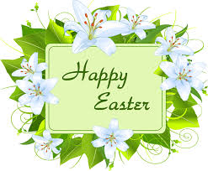
April Break
Easter weekend is April 2nd and April Break is April 12th!
Lent
Students have been completing various Lenten activities this month and reciting many student generated prayers.
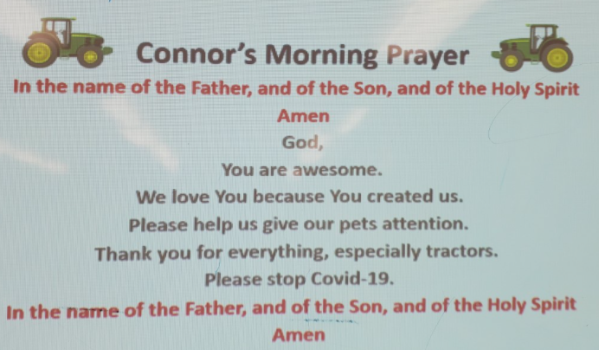
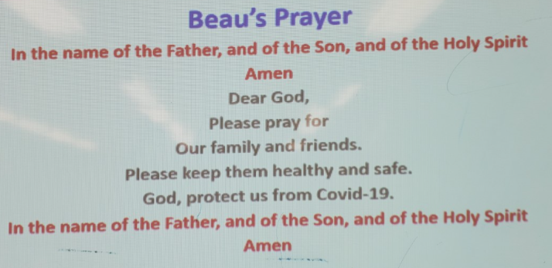
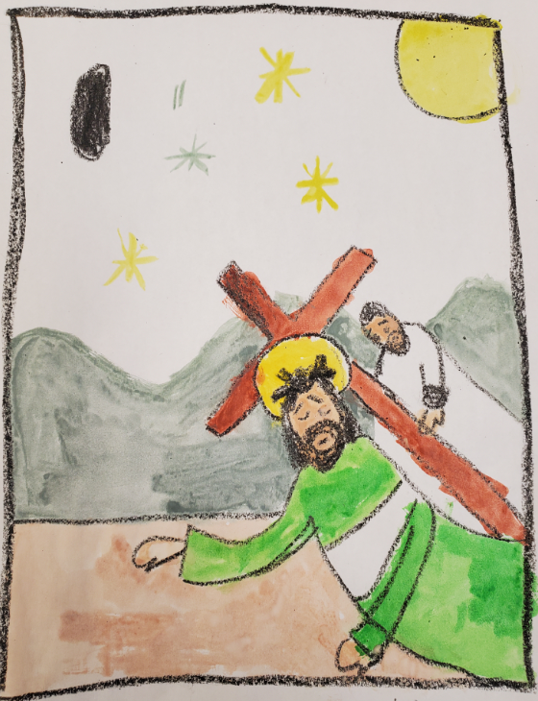

Sacraments
Confirmation will take place on May 22nd at 6:45pm. First Eucharist will be on May 29th at 6:45pm. Students can have up to 11 guests, including their sponsor (Gr 7 and 8). First Reconciliation will take place on April 28th at 5:00pm. This is just for immediate families. More information will be shared closer to these dates.
Math and the Outdoors
We love integrating different subject matter while being outside! Check out the size of this snowman!
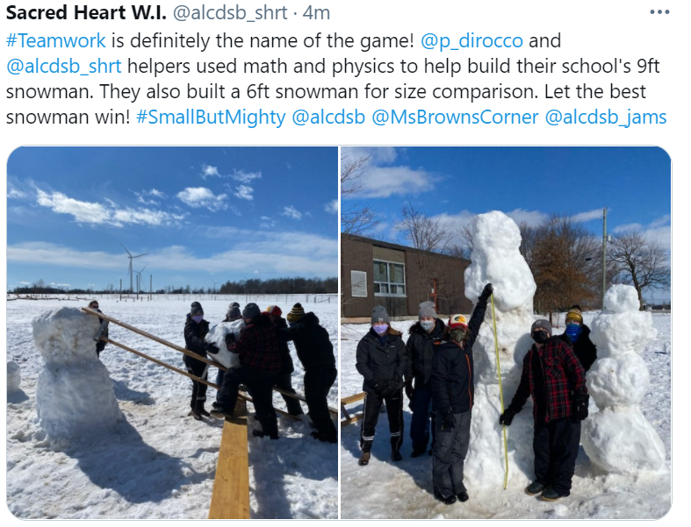
Catholic School Council
Our next Catholic School Council meeting will take place VIRTUALLY on April 19th at 6:00pm. Please let Mrs. Cuthbert-Brown know if you would like an e-vite.
Covid Update
Thank you for using the updated Covid Screening Tool before sending your child/ren to school. Please ensure your child has a few extra masks in his/her bag and

please check the stock regularly, especially since they are worn outside, during recesses, and get quite moist!
Ticks
It’s that time of year again! We will remind students to check for ticks after each recess. Please do a thorough check once students come home.
Kingston Symphony
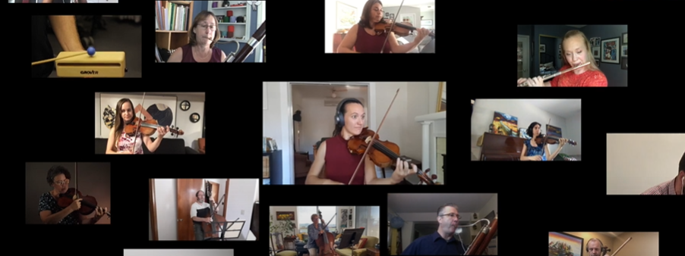
Even though we cannot go on any field trips this year, we have taken part in many virtual ones, including ‘attending’ a performance by the Kingston Symphony!
Outdoor Kitchen
If you have any wood pallets, old sinks, utensils (large spoons, spatulas, bowls, pots, pans, tins, measuring cups and spoons, etc., please consider donating them for our ‘Wood Kitchen’. We are also looking for someone to facilitate making two of these kitchens. We will provide all materials and student laborers. Thanks!
