Progress Reports and IEPs
Progress Reports and Individual Education Plans will be sent home on November 2nd. Teachers have sent home a form indicating available time slots for interviews. These are only taking place by parent/guardian or teacher request and are not mandatory.
Fundraisers
The Catholic School Council’s gift card fundraising form was sent home and orders are due November 12th. The Wilton Cheese order form will be going home November 19th and is due December 3rd. We appreciate your support! The money raised last year went towards items such as physical education and recess equipment, pavement painting (hopscotch, 4 Square, basketball court lines and a target game), and school jerseys.
Follow us on Twitter: @alcdsb_shrt

Catholic School Council
The Sacred Heart Catholic School Council is a dynamic and integral part of this school community.
Our second Catholic School Council meeting of the year will be taking place VIRTUALLY on Monday November 8th at 6:00. All are invited and welcome to attend! Please let Mrs. Cuthbert-Brown know if you would like her to send you an e-vite!

Other Upcoming Events
*Mass at the church Nov 3 at 9am
*Praying for the dead at the graveyard with Father Raymond Nov 3 at 10am
*Picture Day is November 24th

Bloom Club
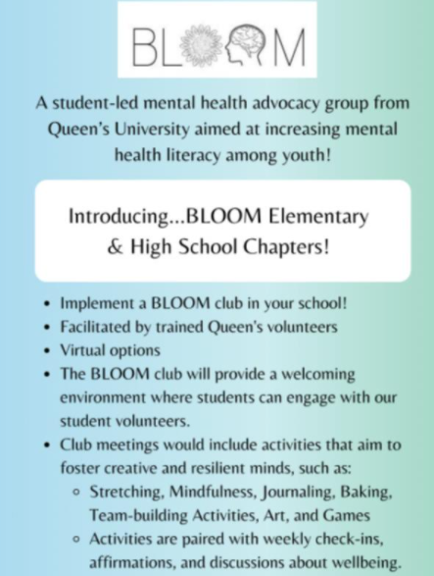
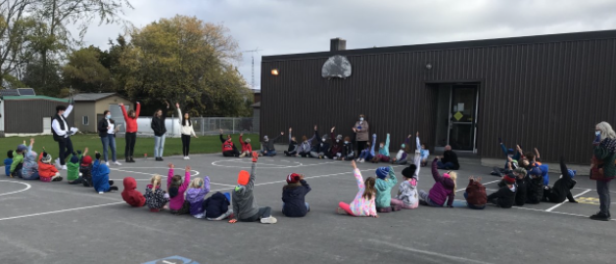
We are excited to be partnering with Queen’s University to offer this fantastic mental health and well-being initiative. Intermediate students will also take on a leadership role in helping to implement this program!

Remembrance Day
Students have been writing letters to veterans and are preparing for a day of remembrance on November 11th. We have a poster contest taking place, we will pray for our current and retired military workers and complete various activities, including making 100 poppies (crafted, painted, from recyclables) to commemorate the 100th anniversary of the remembrance poppy in Canada.
JK- grade 1s will be starting their 30-day Bucket filling campaign, which will continue through to Advent, promoting kindness and consideration for all. Each day, students will record how they filled a bucket that day.
Grades 2-4 have another Sandy Pines Virtual Field Trip on November 15,2021. The topic is At Home with Wildlife. They have sent off their questions to the two authors for the Global Read Aloud books that they are reading in class.

