Hello Sacred Heart families! How is it already June? Although this will be another year to remember, we are so thankful that we were attending school in this physical building so much this year!
Chantal Courneyea will be the in-coming Vice-Principal for September. It’s been wonderful working with you and your child(ren) the past two years!
We are sad to say goodbye to Mrs. Sherriff, Mrs. Rand and Mrs. LaPrairie! They have been such a fantastic addition to our school this year and will be greatly missed by everyone! Happy Retirement to Mrs. LaPrairie and Mrs. Sherriff!
Beacon of Hope
Congratulations to Cameron, this year’s Beacon of Hope!
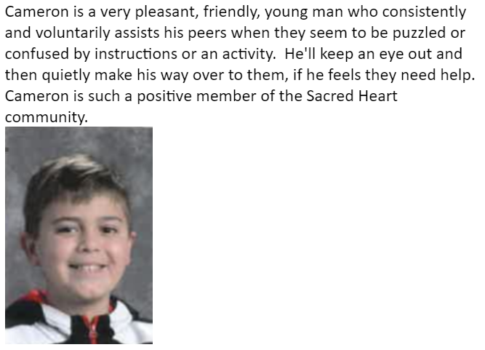
Hot Lunch and Milk
Just a reminder that orders for hot lunch and milk will not be processed if we receive paperwork or money after the due dates. It is too hard to complete billing. Please only contact Nicole Chown

with your questions about these orders. Thank you for understanding.
Pride Month
The month of June is designated as PRIDE month. This month, and every month, Sacred Heart is committed to nurturing safe and inclusive learning environments where every student and every member of our community is welcomed, valued, and respected. All are truly welcome in this Place.
Catholic School Council
Our final Catholic School Council meeting took place on May 16st. Thank you to all parents who took the time out of their busy lives to meet regularly and help make Sacred Heart a better place! We all appreciate your generous support you have provided us throughout this year!
Grade 8 Graduates
Congratulations to Ava, Hanah, Ronnie, Bridget, Kale and Ryan! We wish you all the best on your next adventure at Regi!

Catholic Education Week
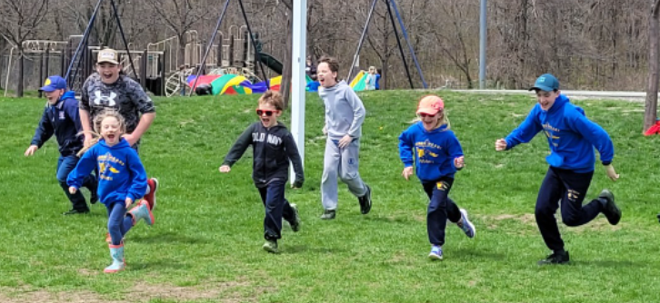
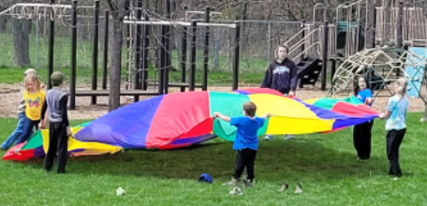
We celebrated Catholic Education Week and Mental Health Week with various activities, including our Play Day. Intermediate students took on a leadership role by planning and running stations that day!
Spring Sports Events
Congratulations to our cross country runners who took part in the board meet on May 9th! They should all be so proud of their performances. Ms. De Sasio will be bringing the gr 6 to 8 students to the Flag Football tournament at Regi on June 7th. The grade 5s are invited to watch that day. Best of luck to all of our track and field participants who will attend the board meet on June 20 and 21.
