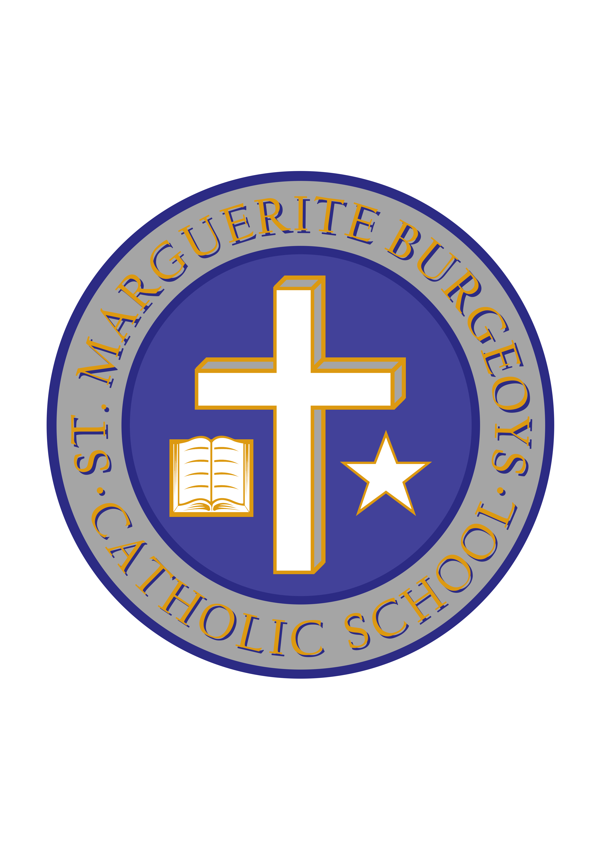

Kingston Remembrance Day Ceremony

Dear parents/guardians,

On Friday, November 9th, Mrs. Wimmer, our school Learning Resource Assistant, will be taking 15 of our Gr. 7-8 students to participate in the annual Remembrance Day Ceremony at the Cataraqui Cemetery in Kingston. They will travel by bus at 9:15 and return to the school during our lunch period. This is a wonderful opportunity for some of our students to take part in this ceremony, which recognizes the contributions of those who have given their lives so that we may live in peace as we do today.

Many thanks,

Mr. Minutillo,
Principal

