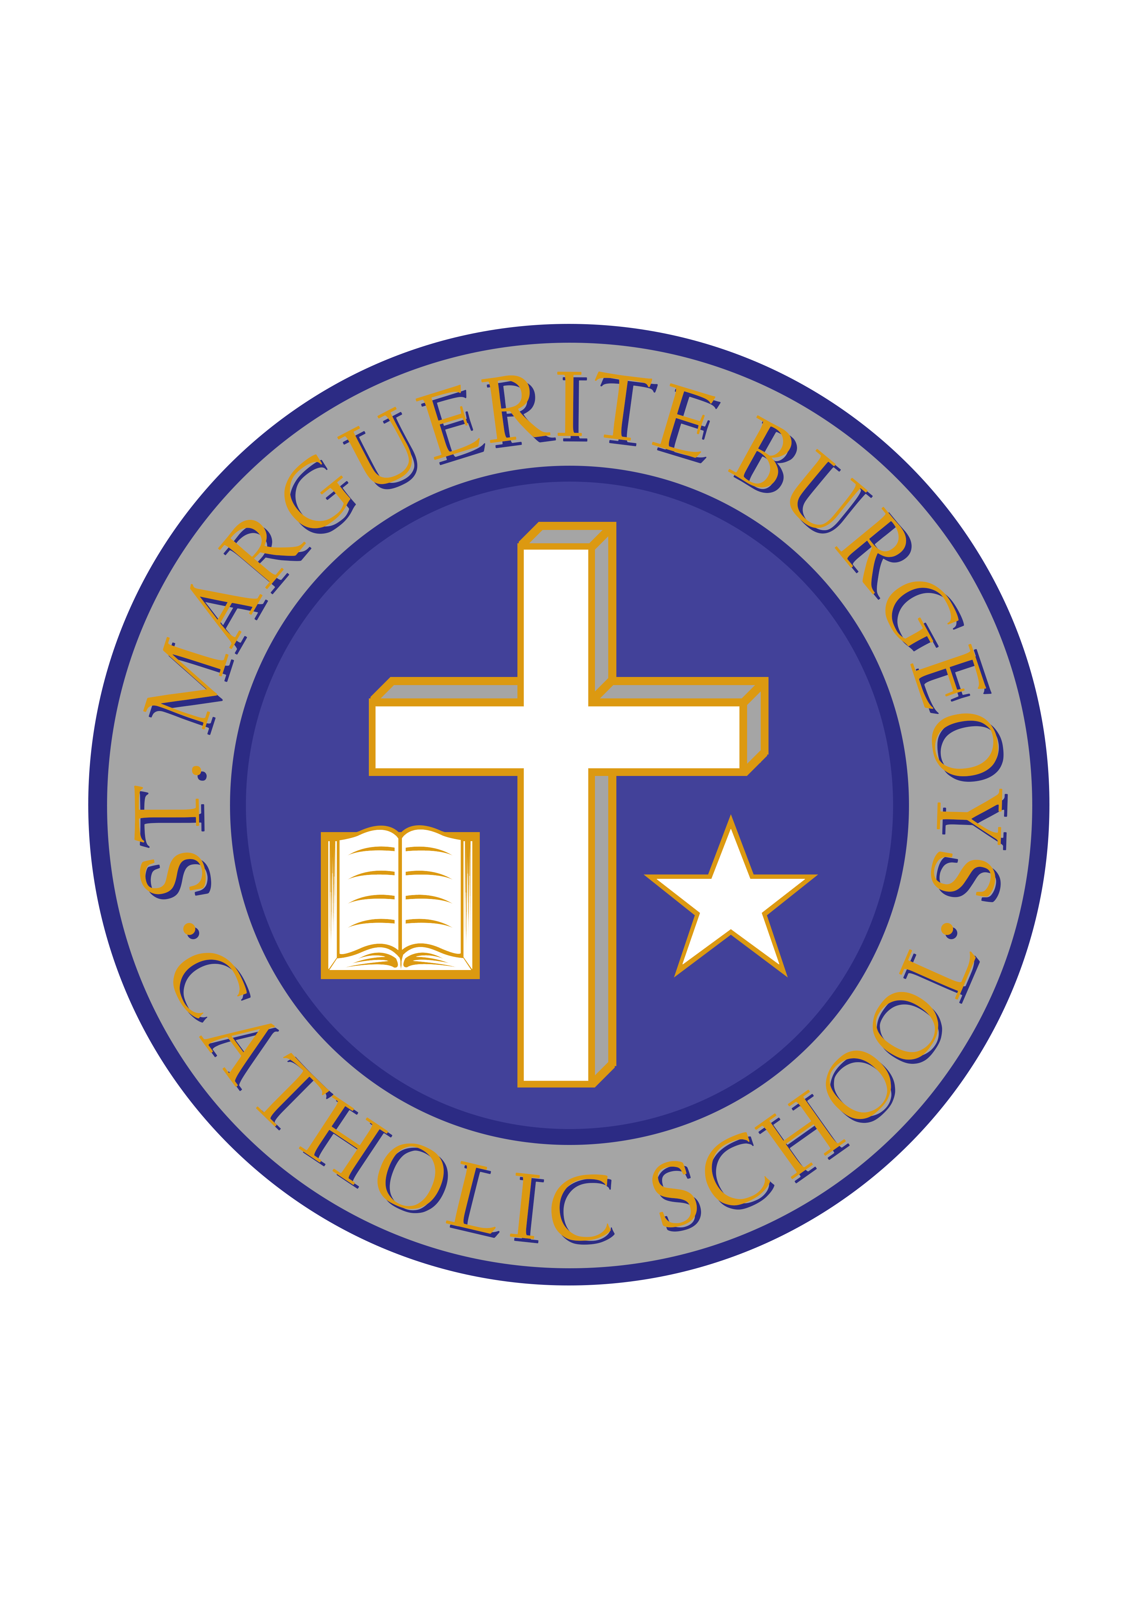

Dress Purple Day

In support of child abuse prevention awareness, St. Marguerite Bourgeoys is joining many other schools in our school board and across the province in wearing purple on Wednesday, October 24th. Students are encouraged to wear purple on this date to raise awareness around this important topic. There is no cost to this initiative.

We are looking forward to seeing lots of purple on October 24th!

Sincerely,

Mr. C. Minutillo Ms. L. Bryden
Principal Vice-principal

