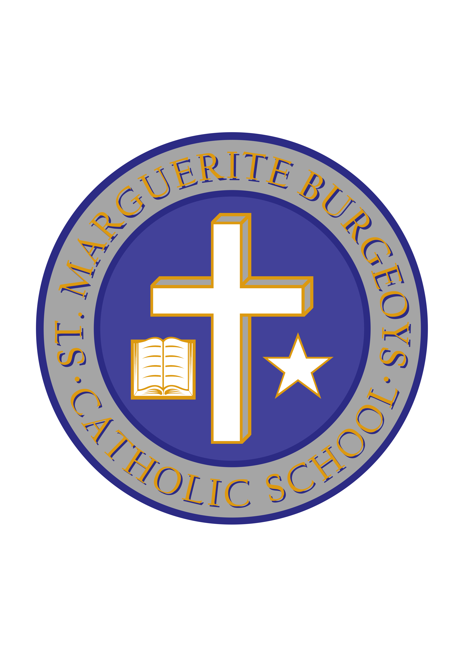

October Staffing Update

Dear parents/guardians,

We are writing to inform parents of a handful of staffing changes that have/will take place in October.

Ms. Conlon, one of our Gr. 2 teachers, is due to have her baby in the near future. As a result, her last day will be on Friday, October 19th. Ms. Gibson will be the new Gr. 2 for the remainder of the school year. Congratulations to Ms. Conlon on the new addition to her family!

Ms. Gottlieb, an educational assistant, is also due to have her baby in the near future. Her last day will be Friday, October 12th. Ms. Crawford will replace Ms. Gottlieb for the remainder of the school year. Congratulations to Ms. Gottlieb as well!

After many years in our school board and at SMB, Ms. Alexander, an educational assistant, has decided to retire. Ms. Brennan, who has worked at our school in the past in our Kindergarten classrooms, has taken over from Ms. Alexander. Congratulations to Ms. Alexander on her retirement.

Lastly, Ms. Purcell, a part-time teacher who helped to teach in all three of our Kindergarten classrooms, has moved on to a full-time position at another school. In her place, Mr. McIntyre and Ms. White will take on her teaching duties.

Welcome to all of our new staff members and all the best to those who are leaving our school!

Sincerely,

Mr. C. Minutillo Ms. L. Bryden
Principal Vice-principal

