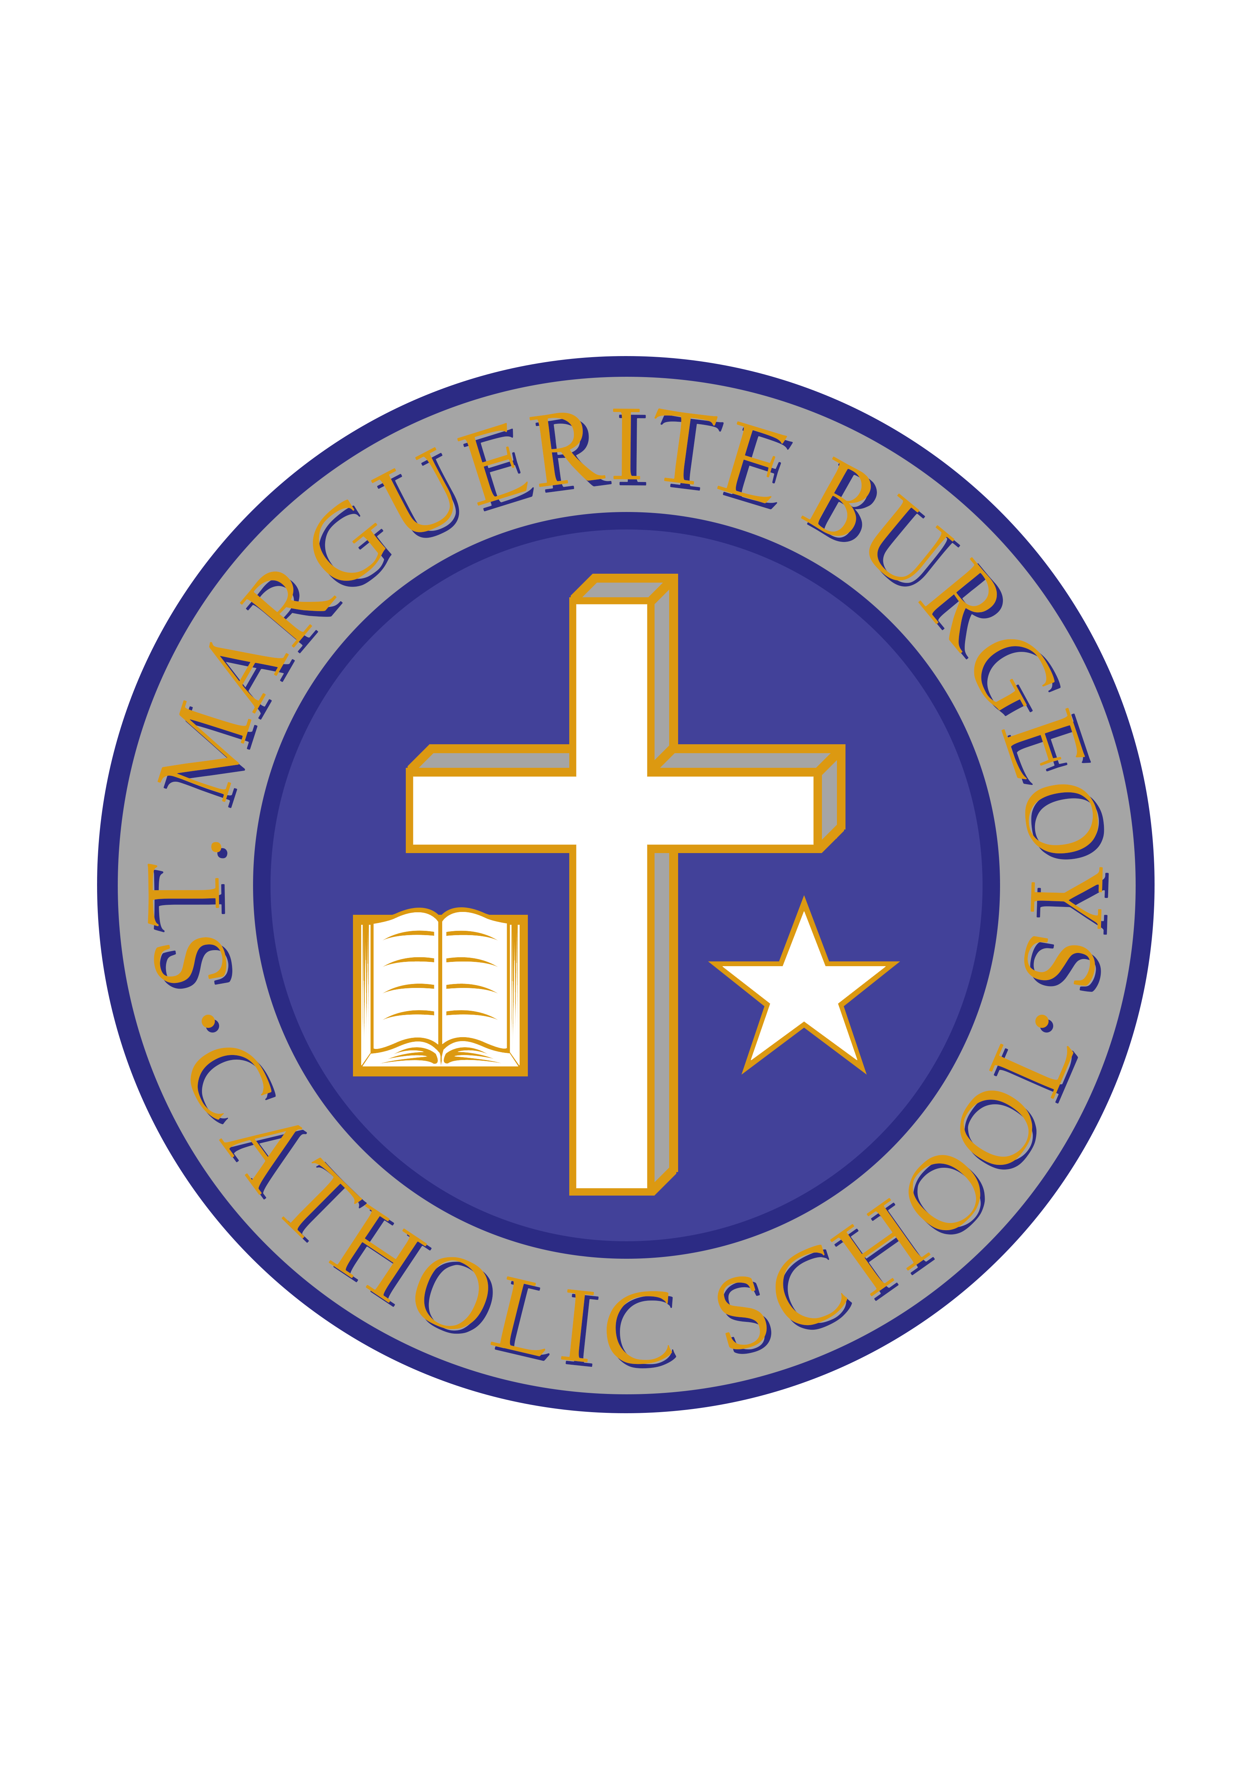

Jersey Day in Support of #jakestrong

Dear parents/guardians,

As you may have heard in the news recently, some students from Holy Cross Catholic Secondary School were in a terrible automobile accident. The accident has caused one of the students to remain in hospital as he recovers and undergoes treatment (#jakestrong on Twitter). In an effort to support our local high school and its students, we are hosting a “Jersey Day” on Friday, October 12th in which staff and students can wear their favourite sports jersey to school for a loonie. All money raised will be given to the family of the injured student to offset some of the costs associated with his recovery.

Many thanks for your ongoing support.

Mr. C. Minutillo Ms. L. Bryden
Principal Vice-principal

