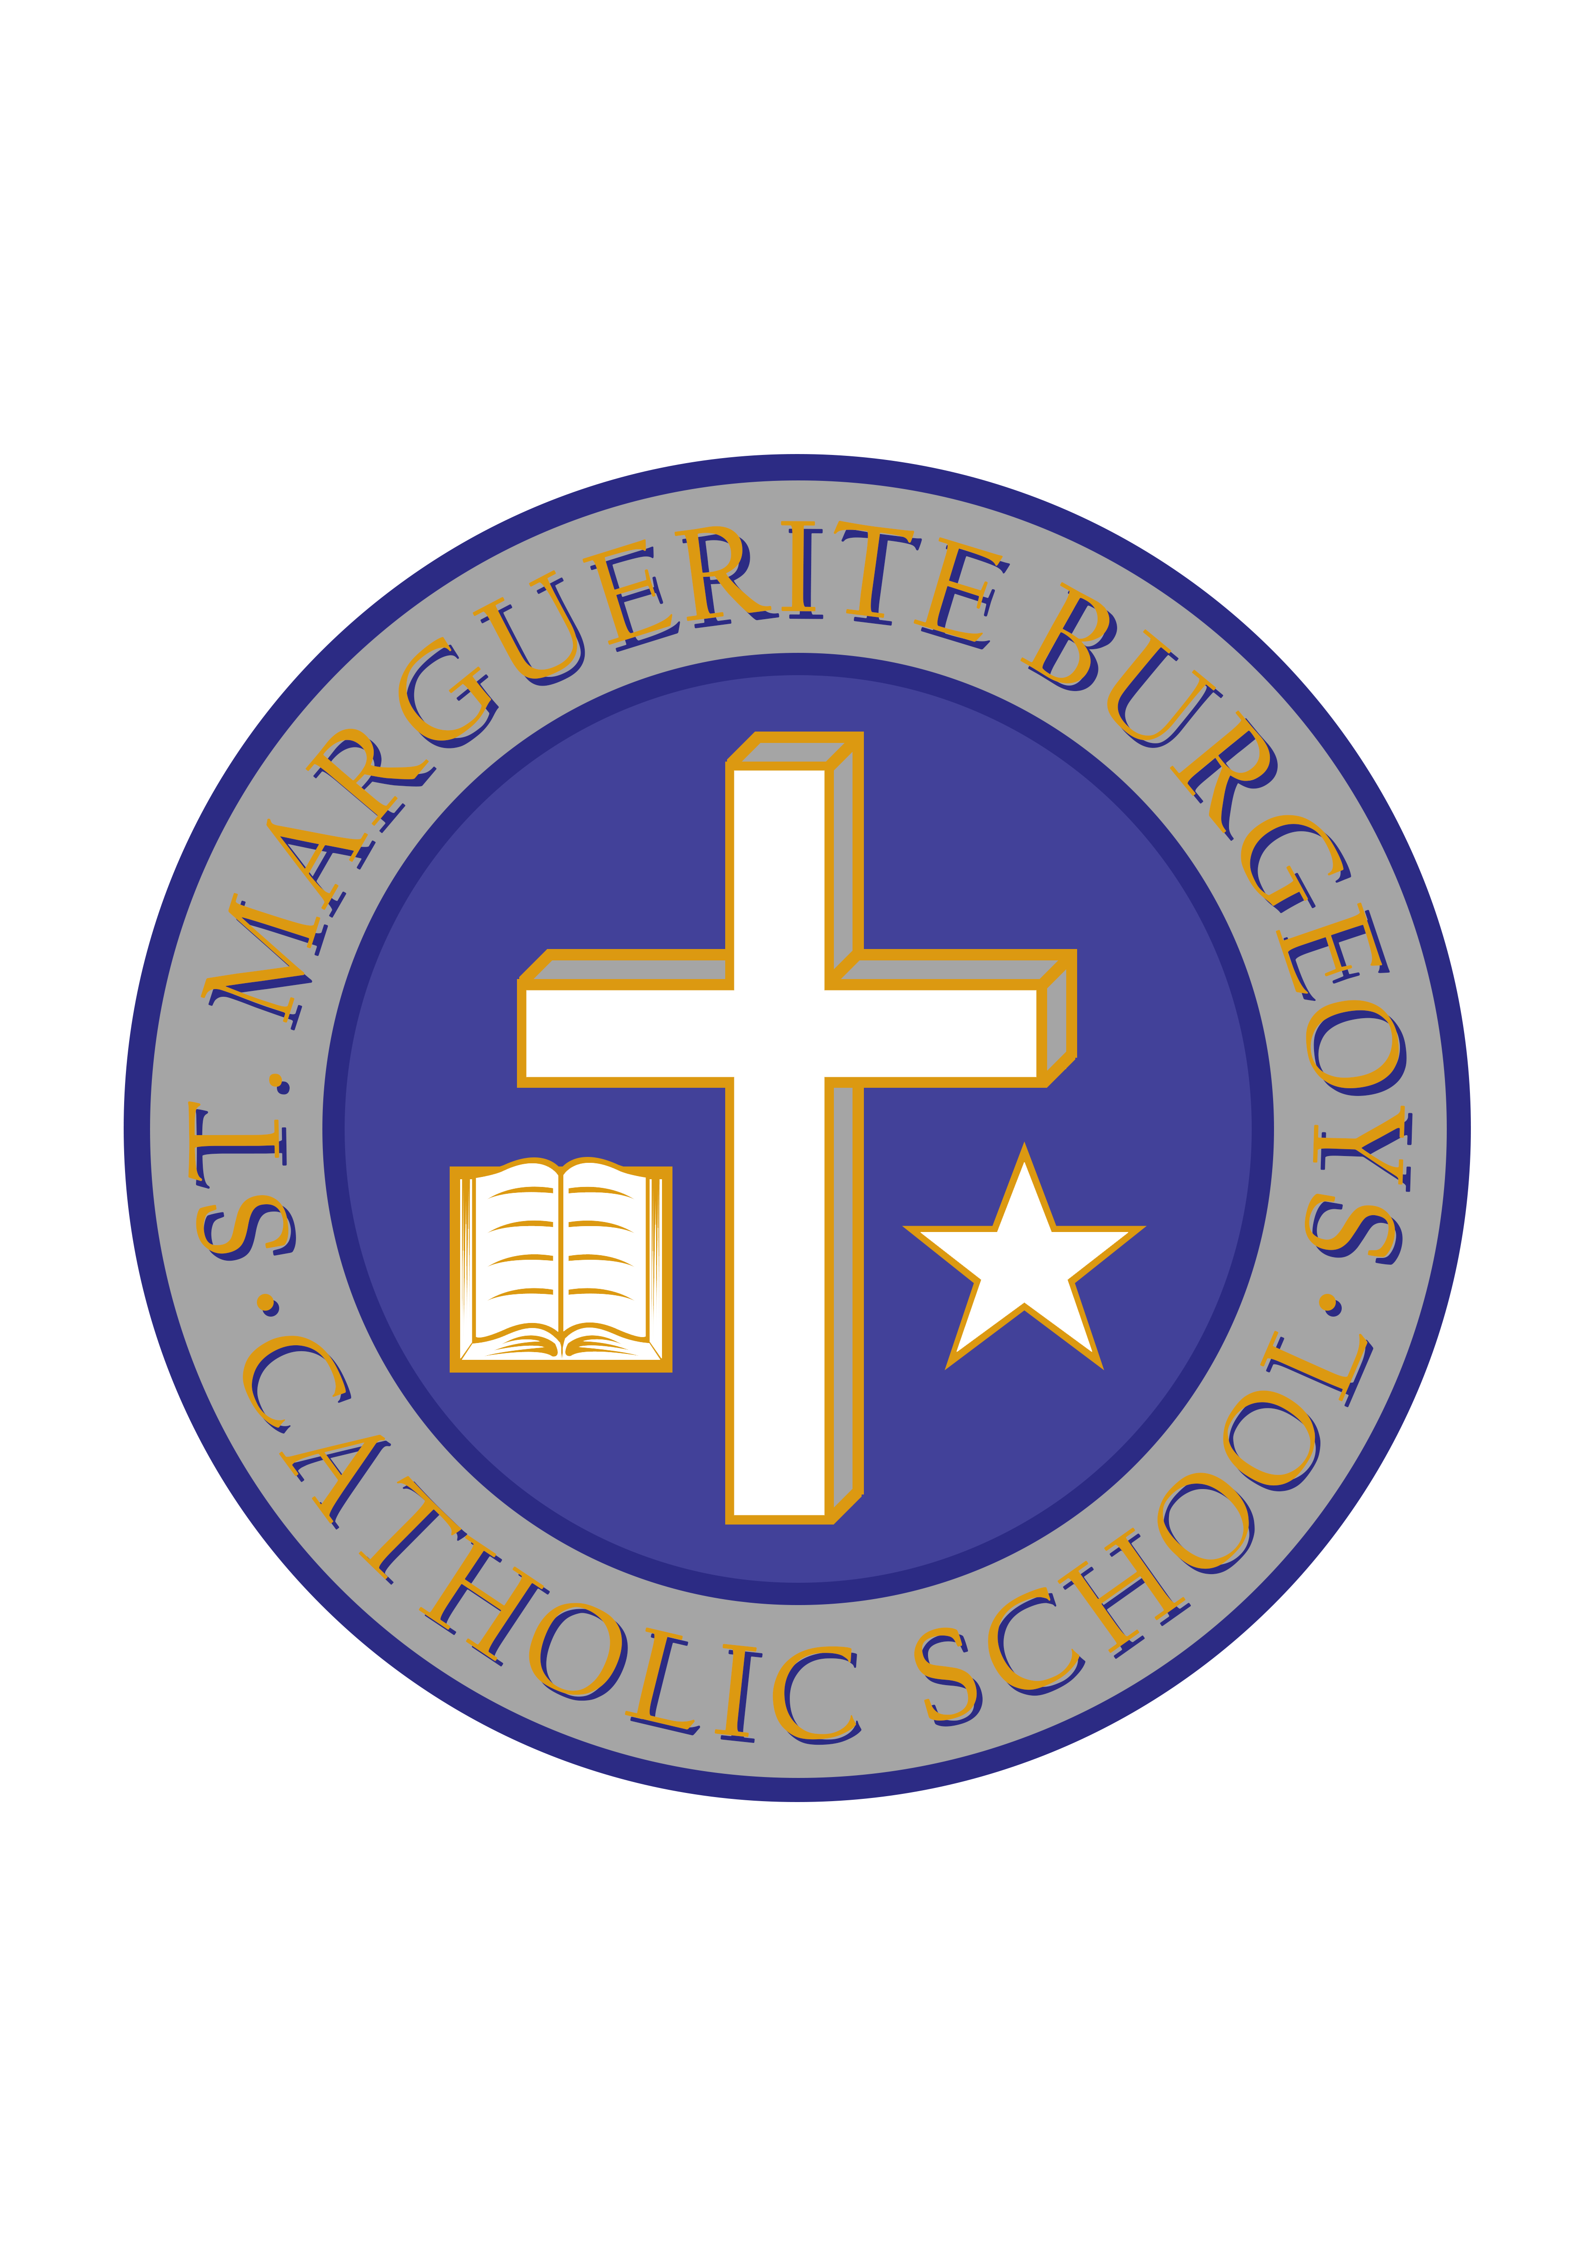

St. Marguerite Bourgeoys Catholic School is pleased to announce that we will be sponsoring a Terry Fox walk to raise money for cancer research on Thursday, September, 27, 2018.
Last year’s Terry Fox event was a tremendous success! Our final total was $6,276.45, bringing our 10 year fundraising total to $38,408.71. We even had a representative from the Terry Fox organization come to our school to congratulate us on our totals and to give us our 10 year pennant!
We want to keep this momentum going!
We will be one community raising money to help find a cure for cancer! For every monetary donation a student makes they will receive a ballot to enter their name in a draw for a Terry Fox t-shirt. There will be one winner for each division!
As well, students, staff and parents are asked to fill out a shoe, or bring in a picture, with the name of someone they know who has survived cancer, is presently fighting cancer, or has passed away from cancer. These shoes and photos will be prominently displayed and serve as a reminder that every step we take, and every coin we donate is bringing us closer to finding a cure for cancer!
Students are asked to bring in money in the following denominations on the following days:
Monday, September 24th Nickle Day
Tuesday, September 25th Dime Day
Wednesday, September 26th Quarter Day
Thursday, September 27th Loonie/Toonie Day (Pledge sheets must be returned by this date).
All donations are at your discretion. On the afternoon of Thursday, September 27th, there will be a small assembly in the gym before we proudly walk through the neighbourhood! Thank you in advance for your generous support!
The Terry Fox Committee

