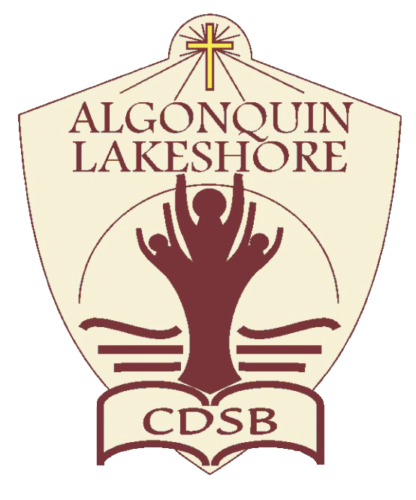
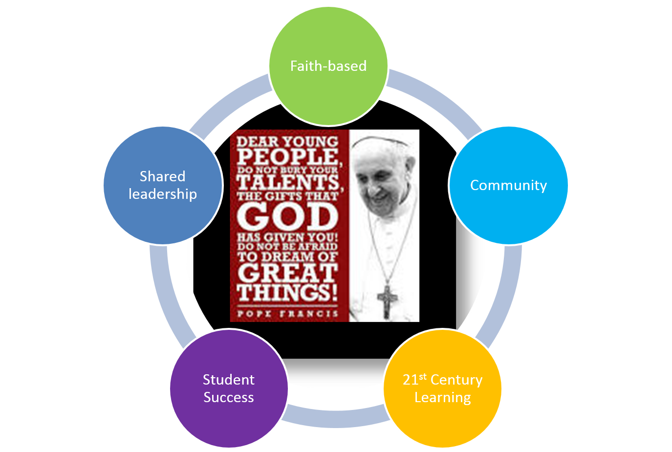
Preamble
Promoting Positive School Climate and Well-being
The ALCDSB is dedicated to creating and promoting positive school climate and well-being in all of our schools. Respecting the dignity of all persons by fostering trusting relationships through policies and practices that promote equity, inclusion and diversity are at the core of our Catholic values, the Board’s spiritual theme of Faith in Action and our provincial Catholic Graduate Expectations. A positive school climate is directly linked to student success and well-being ensuring students are motivated to do well and will realize their full potential. We are committed to sustaining healthy and nurturing communities of belonging that are safe, caring and respectful and built on the principles of restorative practice and progressive discipline.

The ALCDSB and its school communities engage in a whole school approach in putting prevention and intervention strategies in place to facilitate a positive relationship between students, staff, parents and community partners.

- Education, Awareness, and Outreach
Georges Vanier Catholic School respects and values all members of our community – students, staff, parents, volunteers, parish and community partners. We are committed to building and sustaining a positive school climate, based on the following foundations and guiding practices: Restorative Justice, The mission of ALCDSB, The Catholic Graduate Expectations and our faith-based school mission of What Would Jesus Do.

To these ends, the School will utilise the Ministry of Education definition of bullying in communications with the school community:

In its communication efforts, the School will:

- Make known that a positive school climate is essential for student achievement and well-being
- Identify the factors that contribute to a safe, inclusive caring and accepting school climate.
- Support relationship building and focus on promoting healthy relationships using a variety of strategies
- Educate parents and students regarding the differences between bullying, conflict, aggression and teasing
- Explore and identify the underlying factors that contribute to conflict and/or bullying
- Work in partnership with all members of our school community and be open to listening to all voices and all concerns..
Georges Vanier Catholic School will communicate and share with the school community, policies and procedures including the Board/school Code of Conduct, equity and inclusive education policy and guidelines for religious accommodations, procedures to address incidents of discrimination, progressive discipline approach, and promoting positive school climate and well-being.”

- The School will endeavour to increase education, awareness and outreach by using the following best practices:

- A whole-school approach to creating a safe and caring school through our focus on the guiding school improvement plan ‘I AM VANER’; student leadership opportunities; open and respectful communication for all members; invitational atmosphere for parents and the broader community and parish.
- Religious and Family Life Education curriculum focused on building relationships;
- Restorative Justice Philosophy and Practices
- The School has identified the following strategies to engage parents in conversations about promoting a positive school climate:
- Parent representation on Caring and Safe Catholic Schools Team
- Discussions with School Council regarding the results of our school climate survey, school code of conduct, as well as growth mind set and resiliency building strategies.
- Invitational Atmosphere encouraging parents to discuss concerns with staff

- Evaluation of Evidence
Georges Vanier Catholic School recognizes that effective prevention strategies must be evidence-based.

The School will base its interventions, strategies, practices and programs on evidence from the school climate surveys and other relevant information. The school will take the following steps to assess prevention initiatives and strategies:

- Evaluate the evidence to determine the main areas of concern, and identify issues in the physical environment, determine current procedures, and assess the strategies in place based on results of the school climate surveys and other relevant information.
- Review and update the School’s strategies as a result of gathering new information.

- Share the updated strategies with the school community.

Pre-evaluation strategy
- The School’s main issues of concern raised by students, staff and parents in the school climate surveys and based on other relevant information are addressed by the following:
- Ensuring that students, parents, and staff have a common understanding of bullying and positive conflict resolution strategies.

- Ensuring that students can report incidents of bullying safely and in a way that minimizes the possibility of reprisal.

- The School’s areas of focus with respect to the physical environment are:
- Ensuring supervision of students inside the school and on school property.
- Ensuring students, parents, and staff are knowledgeable of our school rules and permitted areas both inside the school and on school property.

- The School’s current processes for reporting on, responding to, supporting, and following up on issues are as follows:
- Use of the Board’s Caring and Safe Catholic School Administrative Procedures;

- Students and parents will inform staff of issues.

- Staff will respond to all reported information in a way that supports the needs, development, and rights of all students involved.

- Supports may involve Board personnel and/or community agencies.

- Based on a review of the school climate survey results and other relevant information, the following areas have shown success/improvement:
- Students feeling that they have someone at school who consistently provides encouragement and can be turned to for advice.

- Students feeling that they have someone at home or in their community who consistently provides encouragement and can be turned to for advice.

- Students feeling teachers are responsive to their needs and encourage independence with a democratic approach.

- The school staff emphasizes academic skills and hold high expectations for all students to succeed.
- Based on the school climate survey and other relevant data, the School proposes the following action plan to address areas requiring improvement:
- Staff will discuss problems and reinforce positive conflict resolution strategies during morning meetings and restorative justice circles; student mentors; boys and girls’ groups under the guidance of our CYW
- Ensure students, parents, and staff have a common definition of bullying and awareness of our school’s policy through regular and on-going communication.
Post-evaluation Strategy

The School will reassess the results of subsequent school climate surveys to verify the efficacy of the positive initiatives implemented. The “post-evaluation phase gathers evidence to test the efficacy of the prevention, responses, interventions or supports provided in order for changes to be made, where necessary.”

2020-21 School Based Strategy (Note: Approach is based on Pre-COVID information for this school year)

Based on results of our MDI Report, the following recommendations were made to improve student well being

- Increased Focus on Breakfast Club (provide more options with balance and variety)
- Revised Kindergarten Welcome Night (introduce families to community supports and programming available) Link to Community Partners
- Provide more clubs of interest for students and increase Healthy Active Living – Student Voice
- Minds Up – Increased Visible messages within school to promote positive relationships and inclusivity.
- Promote the school as a community Hub – Focus on Parent Engagement

- Policies and Procedures
The School recognizes that a whole school approach and the policies and procedures of ALCDSB are important for promoting positive school climate and well-being.
The School also recognizes that the goals of policy initiatives must address the areas of challenge identified in school/Board climate surveys and other relevant data.
- The School will actively communicate its policies, procedures and guidelines to the school community (including involving the school community in the review and/or development of policies, procedures and guidelines relating to Caring and Safe Catholic Schools), by taking the following steps:
- School Code of Conduct online

- Ministry of Education Provincial Parent Guide;

- The roles/responsibilities of the school community (students, staff, parents, and community members) are as follows:
- To follow the standards of behaviour as outlined in the Code of Conduct. The code of conduct is located at the front of each child’s agenda.
- To participate in a whole-school approach to positive school climate in order to ensure that schools are safe, inclusive, and accepting. The Ministry of Education Provincial Parent Guide link: http://www.edu.gov.on.ca/eng/safeschools/code.pdf.

- Prevention
The School recognizes that fostering a positive learning environment will help to reduce possible bullying, harassment, and discrimination incidents. The School is committed to taking steps to strengthen prevention measures.

- The roles and responsibilities of the Caring and Safe Catholic Schools Team (which will be communicated to the school community) are as follows:
- Team members are responsible for addressing issues identified in the School Climate Surveys (MDI) and other related data.
- Team members attend in-services and work with school staff to implement strategies.

- Team members share information at Catholic School Council meetings.

- From its evidence-based analysis, the School has identified the following practices and initiatives for promoting positive school climate and well-being:
- Bullying prevention and intervention programs or activities that are evidence-informed and that address the needs identified by the Board or the School:
- Responsive Classroom environment through the use of restorative circles, morning meetings, identifying Conflict vs Bullying
- Community events such as wonder buddies for building positive relationships among the students and wider school community

- Relationship-building and community-building resources that are present in the school, classroom and in the larger community:
- Promoting connections to caring adults;
- Peer assistance and mentoring programs;
- Student Leadership opportunities
- Extra-curricular activities such as boys and girls groups, clubs etc.
- Youth Workers;
- Mental Health and Addictions Nurse
- Peer Helpers
- Parish connections
- Community connections

- Activities that promote a positive school climate:
- School-wide focus on gospel values, virtues, & Catholic Graduate Expectations
- School-wide social justice and charity initiatives
- Spirit Weeks
- Wonder Buddies
- Peer Mentors
- Boys and Girls Groups
- School community events such as spaghetti dinner, family fun night, winter carnivals, guest speakers

- Awareness-raising strategies for students, e.g. social-emotional learning, empathy, developing self-regulation skills:
- Roots of Empathy
- Minds UP
- Umbrella Project (TBD)
- School events – Guest Speakers

- Awareness-raising strategies to engage community partners and parents in early and ongoing dialogue:
- Presentation to Caring and Safe Catholic Schools Team and School Council on results from School Climate Surveys / MDI
- Regular communication through school website, classroom newsletters & Twitter.

- Strategies for linking curriculum and daily learning for promoting positive school climate and well-being:
- School-wide focus on restorative practice as a whole-school approach;
- School-wide focus on the Catholic virtues;
- Curriculum planning through the lens of our Catholic faith.

- Strategies to support and encourage role modeling by caring adults and student leaders within the School and school community:
- Catholic Student Council; (In Progress)
- Peer assistance and mentoring programs;
- Regular staff prayer.

- The School has identified the following learning and training opportunities for school staff and the school community that are needed:
- Annual training promoting positive school climate and well-being;
- Promoting Positive School Climate and Well-being pamphlet for parents (available at the Board’s website www.alcdsb.on.ca);
- Creating Sacred Spaces (exploring aboriginal education opportunities to make our school yard a sacred space promoting safety and respect)

- Interventions and Support Strategies
The School recognizes the importance of using timely interventions and supports with a school-wide approach.
- To this end, the School will:
- Use teachable moments within a progressive discipline approach to address inappropriate behaviour, and consider mitigating and other factors;
- Have in place processes and strategies to identify and respond to bullying when it happens;
- Restorative Practices are in place to support prevention and intervention practices;
- Communicate the progressive discipline approach to the school community and the procedures in place to support the student.
- Clear and Transparent communication
- Classroom management/student engagement

- The School supports the use, in a timely manner and using a whole school approach, of the following evidence-informed interventions and support strategies:
- Restorative practices;
- Discussion with Board Social Worker (Mental Health Leader);
- Referral of students to school Youth Worker;
- Referral of students to the Board Mental Health and Addictions Nurse;
- Supporting students by working with outside agencies such as Children’s Mental Services, Parent Child Clinic, Counseling Services of Belleville and District, Community Living, local parishes, St. Theresa’s Secondary School for positive transitions to high school etc.

Bullying - means aggressive and typically repeated behaviour by a pupil where,
- the behaviour is intended by the pupil to have the effect of, or the pupil ought to know that the behaviour would be likely to have the effect of,
  - causing harm, fear or distress to another individual, including physical, psychological, social or academic harm, harm to the individual’s reputation or harm to the individual’s property, or
  - creating a negative environment at a school for another individual, and
- the behaviour occurs in a context where there is a real or perceived power imbalance between the pupil and the individual based on factors such as size, strength, age, intelligence, peer group power, economic status, social status, religion, ethnic origin, sexual orientation, family circumstances, gender, gender identity, gender expression, race, disability or the receipt of special education (“intimidation”)
For the purposes of the definition of “bullying” above, behaviour includes the use of any physical, verbal, electronic, written or other means.
Cyber-bullying
For the purposes of the definition of “bullying” above, bullying includes bullying by electronic means (commonly known as cyber-bullying), including,
- creating a web page or a blog in which the creator assumes the identity of another person;
- impersonating another person as the author of content or messages posted on the internet; and
- communicating material electronically to more than one individual or posting material on a website that may be accessed by one or more individuals.

