School Council-Principal’s Report
Wednesday, February 7th 7:00-8:00 p.m.

- Thank you and to all families for your support of our Advent Campaign. The Partners in Mission Food Bank was so appreciative of our donations. We donated many boxes of food as well as over $850.00 collected during our spirit week. There continues to be an increasing demand for this service in our area with more and more residents of Kingston accessing the Food Bank. They were very appreciative of the generosity of our school community.
- Thank you to the many parents who came to help with our skating day at the Leon’s Centre. So great to see the improvements that many kids made in just an hour! We had a number of students new to Canada who were so excited because they have never skated before!
- St. Genevieve Catholic School Update: We are getting close to completion. The school board is working on staffing and other pieces and there will be an open house and parent information night coming soon.
- Boot Drive: We are still collecting new or gently used boots to be donated to the St. Rita’s Drop In Centre of St. Mary’s Cathedral. Please check your closets and donate what you can!
- OFIP Tutoring: The format will be a little different this year and based on the Strong Start Program. It will target early reading instruction and will be run by our SERT Kelly Steele. The program will last 16 sessions.
- Pink Shirt Day: Pink shirt day is on Wednesday, February 28th and will be during our Lenten Spirt Week. Pink Shirt Day is an antibullying campaign that celebrates diversity and creates environments where all people can feel safe, valued and respected. We ask students to wear pink and we will be following that up with announcements and activities in classrooms.
- Lenten Campaign: This year our Lenten campaign is being lead by our Student Leadership Team. For Advent we usually chose a local charity and for Lent we chose a global charity. This year they have chosen to support the Red Cross. To raise money they have chosen to host a spirit week for students:
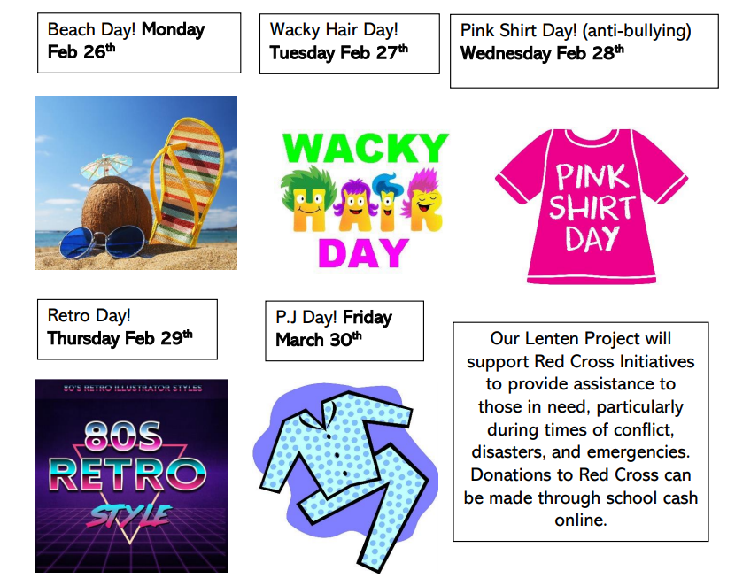
- Lots of things to look forward to! (Basketball, trips to the outdoor education centre, math night, book fair, etc.
- Report Cards and IEPs go home on Tuesday, February 20th through School Messenger.

