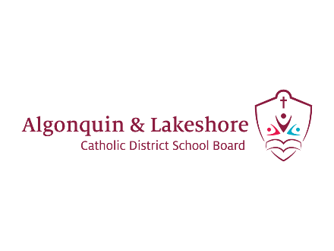
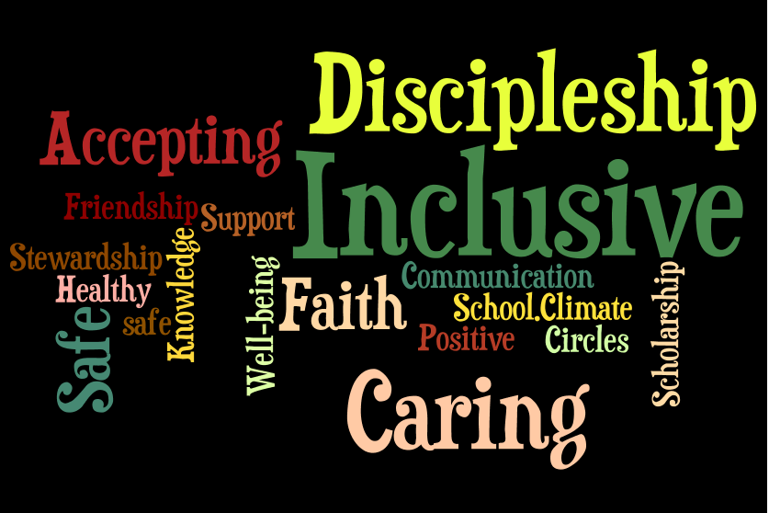
Preamble
Promoting Positive School Climate and Well-being
2023-2024
The ALCDSB is dedicated to creating and promoting positive school climate and well-being in all of our schools. Respecting the dignity of all persons by fostering trusting relationships through policies and practices that promote equity, inclusion and diversity are at the core of our Catholic values, the Board’s spiritual theme of Blessed Beyond Belief and our provincial Catholic Graduate Expectations. A positive school climate is directly linked to student success and well-being ensuring students are motivated to do well and will realize their full potential. We are committed to sustaining healthy and nurturing communities of belonging that are safe, caring and respectful and built on the principles of restorative practice and progressive discipline.

The ALCDSB and its school communities engage in a whole school approach in putting prevention and intervention strategies in place to facilitate a positive relationship between students, staff, parents and community partners.

- Education, Awareness, and Outreach
St. Teresa of Calcutta proclaims that all people are created in the image and likeness of God and, as such, have the right to be treated with dignity, respect and fairness. Our school further recognizes that a whole-school approach to engaging the school community will help the School’s efforts to address inappropriate behaviour.

To these ends, the School will utilise the Ministry of Education definition of bullying in communications with the school community:

Bullying - means aggressive and typically repeated behaviour by a pupil where,
- the behaviour is intended by the pupil to have the effect of, or the pupil ought to know that the behaviour would be likely to have the effect of,
  - causing harm, fear or distress to another individual, including physical, psychological, social or academic harm, harm to the individual’s reputation or harm to the individual’s property, or
  - creating a negative environment at a school for another individual, and
- the behaviour occurs in a context where there is a real or perceived power imbalance between the pupil and the individual based on factors such as size, strength, age, intelligence, peer group power, economic status, social status, religion, ethnic origin, sexual orientation, family circumstances, gender, gender identity, gender expression, race, disability or the receipt of special education (“intimidation”)
- For the purposes of the definition of “bullying” above, behaviour includes the use of any physical, verbal, electronic, written or other means.
Cyber-bullying
For the purposes of the definition of “bullying” above, bullying includes bullying by electronic means (commonly known as cyber-bullying), including,
- creating a web page or a blog in which the creator assumes the identity of another person;
- impersonating another person as the author of content or messages posted on the internet; and
- communicating material electronically to more than one individual or posting material on a website that may be accessed by one or more individuals.

For the purposes of policies on bullying prevention and intervention, school boards must use the following definition of bullying, given in subsection 1(1) of the Education Act:

“Bullying” means aggressive and typically repeated behaviour by a pupil where, the behaviour is intended by the pupil to have the effect of, or the pupil ought to know that the behaviour would be likely to have the effect of,

- causing harm, fear or distress to another individual, including physical, psychological, social or academic harm, harm to the individual’s reputation or harm to the individual’s property, or
- creating a negative environment at a school for another individual, and the behaviour occurs in a context where there is a real or perceived power imbalance between the pupil and the individual based on factors such as size, strength, age, intelligence, peer group power, economic status, social status, religion, ethnic origin, sexual orientation, family circumstances, gender, gender identity, gender expression, race, disability or the receipt of special education;

Bullying (1.0.0.1)
For the purposes of the definition of “bullying” in subsection (1), behaviour includes the use of any physical, verbal, electronic, written or other means.

Cyber-bullying (1.0.0.2) For the purposes of the definition of “bullying” in subsection (1), bullying includes bullying by electronic means (commonly known as cyber-bullying), including,
- creating a web page or a blog in which the creator assumes the identity of another person;
- impersonating another person as the author of content or messages posted on the internet;
- communicating material electronically to more than one individual or posting material on a website that may be accessed by one or more individuals.

Aggressive behaviour may be intentional or unintentional, direct or indirect. It can take many forms, including physical, verbal, and social. If aggressive behaviour is physical, it may include hitting, pushing, slapping, and tripping. If it is verbal, it may include name calling, mocking, insults, threats, and sexist, racist, homophobic, or transphobic comments. If it is social, or relational, aggression, it is more subtle and may involve such behaviours as gossiping, spreading rumours, excluding others from a group, humiliating others with public gestures or graffiti, and shunning or ignoring. Social aggression may also occur through the use of technology (e.g., spreading rumours, images, or hurtful comments through the use of e-mail, cell phones, text messaging, websites, social networking, or other technology).

In the course of a day, there are many “teachable moments” when issues arise. Prompt intervention with a few moments of coaching and support at these critical times can help all children and youth, including those who may be at risk, to develop the skills and understanding that they need to maintain positive relationships with others. Such interactions that students have with their teachers, other school staff, and fellow students, as well as with principals, vice-principals, their parents, and others, can be used to help them improve their social skills.

In its communication efforts, the School will:

- Make known that a positive school climate is essential for student achievement and well-being;
- Identify the factors that contribute to a safe, inclusive caring and accepting school climate;
- Educators model and nurture positive, respectful, and inclusive behaviour and attitudes;
- Support relationship building and focus on promoting healthy relationships using a variety of strategies;
- Encourage students’ voice and engage them in conversations about their school’s learning environment;
- Educate parents and students, and engage in open an ongoing dialogue regarding the differences between bullying, conflict, aggression and teasing;
- Build on successes and explore and identify areas that could use more attention the underlying factors that contribute to conflict and/or bullying;
- Work in partnership with parents and the broader school community to build awareness about the resources and pathways available;
- Be responsive to parental and student concerns and continue to build relationships and resiliency.

St. Teresa of Calcutta C.S. will communicate and share with the school community, policies and procedures including the Board/School Code of Conduct, equity and inclusive education policy and guidelines for religious accommodations, procedures to address incidents of discrimination, progressive discipline approach, and promoting positive school climate and well-being.

- The School will endeavour to increase education, awareness and outreach by using the following best practices:

● A whole-school approach to creating a safe and caring school;
● School-based initiatives such as PALS, Child and Youth Worker programing, and classroom lessons.
● Ongoing communication with the school community through the school website and School Messenger phone and email service;
● Student representation on Caring and Safe Catholic Schools Team;
● Religious and Family Life Education curriculum focused on building positive relationships;
● Celebration of Board Theme “Blessed Beyond Belief” through prayer and song.
- Celebrating mass and school liturgies, praying the rosary together in community.

- The School has identified the following strategies to engage parents in conversations about promoting a positive school climate:
● Parent representation on Caring and Safe Catholic Schools Team;
● Communication with the school community through varied methods;
● Encourage dialogue and sharing with students and families;
● Engage in partnerships where possible to support parent engagement (e.g., PRO grant
applications, Community Police presentations, Maltby Centre parent programs, etc.).

- Evaluation of Evidence
St. Teresa of Calcutta C.S. recognizes that effective prevention strategies must be evidence-based.

The School will base its interventions, strategies, practices and programs on evidence from the school climate surveys and other relevant information. The school will take the following steps to assess prevention initiatives and strategies:

- Evaluate the evidence to determine the main areas of concern, and identify issues in the physical environment, determine current procedures, and assess the strategies in place based on results of the school climate surveys and other relevant information.
- Identify children and youth involved in bullying (including the bully, the person being bullied, and those who may have witnessed or been affected by the bullying). The School will consider using a risk assessment approach in this process.
- Review and update the School’s strategies as a result of gathering new information.
- Share the updated strategies with the school community.

Pre-evaluation strategy
- St. Teresa of Calcutta’s main issues of concern raised by students, staff and parents in the school climate surveys and based on other relevant information are the following:
- Ensuring that students can report incidents of bullying safely and in a way that minimizes the fear of or possibility of reprisal;
- Providing methods for student voice so that concerns and issues can be heard;
- Ensuring a process is in place to deal with issues that arise and that this process is transparent;
- Providing authentic opportunities for students to further learn about relationships, restorative practices and dealing with conflict;
- Ensuring a common language is understood and used by students, parents, and staff.

- The School’s areas of focus with respect to the physical environment are:
- Ensuring active supervision of students inside the school and on school property;
- Ensuring student safety during drop off/pick up times by frequently communicating routines and expectations for vehicles entering the school parking lot with parent community;
- Ensuring students are in an optimal learning environment through such measures as strategic and flexible seating in classrooms.

- The School’s current processes for reporting on, responding to, supporting, and following up on issues are as follows:
- Use of the Board’s Caring and Safe Catholic School Administrative Procedures;
- Following the processes as identified in the School Code of Conduct;
- Report issues to teacher, yard supervisor and/or principal;
- Implementing restorative practices to help resolve conflict as appropriate.

- Based on a review of the school climate survey results and other relevant information, the following areas have shown success/improvement:
- In general, our students are active and healthy;
- Students report a high degree of empathy;
- Students in junior grades report a high degree of self-esteem, which decreases in the intermediate years;
- Students feel safe in their community and neighbourhood;
- In general, our students feel academically successful;
- In general our students have age-appropriate quality relationships with their peers;
- Students do not report a lot of cyber or physical bullying;
- Most students have after-school activities that are beneficial to them.

- Based on the school climate survey and other relevant data, the School proposes the following action plan to address areas requiring improvement:
- Build a community understanding of social and verbal bullying behaviours and the process to deal with it;
- Develop strategies to help students deal with feelings of anxiety (especially for our junior level students);
- Develop strategies to help intermediate students feel greater self-esteem (e.g. ;
- Build stronger connections between all students and adults in the school community (i.e., each student feels connected to an adult);
- Ensure that each student feels important in our school community;
- Continue to build positive school spirit through community activities such as clubs, spirit days, assemblies, theme days.

Post-evaluation Strategy

St. Teresa of Calcutta C.S. will reassess the results of subsequent school climate surveys to verify the efficacy of the positive initiatives implemented. The “post-evaluation phase gathers evidence to test the efficacy of the prevention, responses, interventions or supports provided in order for changes to be made, where necessary.”

Upon re-evaluation, the school will update the information in this template to reflect the effectiveness of its bullying prevention initiatives.

- Policies and Procedures
St. Teresa of Calcutta C.S. recognizes that a whole school approach and the policies and procedures of ALCDSB are important for promoting positive school climate and well-being.
The School also recognizes that the goals of policy initiatives must address the areas of challenge identified in school/Board climate surveys and other relevant data.

- St. Teresa of Calcutta C.S. will actively communicate its policies, procedures and guidelines to the school community (including involving the school community in the review and/or development of policies, procedures and guidelines relating to Caring and Safe Catholic Schools, by taking the following steps:
- School Code of Conduct and Promoting Positive School Climate and Well Being Plan is posted on school website;
- Inclusion of School Code of Conduct in agendas;
- Information about activities through School Messenger.

- The roles/responsibilities of the school community (students, staff, parents, and community members) are as follows:
- To follow the standards of behaviour as outlined in the Code of Conduct;
- To participate in a whole-school approach to positive school climate in order to ensure that schools are safe, inclusive, and accepting. The Ministry of Education Provincial Parent Guide link: https://www.ontario.ca/page/promote-positive-school-environment

- Prevention
St. Teresa of Calcutta C.S. recognizes that fostering a positive learning environment will help to reduce possible bullying, harassment, and discrimination incidents. The School is committed to taking steps to strengthen prevention measures.

- The roles and responsibilities of the Caring and Safe Catholic Schools Team (which will be communicated to the school community) are as follows:
- Team members are responsible for addressing issues identified in the School Climate Surveys and other related data;
- Proposing a plan and ideas to address areas of concern;
- Review and update the schools Promoting Positive School Climate and Well Being Plan yearly.

- From its evidence-based analysis, the School has identified the following practices and initiatives for promoting positive school climate and well-being:
- Bullying prevention and intervention programs or activities that are evidence-informed and that address the needs identified by the Board or the School:
- Common language and targeted approach to whole school program;
- Community events and activities to bring groups together;

- Relationship-building and community-building resources that are present in the school, classroom and in the larger community:
- Promoting connections to caring adults;
- Peer assistance and mentoring programs;
- Pastoral ministry;
- Child and Youth Worker led programs;
- Mental Health and Addictions Nurse;
- Community Police Officer;

- Activities that promote a positive school climate:
- School-wide focus on board pastoral theme “Blessed Beyond Belief”;
- School-wide social justice and charity initiatives;
- Spirit activities;
- Leadership teams;
- Intramurals;
- Plays;
- Clubs and teams;
- Assemblies (virtual and in small groups);

- Awareness-raising strategies for students, e.g., social-emotional learning, empathy, developing self-regulation skills. Some examples include:
● Peer Helpers (PALS)
- Minds Up;
- Zones of Regulation;
- Christian Meditation;
- Mental Health and Wellness days and activities;
- Reviewing growth mindset philosophy (e.g., growth mindsets and social emotional learning in math, developing perseverance).

- Awareness-raising strategies to engage community partners and parents in early and ongoing dialogue:

- Presentation to Caring and Safe Catholic Schools Team and School Council on
results from School Climate Surveys;

- Sharing of school activities through school website, Twitter (‘X’), and School
Messenger.

- Strategies for linking curriculum and daily learning for promoting positive school climate and well-being:
- School-wide focus on restorative practice as a whole-school approach;
- Board Pastoral theme is incorporated in class lessons, prayer services, and school activities.
- Well-being and mental health focus integrated in class lessons, activities, and environment.
- Strategies to support and encourage role modeling by caring adults and student leaders within the School and school community:
- Catholic School Council;
- Peer assistance and mentoring programs;
- Support from Community Partners (e.g. Kingston Police, Maltby, KAIROS, etc.)
- Guest speakers
- Student Leadership Teams
- Student support provided by Child and Youth Worker.

- The School has identified the following learning and training opportunities for school staff and the school community that are needed:
- Annual training promoting positive school climate and well-being:
- Promoting Positive School Climate and Well-being information provided by the Ministry of Education https://www.ontario.ca/page/promote-positive-school-environment
- Promote workshops/guest speakers, etc. with parent community (i.e., recent eating disorders virtual presentation, Maltby Centre workshops).
- PACE training for staff
- ASSIST training for administrators and Child and Youth Workers

- Interventions and Support Strategies
St. Teresa of Calcutta C.S. recognizes the importance of using timely interventions and supports with a school-wide approach.
- To this end, the School will:
- Use teachable moments within a progressive discipline approach to address inappropriate behaviour, and consider mitigating and other factors;
- Have in place processes and strategies to identify and respond to bullying when it happens;
- Communicate the progressive discipline approach to the school community and the procedures in place to support the student.
- Teach and promote Gospel values in keeping with our Board Pastoral Theme and Catholic values and teachings;
- Use of Tier 1 supports for promoting positive mental health and well being with classes;
- Have in place processes and strategies to report, identify and respond to bullying;
- The School supports the use, in a timely manner and using a whole school approach, of the following evidence-informed interventions and support strategies:
- Restorative practices;
- Discussion with Board Mental Health Lead;
- Referral of students to school Child and Youth Worker
- Case conference with parents and educators.

