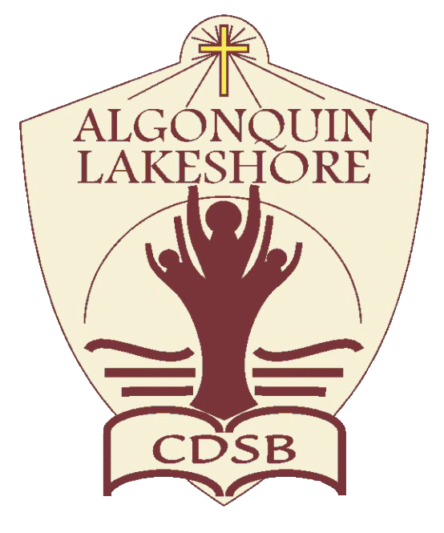
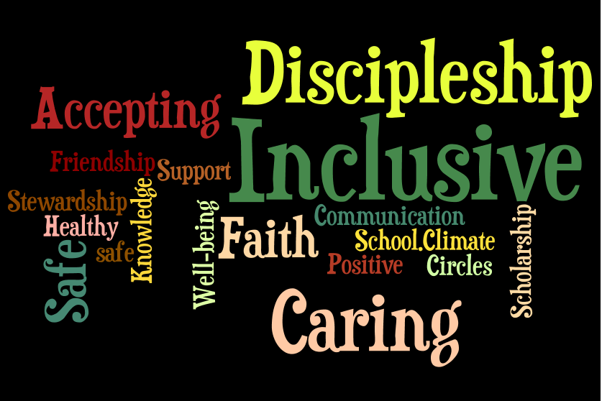
Preamble
Promoting Positive School Climate and Well-being
September 2017
The ALCDSB is dedicated to creating and promoting positive school climate and well-being in all of our schools. Respecting the dignity of all persons by fostering trusting relationships through policies and practices that promote equity, inclusion and diversity are at the core of our Catholic values, the Board’s spiritual theme of Faith in Action and our provincial Catholic Graduate Expectations. A positive school climate is directly linked to student success and well-being ensuring students are motivated to do well and will realize their full potential. We are committed to sustaining healthy and nurturing communities of belonging that are safe, caring and respectful and built on the principles of restorative practice and progressive discipline.

The ALCDSB and its school communities engage in a whole school approach in putting prevention and intervention strategies in place to facilitate a positive relationship between students, staff, parents and community partners.

- Education, Awareness, and Outreach
St. Mary Catholic School (Trenton) proclaims that all people are created in the image and likeness of God and as such, have the right to be treated with dignity, respect and fairness. The school further recognizes that a whole-school approach to engaging the school community will help the School’s efforts to address inappropriate behaviour. We believe that the principles outlined in this guide will support students, staff, parents and community members who support our students and the important adults in their lives.

To these ends, the School will utilise the Ministry of Education’s definition of bullying in communications with the school community:

In its communication efforts, the School will:

- Make known that a positive school climate is essential for student achievement and well-being through the business of the school and our School Improvement Plan.
- Identify the factors that contribute to a safe, inclusive caring and accepting school climate.
- Support relationship building and focus on promoting healthy relationships using a variety of strategies for students, staff and families.
- Educate parents and students regarding the differences between bullying, conflicts, aggression and teasing.
- Explore and identify the underlying factors that contribute to conflict and/or bullying.
- Create a school culture where students advocate for each other and support peers who find themselves in a bullying situation.
- Work in partnership with parents and the broader school community to build awareness about the resources and pathways available.
- Be responsive to parental concerns and continue to build relationships and resiliency.

St. Mary Catholic School (Trenton) will communicate and share with the school community, policies and procedures including the Board/school Code of Conduct (Appendix A), Equity and Inclusion education policy and guidelines for religious accommodations, procedures to address incidents of discrimination, progressive discipline approach, and promoting positive school climate and well-being.

- The School will endeavour to increase education, awareness and outreach by using the following best practices:

- A whole-school approach to creating a safe and caring school;
- Religious and Family Life Education curriculum focused on building relationships;
- The purposeful promotion of “Wellness” in all aspects of working and learning;
- Promotion of community supports as we are “The First Door” for students, staff and families;
- Using Restorative Justice Practices as a first strategy to repair and strengthen relationships, before using punitive measures.
- The School has identified the following strategies to engage parents in conversations about promoting a positive school climate:
- Parent representation on Caring and Safe Catholic Schools Team - each school has a team;
- Presentations to School Council on bullying prevention and positive school climate;
- The direct engagement of School Council in the strategic planning process for the School Improvement Plan;
- The creation of parent engagement activities that promote social and community involvement geared for parents in our community.

- Evaluation of Evidence
St. Mary Catholic School (Trenton) recognizes that effective prevention strategies must be evidence-based.

The School will base its interventions, strategies, practices and programs on evidence from the school climate surveys and other relevant information. The school will take the following steps to assess prevention initiatives and strategies:

- Evaluate the evidence to determine the main areas of concern, and identify issues in the physical environment, determine current procedures, and assess the strategies in place based on results of the school climate surveys and other relevant information.
- Identify children and youth involved in bullying (including the bully, the person being bullied, and those who may have witnessed or been affected by the bullying). The School will consider using a risk assessment approach in this process with the ultimate goal of establishing positive relationships through a restorative justice focus.

- Review and update the School’s strategies as a result of gathering new information.

- Share the updated strategies with the school community yearly.

Pre-evaluation strategy
- The School’s main issues of concern raised by students, staff and parents in the school climate surveys and based on other relevant information are the following:
- Our grade 6 students report higher than average levels of anxiety (37%) and a lower than average report of positive relationships at school (74%).

- Parents report an average response (7.1/10) of feeling welcomed at the school by the administrative team and their child’s classroom teacher.

- There is an average perception (7.1/10) that the school is safe, inclusive and promotes positive behaviour.

- Students reported a high level of being victims of bullying (27.8% mean).

- The School’s areas of focus with respect to the physical environment are:
- Ensuring that students feel safe in their classroom and in common spaces like the hallways and school yard.
- Create a space that honors the voice and needs for students of all ability levels and interests;

- Create a physical environment that promotes our Equity and Inclusion philosophy and welcomes all community members to a Faith filled environment.

- The School’s current processes for reporting on, responding to, supporting, and following up on issues are as follows:
- Use of the Board’s Caring and Safe Catholic School Administrative Procedures;

- Students can report issues to any adult in the building who will help them resolve the issue, or report it to another adult who can help them, including the school Secretary, Principal and vice-Principal;

- Parents are also strongly encouraged to contact their child’s teacher, or school Principal/ vice-Principal to report issues that may be affecting their child from feeling safe.

- Based on a review of the school climate survey results and other relevant information, the following areas have shown success/improvement:
- Students place a high value on academic success for their future.

- Students feel listened too and supported in times of need and crisis.

- Students feel that they have a strong connection to at least one staff member and that they “know” this caring adult will help them in times of need.

- There was an increase in students and families who Self-Identified as Aboriginal/First Nations.

- Based on the school climate survey and other relevant data, the School proposes the following action plan to address areas requiring improvement:
Students did convey a sense of anxiety and stress when it came to school. There was a specific trend amongst students in grade 6, which is an area of concentration and will be our focus. Some of the strategies used will be:
- An increased focus on how to build healthy relationships, how to identify positive friendships and the skills associated with these two key areas of human growth.
- Outreach to central level staff and community partners to aid in teacher education and student education around mental fitness, mental health, self-care and resiliency skill development for personal wellness.
- A focus on more effort to integrate student voice in the business of the school, classroom environment and an inquiry approach to student learning.
- We will continue to be The First Door for our children and adults in need, promoting a positive relationship look between the school and community partners.
- More engagement of students with exceptionalities and their parents. Looking for the hidden and suppressed voices when making major decisions around school culture and our working processes.

Post-evaluation Strategy

The School will reassess the results of subsequent school climate surveys to verify the efficacy of the positive initiatives implemented. The “post-evaluation phase gathers evidence to test the efficacy of the prevention, responses, interventions or supports provided in order for changes to be made, where necessary.”

Upon re-evaluation, the School will update the information in this template to reflect the effectiveness of its bullying prevention initiatives.

- Policies and Procedures
The School recognizes that a whole school approach and the policies and procedures of ALCDSB are important for promoting positive school climate and well-being.
The School also recognizes that the goals of policy initiatives must address the areas of challenge identified in school/Board climate surveys and other relevant data.

- The School will actively communicate its policies, procedures and guidelines to the school community (including involving the school community in the review and/or development of policies, procedures and guidelines relating to Caring and Safe Catholic Schools), by taking the following steps:
- School Code of Conduct (Appendix A) ;

- Ministry of Education Provincial Parent Guide;

- Engagement of our Catholic School Council;

- Use of Newsletters and school website to share information with parents.

- The roles/responsibilities of the school community (students, staff, parents, and community members) are as follows:
- To follow the standards of behaviour as outlined in the Code of Conduct http://schools.alcdsb.on.ca/shrb/default.aspx
- To participate in a whole-school approach to positive school climate in order to ensure that schools are safe, inclusive, and accepting. The Ministry of Education Provincial Parent Guide link: http://www.edu.gov.on.ca/eng/safeschools/code.pdf.

- Prevention
The School recognizes that fostering a positive learning environment will help to reduce possible bullying, harassment, and discrimination incidents. The School is committed to taking steps to strengthen prevention measures.

- The roles and responsibilities of the Caring and Safe Catholic Schools Team (which will be communicated to the school community) are as follows:
- Team members are responsible for addressing issues identified in the School Climate Surveys and other related data;
- The team will help the Principal/ vice-Principal and their leadership team set goals that address specifically creating a caring and safe community;

- Help the Principal/vice-Principal address specific issues and trends that may arise in the school and require a team approach to addressing;

- Help identify key issues, strategies and solutions that have been used during the school year to the broader community.

- From its evidence-based analysis, the School has identified the following practices and initiatives for promoting positive school climate and well-being:
- Bullying prevention and intervention programs or activities that are evidence-informed and that address the needs identified by the Board or the School:
- Use of Restorative Justice Practices;
- The use of relationship building and mentoring as the “strongest” teaching tool and use of student voice;
- The close working relationship with our Catholic Parent Council to create opportunities for community building and strengthening relationships;
- On-going and meaningful dialogue with parents and guardians; eliciting their voice in the creation of a community that reflects their lived experiences.

- Relationship-building and community-building resources that are present in the school, classroom and in the larger community:
- Promoting connections to caring adults;
- Strong relationships with community partner agencies like the Military Family Resource Center, Children’s Mental Health and Highland Shores Children’s Aid.
- Peer assistance and mentoring programs;
- Pastoral ministry and lay support for integration into the Church life.
- Youth Worker role enhancement in the classroom environment.
- Mental Health and Addictions Nurse partnership.
- A specific focus on engaging our Aboriginal/First Nation families and community members through explicit school events and teachings.
- Activities that promote a positive school climate:
- School-wide focus on gospel values and Catholic Graduate Expectations.
- School-wide social justice and charity initiatives.
- Catholic Education Week events.
- An increase in student voice in key choice decisions for the school.
- Awareness-raising strategies for students, e.g. social-emotional learning, empathy, developing self-regulation skills:
- Roots of Empathy
- FRIENDS and Fun FRIENDS
- Minds-On Curriculum
- ECO Club
- Student Council
- Awareness-raising strategies to engage community partners and parents in early and ongoing dialogue:
- Presentation to Caring and Safe Catholic Schools Team and School Council on results from School Climate Surveys;
- Continued community presence through participation in events hosted by The Legion, Lion’s Club, YMCA, Military Family Resource Centre and the City of Quinte West.
- Modelling for our students when and why we as faith leaders engage in supporting/bettering our communities through our own community faith leadership and charitable works.
- Strategies for linking curriculum and daily learning for promoting positive school climate and well-being:
- School-wide focus on restorative practice as a whole-school approach;
- Integration of Catholic social justice teaching in all curriculum areas;
- Specific instruction around mental health, wellness, personal safety, equity and inclusion, accessibility and social skills to assist students in navigating their learning journey beyond their years with us.
- Strategies to support and encourage role modeling by caring adults and student leaders within the School and school community:
- Catholic Student Council;
- Peer assistance and mentoring programs;
- Staff attendance at Catholic School Council events when possible.

- The School has identified the following learning and training opportunities for school staff and the school community that are needed:
- Annual training promoting positive school climate and well-being:
- Promoting Positive School Climate and Well-being pamphlet for parents (available at the Board’s website www.alcdsb.on.ca);
- Regular professional development on diverse teaching pedagogies like inquiry, experiential education, special education, outdoor education and Aboriginal education.
- Interventions and Support Strategies
The School recognizes the importance of using timely interventions and supports with a school-wide approach.
- To this end, the School will:
- Use teachable moments within a progressive discipline approach to address inappropriate behaviour, and consider mitigating and other factors;
- Have in place processes and strategies to identify and respond to bullying when it happens, with a clear focus on prevention and positive relationship building;
- Restorative Practices are in place to support prevention and intervention practices;
- Communicate the progressive discipline approach to the school community and the procedures in place to support students involved in bullying experiences.
- The School supports the use, in a timely manner and using a whole school approach, of the following evidence-informed interventions and support strategies:
- Restorative practices;
- Discussion with Board Social Worker (Mental Health Leader);
- Referral of students to school Youth Worker.
Bullying - means aggressive and typically repeated behaviour by a pupil where:
- the behaviour is intended by the pupil to have the effect of, or the pupil ought to know that the behaviour would be likely to have the effect of,
  - causing harm, fear or distress to another individual, including physical, psychological, social or academic harm, harm to the individual’s reputation or harm to the individual’s property, or
  - creating a negative environment at a school for another individual, and
- the behaviour occurs in a context where there is a real or perceived power imbalance between the pupil and the individual based on factors such as size, strength, age, intelligence, peer group power, economic status, social status, religion, ethnic origin, sexual orientation, family circumstances, gender, gender identity, gender expression, race, disability or the receipt of special education (“intimidation”)

For the purposes of the definition of “bullying” above, behaviour includes the use of any physical, verbal, electronic, written or other means.

Cyber-bullying
For the purposes of the definition of “bullying” above, bullying includes bullying by electronic means (commonly known as cyber-bullying), including:
- creating a web page or a blog in which the creator assumes the identity of another person;
- impersonating another person as the author of content or messages posted on the internet; and
- communicating material electronically to more than one individual or posting material on a website that may be accessed by one or more individuals.

Appendix A: School Code of Conduct
St. Mary Catholic School
Code of Conduct
2017-2018

Community Vision:
As a Catholic Faith community we believe that we are called by God to promote, inspire and love one another as He has commanded us. We are a unique community that demonstrates the values that we proclaim through many different venues and interactions. We also realize that we are responsible to each other, to our-selves and to our community at large. This means that we cannot only think about ourselves, but are also called to remember our brothers and sisters in every decision we make.
Together We Are Stronger:
A fundamental belief we have for our community is the idea that as a collective we not only possess strength; but we also possess a collective wisdom that will help us overcome any challenge we face. We firmly believe that our students have a great deal of knowledge, strength and can contribute to the common good in their own unique ways. We believe that all students have “something” they are great at and value an asset model when thinking about their talents. The idea of community is also one that is at the core of our Church and our weekly celebration of the Eucharist.
Home/School/Church as One:
In a community where we are so closely tied together, there is a strong bond between the families we serve, the school where we serve them and the Church that guides both through incredible leadership by our Parish Priest. This triad of relationship mirrors our belief in the Father, Son and Holy Spirit and is one that often is called upon to get us through crisis and challenge. Through our morning announcements, sacramental preparations, daily religious instruction and monthly masses; we are living the virtues and scriptures of our faith. We are also blessed to be able to openly and publically declare the Good News in an effort to further strengthen our relationships and proclaim the messages of God that we have been taught and teach to our students.

Stewardship
Our Vision:
As a community we are blessed with many natural gifts from God. If we believe this we then must take a greater level of responsibility to ensure these gifts are given the same respect as our spiritual gifts from Him. St. Mary is a Certified ECO School, which is a clear commitment to maintaining not only our school environment, but educating ourselves about the larger issues facing the global community.
We Believe:
- Students have the ability to understand the impact of their choices on the environment around them.
- All students will value and support our ECO School and Boomerang initiatives to reduce our carbon footprint.
- Conservation can become a way of life and one that is integral to all curriculum areas.
- Every community member who utilizes our school community will uphold the values of stewardship, conservation and understanding that we so value.
- Together we can create a different outcome for future generations if we work as a unit with a common goal of protecting God’s creation.
If you need help we will/can:
- Provide you with our data around our school’s reduction success with our carbon footprint.
- Have a student or teacher work with you to further your understanding around the key issues.
- Provide opportunities for direct service.
- Have a community partner share their passion and knowledge around stewardship.
- Give you the opportunity to record your thoughts, research ideas and plan upcoming preventative measures to strengthen your relationship with our community.
- Provide you with a leadership opportunity for you to shine and become a leader in the preservation of God’s gift through nature and our environment.
Discipleship
Our Vision:
Everything we do, we are given and will be given is because of our relationship with God. We are the recipients of his ultimate gift through the birth, death and resurrection of His only Son Jesus. This special relationship is at the core of all that we do at St. Mary. Simply put, we think differently, act differently and hold each other to standards based on teachings through the bible. As a school we are in relationship with St. Peter in Chains Parish and the parishioners who support those communities. This brings a great level of commitment and support for our students and links them to a universal Church that is present around the world.

We Believe:
- God has called all community members to “BE” his Church.
- The power of our scripture teachings can provide us with a vision for living that will lead to our eternal salvation.
- All children are called to God and because of this are inherently good.
- As a faith community we are in relationship with each other on a deeper level and are called to support each other.
- We have a responsibility to care for those in need around us, in our community and globally.
- Every person in our community experiences their own faith development journey and we are powerful sources of growth and support for.
- We are expected to be voices of change for social justice and equity amongst all we encounter.

If you need help we will/can:
- Share our beliefs around certain topics through building a common understanding of God’s expectations for us.
- Provide opportunities for further exploration of scripture teaching.
- Invite our Parish Priest to share his vision and guidance based on your needs for personal growth.
- Construct opportunities to allow you to further grow in your own faith development.
Our goal is to ensure that everyone who comes to our community is willing and supported in their own faith development, building stronger ties amongst their peers and a stronger sense of self.
Scholarship
Our Vision:
As a school community we value the Four Core Instructional Strategies, improving our understanding around assessment and evaluation and create conditions where our students will become academic risk-takers. We believe that a solid foundation in reading, writing and mathematical thinking form the core skills necessary to continue to build on the strengths our students already possess.
We Believe:
- Every student has unique strengths and potential.
- Exploration and deep thinking are always at the root of learning.
- The natural environment is one of the best classrooms and can inspire innovation from our students.
- Children naturally want to explore, create and dream; adults sometimes need to teach and empower them to do this.
- Teaching is a calling based on nurturing children’s God given talents.
- Our students with exceptionalities are important to our school community and remind us that brilliance comes in many different ways.
- All parents and children want the best for their future and scholarship is key in helping them achieve greatness.

If you need help we will/can:
- Differentiate our teaching so you can learn the best way possible to show what you know in multiple formats, or using technology.
- Create an Individual Education Plan based on your strengths, with realistic goals for your personal growth.
- Look for staff, agencies and other community members to help construct a unique program for you.
- Allow you to try something more than once; perfection is in changing the way we think, not just getting something right the first time.
- Look for peers to mentor and coach you as you master certain skills through rich and relevant learning tasks.
- Explore testing options that might help us find out the unique way you see things.
One of the key principles to our belief in scholarship is that fairness does not mean same. There will be times when a student may need individualized attention, or supports and they are entitled to it without being measured against other students, or judged.

Wellness
Our Vision:
“Wellness starts with “ME” at STMT”. We know that our students, staff and families face great challenges at different points in their lives and if we trust our relationships we can support each other in powerful ways. At STMT our goal is to remove the stigma around mental health and wellness and to promote the concept of redemption and restorative justice when we are supporting each other. We also know that in order to fully understand our community’s needs for wellness we also need to respect and listen to everyone’s voice, history and dreams for the future. Our vision of wellness is not based on single events, but a constant stream of discussion, community events and honest conversations about what we need from each other.
We Believe:
- Every member of our community wants to belong and has a right to belong.
- Relationship building and maintenance is the best way to support those who might need help.
- Mental health supports are not always a “forever” thing, sometimes they are short term and impactful.
- Student success is tied closely to their sense of mental wellbeing and belonging and is something that needs to be built, not assumed.
- As a community we possess a lot of influence and power to meet the needs of those who are struggling amongst us.
- In order for students to excel at wellness they need to SEE themselves reflected in the school building and what they are being taught.
- Our aboriginal and first nation families possess great knowledge and teachings that are vital to wellness.
- We are the “First Door” and there is no wrong door, we will always help if we can.

If you need help we will/can:
- Discuss the help you need and make plans to implement, or find it.
- Provide access to our board social worker, youth worker or other professionals who might be able to help.
- Work with outside agencies to create a wrap-around level of support for your wellness.
- Support you in the referral process to outside agencies who specialize in the help you need.
- Be empathetic, caring and realistic about the level and kinds of supports we provide. And facilitate what we are capable of.

Belonging

Bullying Prevention and Building Relationships:

Our Vision:

Everyone has a right to feel safe in our community. We recognize the seriousness of bullying behavior and are committed to the power of building positive relationships.

We Believe:

- Both people involved in a bullying situation need support.
- We believe in an inclusive, caring Catholic school community.
- It is important to value different perspectives and experiences to create our community.
- Relationships can be repaired if they are authentic and positive to start with.
- The responsibility of relationship building belongs to everyone.
Progressive Discipline:
Our Vision:
The purpose of discipline is for growth and learning. We believe it should be strengths based, to establish our students for success. At the core, progressive discipline is about maintaining relationship with our community.
We Believe:
- The use of a continuum best meets the needs of students.
- We will reflect on our students’ strengths and needs to help them grow.
- Discipline should be founded on the ideas of redemption; growth and dignity.
Attendance:
We believe that “every school day counts.” (Dr. Wayne Hammond) To create strong relationships we need to be in community as much as possible. We also need our students to be with us to help them learn and gain the skills they will need for their future success. Attendance is about the relationship between home and school and a common understanding of benefit.

