Prayer of Thanksgiving
Father in Heaven, Creator of all and source of all goodness and love, please look kindly upon us and receive our heartfelt gratitude in this time of giving thanks. Thank you for all the graces and blessings You have bestowed upon us: spiritual and temporal, our faith and religious heritage. Thank you for food and shelter, our health, the love we have for one another, our family and friends. Father, in Your infinite generosity, please grant us continued graces and blessings throughout the coming year. This we ask in the Name of Jesus, Your Son and our Brother. Amen.

School Council Update
Thank you to all Parents who came out to our first Catholic School Council Meeting on September 23, 2019. Thank you to the following members who were acclaimed and will serve as the School Council Executive during the 2019-2020 school year:
• Chair: Susie Hulton
• Treasurer: Katherine Slagle
• Secretary: Christie Lacelle
(Vote for Co-chair position from 2018-2019 school year, Colleen Hogan, will take place at our October meeting). School Council Meetings are open to all Parents/Guardians of students at Sacred Heart Catholic School and everyone is welcome to attend! Our next School Council Meeting will take place on Monday, October 28th at 5:45 p.m. in the Learning Commons.

History of Schools Committee
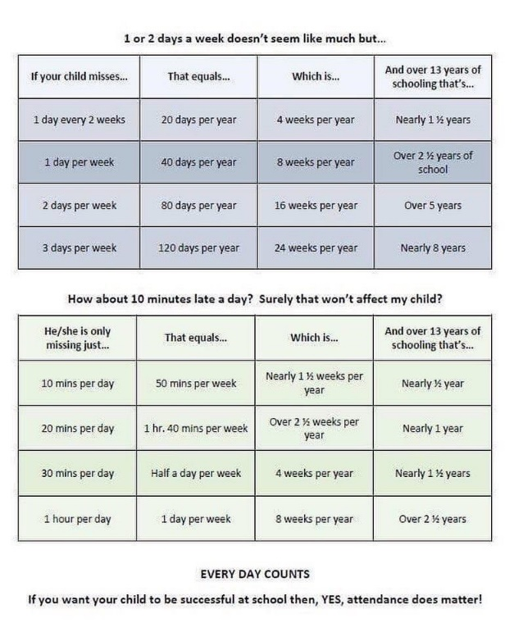
ALCDSB is looking for a member of each school community to serve on a “History of Schools” committee. The plan is to, over the course of the year, update the old “History of Schools” document from the mid 1990’s that has a 1 – 2 page written history of each school in the board. The committee will be tasked with bringing back their school’s history to update this document. The end goal is to create an online, interactive document that will be linked to the Board website and become part of the Multi-Year Strategic Plan.

Schools can include video links, photos etc. The first meeting will be at the Board office sometime in October. After this there may be 1 – 2 other meetings or phone/skype check ins with the school contacts. The person will need to take on some leadership at the school community level to organize the writing/ history gathering. If you think you might be interested, please call or email the school asap to let us know!

School Mass
Our October school Mass is scheduled to take place on Tuesday, October 8th, 2019 at 1:00 p.m. at St. Mary’s Catholic Church. Parents and families are invited to join us.

Every School Day Counts!

Student Accident Insurance
Student Accident Insurance is available through the board. Please visit this link: http://www.insuremykids.com/en/Default.aspx or visit the same link found in the drop-down list under the Parents/Community tab on the Board website.

CUPE Job Action Update
Monday, September 30
Today, CUPE will commence its job action with a partial withdrawal of services. Principals and Vice-principals will work together with staff to maintain a caring and positive school environment for students.
As always, student safety and learning remain the top priorities of all ALCDSB staff. Our superintendents will be in daily contact with our schools during this time to assess any concerns that may arise.
Please understand that as the partial withdrawal of services continues, it may have a more significant impact on school activities, permits and school operations.

Students will be eating lunch in their classrooms during this time.

The Algonquin and Lakeshore Catholic District School Board will continue to monitor this job action closely and will provide parents and guardians with updates and information via board and school websites and social media.

Individual Education Plans
Please return consultation forms sent home earlier in the month. The parent perspective is vital for us as we prepare draft IEPs. Please note that a draft copy of student IEPs will be sent home with students on October 15th, 2019. Please look for the IEPs to come home and complete and return the form indicating that it has been receive and adding any feedback. Thank you!
Safe Schools/ Transportation/Pick-Up Arrangements:
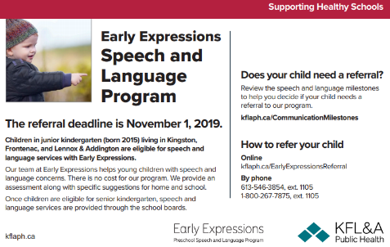
Just some friendly reminders about school and board policies related to student safety. Please call or send a note regarding any changes to your child’s home time routine. Messages are checked daily at 2:30 so any voice messages left prior to this time will be received and acted upon. During school-day hours (8:20 – 8:55) school yard access is reserved for students and staff only.

Terry Fox Walk
A huge thank-you for your support of our Terry Fox Walk! We exceeded our goal and raised a total of $614.75! Thanks for Mrs. Sherriff and her grade 5-8 class for leading our fundraising and our walk!
Orders due Monday, October 7th!
Other Upcoming Events:
October 3rd: Witness Faith Day (Grade 6)
October 4th – Board communications officer visiting to take photos of the school
October 10th – Grade 1-4 trip to Indigenous Garden ceremony
October 14th – Thanksgiving
Friday, October 25th: School Council Halloween Dance
October 30th: Tentative whole-school trip to Corn Maze
October 31st: School visit by Superintendent Theresa Kennedy
October 31st: Orange and Black day AND Halloween Activities! (more details to follow)
Friday, November 1st – PA Day (Numeracy Focus)

School Payment Reminders:
A friendly reminder to, when sending in cheques or cash, to please send funds for separate items (e.g., milk, hot lunch, field trips) on separate cheques or as separate money amounts. This is for our banking and accounting purposes as items must be entered separately online and we don’t have the ability to make change at school Thanks for your understanding!

Thank-you!
I would like to personally thank all students, families and staff for their warm welcome to the Sacred Heart Catholic School Community. This is truly a special place to be!
Laurie Day
Vice-Principal

