Dear God,
Help us to devote our whole life and thought and energy to the task of making peace, praying always for the inspiration and the power to fulfill the destiny for which we were created. What did Jesus say about Peace? Blessed are the peacemakers, for they shall be called children of God (Matthew 5:9) Peace be with you. As the Father sent me, so I send you (John 20:19) Finally, brothers and sisters, farewell. Put things in order, listen to my appeal, agree with one another, live in peace; and the God of love and peace will be with you (2 Corinthians 13:11) And let the peace of Christ rule in your hearts, to which indeed you were called in one body. And be thankful. (Colossians 3:15)
School Council Update
A huge thank-you to our Catholic School Council members who did a fantastic job preparing for and running our Halloween Dance on October 25th! It was wonderful to see so many students and families! Thanks also for your ongoing support in running the hot lunch program. Students (and parents!) very much appreciate this program!
Our next Catholic School Council Meeting will take place on Monday, November 25th at 5:45 p.m. in the Learning Commons.

History of Schools Committee
ALCDSB is establishing a “History of Schools” committee to update the old “History of Schools” document from the mid-1990s. School representatives will be tasked with bringing back their school’s history to update this document. The end goal is to create an online, interactive document that will be linked to the Board website and become part of the Multi-Year Strategic Plan.
The first meeting for this committee is Wednesday, November 13th at the board office in Napanee (151 Dairy Avenue), from 5:30-6:30. Subsequent meetings will take place electronically. If you are interested in helping with this project please contact the school to let us know. Thank-you!

School Mass and Parish Connection
Our November school Mass is scheduled to take place on Wednesday, November 13th, 2019 at 1:00 p.m. at Sacred Heart of Mary Catholic Church. Parents and families are invited to join us.
Thanks to members of the CWL who joined our grade 5-8 students to pray The Rosary on Tuesdays during the month of October!
Remembrance Day, Monday, November 11th, 2019

On Monday, November 11th students and staff will visit the Remembrance Day Ceremony taking place at Town Hall Square at 10:30 p.m. More information will follow closer to the date.

Popcorn is now available for purchase at the school for $1! You may purchase bulk amounts (e.g., 10 or 20) in advance on a popcorn card! CASH ONLY PLEASE!

Parent Communication
We were very pleased that our student agendas arrived in October! The agenda and phone calls are the best (and most efficient) ways to communicate with teachers and staff at school. Thanks for your patience while we waited for these to arrive!
Fresh From the Farm orders should arrive this month. We will strive to provide you with one week’s notice of the pick-up date.

Other Upcoming Events:
November 4th: Teens Trashing Tobacco Presentation (Grades 5-8)
ALCDSB Communications officer, Jessica Salmon, visiting to take photos of the school (original date was postponed).
Grade 7 Immunizations
Tuesday, November 5th: Junior Volleyball Tournament
Progress Reports and IEPs go home.
Wednesday, November 6th: Parent-Teacher interviews
Monday, November 11th: Remembrance Day Ceremony
Wednesday, November 13th: School Mass
Friday, November 15th: Senior Volleyball Tournament
November 18th to 23rd: Bullying Prevention Week
Wednesday, November 27th: Science Fair (Grades 5-8)
Friday, November 29th: PA Day (Student-Centered Learning and UDL Focus)
Christmas Concert and Community Lunch
Our annual school Christmas Concert will be Tuesday, December 17th, in the evening. The Christmas lunch will be Thursday, December 19th. More information to follow closer to the date!

Strive for 5!
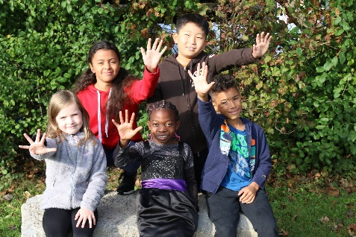
Good attendance is foundational for essential learning skills, developing healthy habits and enjoying school experience but some may be surprised that good attendance means missing fewer than 5 school days a year! #AlcdsbStriveFor5
School Payment Reminders:
Thank-you for continuing to send funds for separate items (e.g., milk, hot lunch, field trips) on separate cheques or as separate money amounts. This helps us tremendously!
Kindergarten Initial Observations and Elementary Progress Report Cards (Grades 1-8)
The Kindergarten Initial Observations Report will be sent home on Tuesday, November 5th . The purpose of this report is to provide an overview of observations of your child’s learning since the start of the school year and early evidence of growth in learning in relation to the overall expectations of The Kindergarten Program (2016). As well, The Provincial Progress Report for Grades 1-8, will also be sent this day. The Provincial Progress Report places significant focus on the Learning Skills and Work Habits necessary for success in school and in life. The Learning Skills and Work Habits that will be assessed include: Responsibility Collaboration Organization Initiative Independent Work Self-Regulation You will receive personalized feedback on student performance in these areas, which will serve to recognize their strengths and identify next steps which may enhance performance. Similarly, you will receive general feedback on their performance in subject areas as well. Again, the comments will recognize strengths and identify next steps for learning and achievement. Please note the traditional mark or percent will not be given on the Elementary Progress Report Card. Rather the Progress Report will tell you how well your child is progressing: “very well”, “well”, or “with difficulty”. Parent – Teacher conferences for students in Kindergarten to Grade 8 will be held on Wednesday, November 6th.

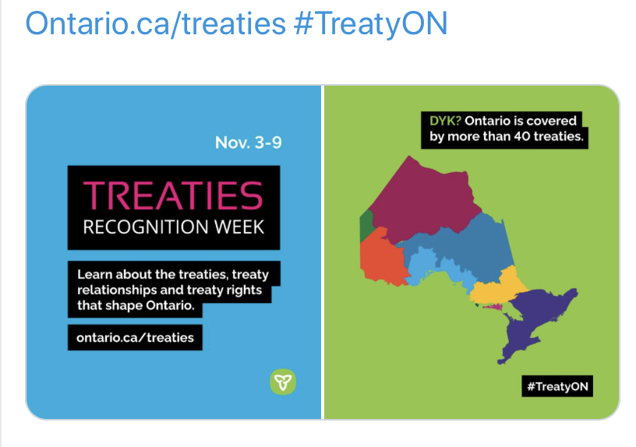
Treaties Recognition Week November 3-9, 2019

A Parent’s Guide to Focusing on the Fundamentals of Math (Ministry of Education)
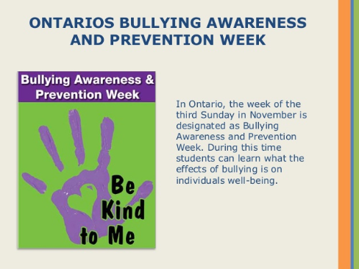
Making sure that students have a strong understanding of the fundamentals of math is one of the best ways to prepare them for success, now and in the future. What students learn today will help best position them to solve everyday problems and to increase their employability in tomorrow’s economy. Key concepts include addition, subtraction, division, and multiplication, which will help to set the stage for more advanced skills, including algebra, and working with integers and decimals, among others. By developing a strong understanding of numbers, students will be able to perform mathematical calculations quickly and accurately – whether they do so mentally, on paper, or by using a calculator. The ultimate goal is for them to be able to perform mathematical procedures with ease. This skill will also support students as they develop their skills in critical thinking and problem solving. Ontario’s publicly funded schools are focusing on the fundamentals of math. For an an overview of what Ontario students in Grades 1-8 are learning in math, and how you can support your children’s math learning at home, please visit http://www.edu.gov.on.ca/eng/parents/parent_guide_math_en.pdf or speak with your child’s teacher.
Learner Profiles
ALCDSB is committed to further developing student-centered learning environments and practices. To this end, students across the board are developing Learner Profiles. An important piece of each profile is the parent perspective, and to this end, a short survey will accompany your child’s progress report. Please take the time to complete and return this form to us!
School Messenger
We are hoping to get School Messenger – a platform for communicating through email or group phone messages – up and running at the school to improve ease and timeliness of communication with families. Please complete and return the attached consent form to participate!

Did you know, a recent study in the US found that only 48% of school age children get the recommended amount of sleep each weeknight? Children who get enough sleep are more likely to show a positive outlook toward school, among other benefits including physical and mental health!

