A New Year’s Prayer
God of this New Year, we are walking into mystery. We face the future, not knowing what the days or months will bring to us or how we will respond. Be love in us as we journey. May we welcome all who come our way. Deepen our faith to see all of life through Your eyes. Fill us with hope and an abiding trust that You dwell in us amidst all our joys and sorrows. Thank You for the treasure of our faith life. Thank You for the gift of being able to rise each day with the assurance of Your walking through the day with us. God of this New Year, we praise You. Amen.
School Council Update
We wish to extend a tremendous thank-you to our Catholic School Council for their efforts and contributions in support of our students, in December. Our Christmas shop and Christmas luncheon were both very successful and the students (and staff) thoroughly enjoyed them! Our next Catholic School Council Meeting will take place on Monday, February 3 at 5:45 p.m. in the Learning Commons. All are welcome!

School Mass and Parish Connection
Our January School Mass will be Wednesday, January 22nd at 1:00. All are welcome!
Upcoming Events:
Monday, January 6th: Feast of the Epiphany Prayer Service
Wednesday, January 22nd: School Mass 1:00
Thursday, January 16th: 6:30 – 8:00
Grade 8 Parent Info night at Regi
Friday, January 31st: PA Day (Assessment and Reporting)

Safe and Caring Schools Update:
All classes will continue participating in the Mind Up program, for Social-Emotional Learning, weekly with Mrs. Day and their classroom teacher. Visit the links below to learn more about foundational elements of the program!
“My Brain is So Very Important” Song (learned with the kindergarten class): https://www.youtube.com/watch?v=U645uqo3IPM
A Video outlining the lesson on mindful awareness: https://mindup.org/mindup-lesson-2-mindful-awareness/

Visit the website below for valuable information and resources on promoting positive mental health at home!
https://smho-smso.ca/parents-and-families/
Tip for Getting Kid’s Back on Track with Sleep after a Break from School: Gradually Adjust Bedtimes!
A sudden change in bedtime could make it difficult for him or her to fall—and stay—asleep. Instead, slowly start making his or her bedtime earlier before the first day back (try pushing it forward five to 15 minutes each day). This will help your child’s circadian rhythm adjust to the new schedule. Not sure what time to set bedtime? Kids aged seven to 12 need 10 to 11 hours of sleep, while older kids need eight to nine hours.
(source:https://www.sleep.org/articles/kids-bedtime-back-to-school/)

School Messenger
We are pleased and excited to announce that our school messenger service is up and running! All families who have returned the consent form will now receive school notices by email. We will continue to send notices by paper for the time being, until we’re sure school messenger is working for all families.

Staffing Update and Lunch/Yard Expectations:
We are pleased to welcome our new lunchtime supervisor, Judi Williams. Judi also works as an EA at Marysville School in the mornings. This staffing change provided the opportunity to review our school procedures and expectations for lunchtime and the yard (outlined below). As a school community it is always optimal for everyone to “be on the same page”; to this end we will use circle time as an opportunity to communicate and discuss these procedures and expectations with students during the first week back in January.
Lunchtime procedures:
- All students eat together in the gym (unless there are special circumstances)
- Monday to Thursday, students eat in table groupings by grade
- “Free Choice” Fridays – students sit where they want!
- Students have a 5-minute notice to start cleaning up for end of lunch
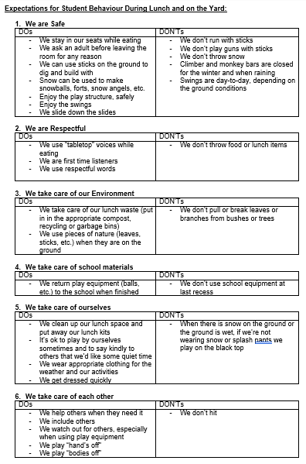
- Students leave the gym to pack up and get dressed for outside.
- Older students are encouraged to help younger students, as needed
- When a first large group of students is dressed, the supervisor goes outside with students.
- Remaining students head out as they are ready!
Progressive Discipline During Lunch and on the Yard:
- We want students to get exercise and have fun!
- Students are always given a verbal reminder when any “misbehavior” is observed
- After this, if the behaviour continues possible responses (“consequences”) include the student being asked to:
  - stay on the blacktop
  - walk with the supervisor
  - stand on the wall
- the choice and duration of consequence is at the discretion of the supervisor at the time.
- consideration is always given to the specific circumstances, context and age/ability of individual students
- Please contact the school with any questions or concerns!

Skating
Classes will be going skating a few times during the month. Please watch for notices from your classroom teacher!

Board News
Please visit the following link to read our annual report: http://www.alcdsb.on.ca/Documents/Director%27s%20Annual%20Report%202019%20[links].pdf
The Algonquin and Lakeshore Catholic District School Board continues to focus on Every School Day Counts in supporting staff and families with strategies to promote good attendance. This 2019-20 school year we are embarking on the STRIVE FOR 5 Campaign. Students are encouraged to attend school 5 days a week and to limit absences to 5 per year!

Happy New Year from all the staff!
Laurie Day

