A Winter Prayer
Lord,
In the midst of Winter, when the days are cold and wind can pierce, remind us of the warmth of Your love. In the midst of Winter, when days are short, dawn comes late, and dusk arrives early, remind us that in the darkness Your light still shines. In the midst of Winter, when the flowers of spring still lie hidden in the earth, when leaves are off the trees, and the world can seem bleak, remind us that Easter is but a short time away. And when in our lives we feel as if we are experiencing a season of winter, reach out to us with the power of Your resurrection, so that we may feel the warmth of Your love and see Your light that alone can take away the darkness of our soul.
Amen
School Council Update
Students (and staff!) are very thankful for our weekly hot lunch program, provided by parent council! Our next Catholic School Council Meeting will take place on Monday, February 3 at 5:45 p.m. in the Learning Commons. All are welcome!

School Mass and Parish Connection
Our February School Mass will be Wednesday, February 26th (Ash Wednesday) at 9:00 a.m. All are welcome!

Upcoming Events:
Wednesday, February 5th: Dairy Presentation for all classes
Thursday, February 6th: Ball Hockey Tournament at St. Martha Catholic School
Monday, February 10th: Grade 5-8 Speeches Presentation
Friday, February 14th: Valentine’s Day! Wear red, pink or white! Pizza Lunch (courtesy of Mrs. LaPrairie!)
Monday, February 17th: Family Day Holiday
Wednesday, February 19th: Term 1 Report Cards and IEPs go home.
Tuesday, February 25th: Shrove Tuesday (Pancake lunch served Wednesday, February 26th)
Tuesday, February 25th: Junior Boys basketball tournament
Wednesday, February 26th: School Mass 9:00
Wednesday, February 26th: Pink Shirt Day!
(More information: !https://www.pinkshirtday.ca/support-for-parents-teachers)

Safe and Caring Schools Update:
Classes will continue participating in the Mind Up program, for Social-Emotional Learning, weekly with Mrs. Day and their classroom teacher. Visit the links below to learn more about foundational elements of the program!
A Video outlining the lesson on mindful listening: https://mindup.org/mindup-lesson-4-mindful-listening/

Five Finger Breathing is a calming strategy used by many of our students!

Winter Sleep Tip! Regular exercise goes a long way toward improving winter sleep! If you can exercise outdoors, soak up some natural light in the morning when you can.

Kindergarten Registration
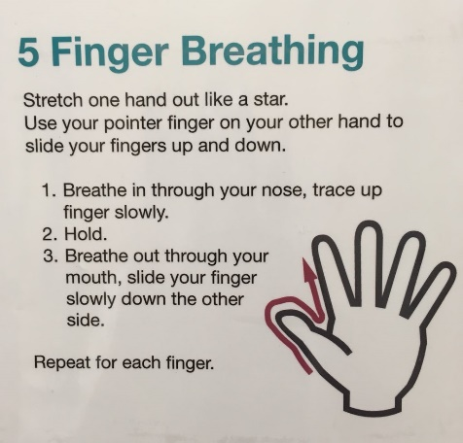
Registration for September 2020 is now open! Visit the link below, call or stop in to the school to learn more! https://www.alcdsb.on.ca/Schools/Pages/Registration.aspx#/=

School Messenger
We are pleased and excited to announce that our school messenger service is up and running! All families who have returned the consent form should now receive school notices by email. We will continue to send notices by paper for the time being, until we’re sure school messenger is working for all families. Please let us know if your family is not yet receiving email messenger notices!
Hot Lunch Orders
A reminder to place hot and milk lunch orders by the deadline, in order to receive them for the week requested. Orders received after the deadline will be applied to the next week’s order. Thanks for your understanding!
Board News

Labour Update: On Tuesday, January 28 the Ontario English Catholic Teachers Association announced that Catholic teachers will hold a second one-day walkout on Tuesday, February 4, 2020. As a result, all ALCDSB elementary and secondary schools will be closed to students. Further details will be communicated as soon as we become aware. Thank-you!

February is Black History Month!
During Black History Month, Canadians celebrate the many achievements and contributions of Black Canadians who, throughout history, have done so much to make Canada the culturally diverse, compassionate and prosperous nation it is today!

