March Break
March Break will take place March 14 to 18th. Easter weekend is April 16 and 17th.
Lent
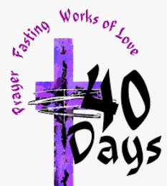
Ash Wednesday is March 2nd. We will attend mass at the church that day. Students will make their Lenten promises, help others, and pray often.
Black History Month
This past month, we celebrated, learned, shared and honoured the tremendous legacy of Black Canadians of the past and present.
Pink Shirt Day
There was a wave of pink at Sacred Heart for Pink Shirt Day. Students completed various activities and had discussions about anti-bullying.

Halenda’s Meat Stix Fundraiser
Fundraising forms went home yesterday for our school’s fundraising event. Please return forms by March 25th and pay using School Cash Online. Thank you for supporting the school!
Catholic School Council
The Sacred Heart Catholic School Council is a dynamic and integral part of this school community.
Our next Catholic School Council meeting will take place VIRTUALLY on March 21st at 6:00pm. All are invited and welcome to attend! Please let Mrs. Cuthbert-Brown know if you would like her to send you an e-vite.
Covid Update
Thank you for using the updated Covid Screening Tool before sending your child/ren to school.
https://covid-19.ontario.ca/school-screening/

Protect and promote Catholic education…Ensure you are registered to vote as a Catholic separate school supporter
Ensuring you are registered as a separate school supporter is important for the protection and preservation of Catholic education in Ontario.
As a registered Catholic school supporter, you have the opportunity to elect trustees who will represent and address your interests and concerns at the school board level and at various levels of the government.
Registering your Catholic school support ensures your school board’s assessment roll is accurate. This is important because:
- Your school board’s assessment base is a public record of the breadth of support for Catholic schools;
- It helps track demographic trends for educational planning purposes;
- It guarantees your right to enroll your children in Catholic schools.

https://www.voterlookup.ca/home.aspx

