Cold Weather
Now that the colder weather is finally here, we are asking that students come to school properly dressed for the outdoors. They are outside for at least an hour per day. Extra mitts and socks are always helpful items to have in backpacks, also!
Catholic School Council
Our next Catholic School Council meeting will take place VIRTUALLY on Monday January 24th at 6:00. Please let Mrs. C-B know if you would like an e-vite!
MDI
The MDI is a self-report questionnaire that asks children in Grades 4 to 8 about their thoughts, feelings and experiences in school and in the community. This will take place early January.
Fundraisers
Thank you so much for taking part in all of our fall/Christmas fundraisers! Your generosity is greatly appreciated.
Remembrance Day
Students took part in the community Remembrance Day ceremony. They also created some amazing works of art for our poster contest! Congratulations to Maysie, Scarlett, Kayla, Marleigh, Lilly and Hanah!

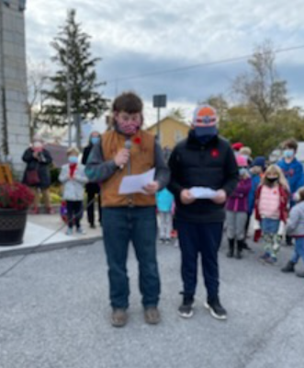
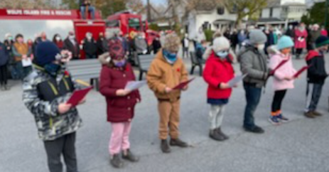
Covid
This new screening tool is to be used daily:
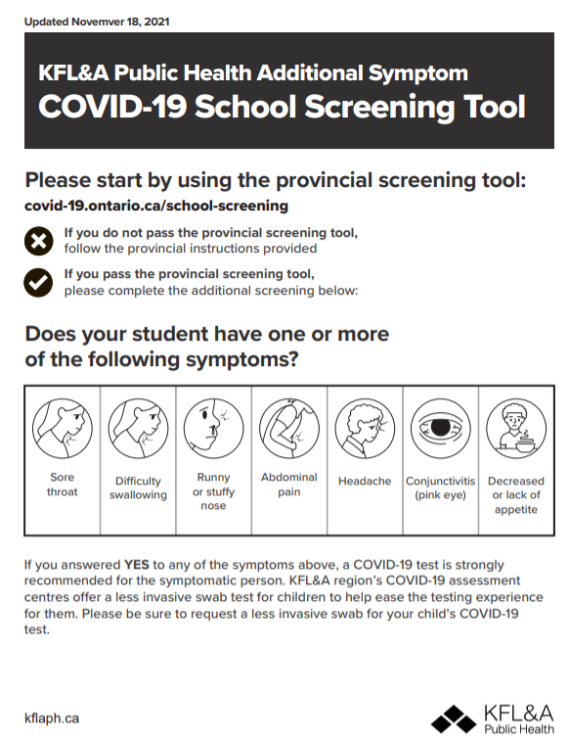
Please ensure your child’s backpack is stocked with a few extra masks each day. Thanks.

Santa Claus Parade
We received permission from the board to take part in the Island’s Santa Claus Parade. Thanks to School Council for purchasing the decorations and candy canes! More information to follow.
Advent
We will attend mass at the church on Wednesday December 1st at 9am. Classes will complete many Advent activities and prayer services this month.
Eco-Wolves Christmas Sale
The Sacred Heart Eco- Wolves are having a Christmas gift sale! Please send in gently used items that the students can purchase as Christmas gifts for family members. They can have a Christmas theme, but it is not necessary. Items such as puzzles, toys and decorative items would be appropriate. We also will need Christmas gift bags and tissue paper, that are reused if possible. Since we are raising money to help clear the oceans and rivers of plastic, please do not purchase new bags for our sale. Please send in items over the next two weeks and we will have our sale on Monday December 6, 2021. If you send a list with the younger students of people that they need to buy for that would be helpful.

