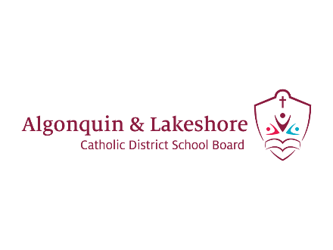
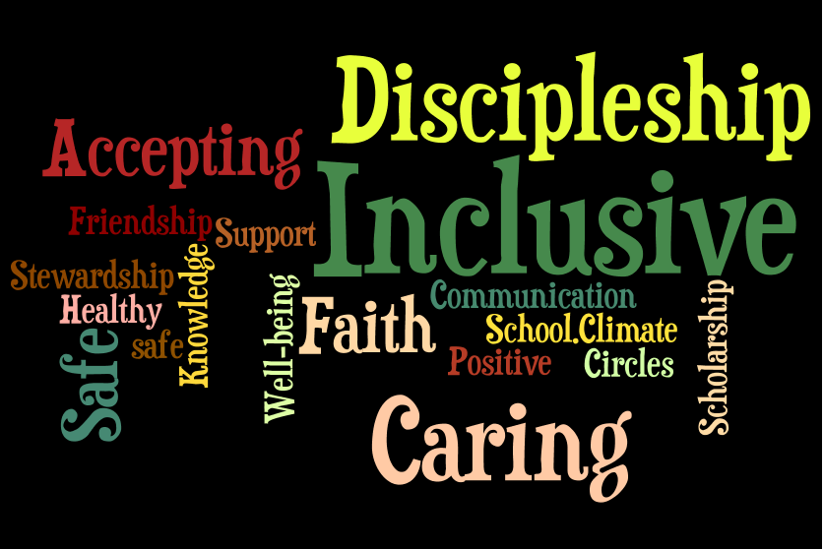

Promoting Positive School Climate and Well-Being
September 2021

Preamble
The ALCDSB is dedicated to creating and promoting positive school climate and well-being in all of our schools. Respecting the dignity of all persons by fostering trusting relationships through policies and practices that promote equity, inclusion and diversity are at the core of our Catholic values, the Board’s spiritual theme of Faith in Action and our provincial Catholic Graduate Expectations. A positive school climate is directly linked to student success and well-being ensuring students are motivated to do well and will realize their full potential. We are committed to sustaining healthy and nurturing communities of belonging that are safe, caring and respectful and built on the principles of restorative practice and progressive discipline.

The ALCDSB and its school communities engage in a whole school approach in putting prevention and intervention strategies in place to facilitate a positive relationship between students, staff, parents and community partners.

- Education, Awareness, and Outreach
Holy Name of Mary Catholic School proclaims that all people are created in the image and likeness of God and, as such, have the right to be treated with dignity, respect and fairness. The school further recognizes that a whole-school approach to engaging the school community will help the School’s efforts to address inappropriate behaviour.

To these ends, the School will utilise the Ministry of Education definition of bullying in communications with the school community:

In its communication efforts, the School will:

- Make known that a positive school climate is essential for student achievement and well-being
- Identify the factors that contribute to a safe, inclusive caring and accepting school climate.
- Support relationship building and focus on promoting healthy relationships using a variety of strategies
- Educate parents and students regarding the differences between bullying, conflict, aggression and teasing
- Explore and identify the underlying factors that contribute to conflict and/or bullying
- Work in partnership with parents and the broader school community to build awareness about the resources and pathways available.
- Be responsive to parental concerns and continue to build relationships and resiliency.

Holy Name of Mary Catholic School will communicate and share with the school community, policies and procedures including the Board/school Code of Conduct, equity and inclusive education policy and guidelines for religious accommodations, procedures to address incidents of discrimination, progressive discipline approach, and promoting positive school climate and well-being.”

- The School will endeavour to increase education, awareness and outreach by using the following best practices:

- A whole-school approach to creating a safe and caring school;
- Religious and Family Life Education curriculum focused on building relationships;
- Using Restorative Justice Practises as a first strategy to repair and strengthen relationships
- Actively promoting and celebrating a culture of “Wellness” in all aspects of school life

- The School has identified the following strategies to engage parents in conversations about promoting a positive school climate:
- Parent representation on Caring and Safe Catholic Schools Team - each school has a team;
- Presentations to School Council on bullying prevention and positive school climate;
- Invitational atmosphere that encourages parents to discuss their concerns with staff
- The creation of parent engagement activities that promote social and community involvement geared for parents in our community

- Evaluation of Evidence
Holy Name of Mary Catholic School recognizes that effective prevention strategies must be evidence-based.

The School will base its interventions, strategies, practices and programs on evidence from the school climate surveys and other relevant information. The school will take the following steps to assess prevention initiatives and strategies:

- Evaluate the evidence to determine the main areas of concern, and identify issues in the physical environment, determine current procedures, and assess the strategies in place based on results of the school climate surveys and other relevant information.
- Identify children and youth involved in bullying (including the bully, the person being bullied, and those who may have witnessed or been affected by the bullying). The School will consider using a risk assessment approach in this process

- Review and update the School’s strategies as a result of gathering new information and feedback from students.

- Share the updated strategies with the school community.

Pre-evaluation strategy
- The School’s main issues of concern raised by students, staff and parents in the school climate surveys and based on other relevant information are the following:
- Our students reported that they were happy, optimistic and had a good sense of self-esteem, however they were worried about how they were perceived by others.
- A large majority of our students believe that they can make a difference in our world but feel that they are not equipped with the tools necessary to make changes.
- Our students report a high degree of struggle in the area of short-term self-regulation. They find it difficult to adapt their emotions or behaviours to meet immediate goals.

- The School’s areas of focus with respect to the physical environment are:
- Creating an environment where “All are Welcome” in our Faith filled school.
- Ensuring that all students have what they need to be successful (socially, emotionally, academically and spiritually).

- Honouring student’s voice and choice in learning, while celebrating their individual ability levels and interests.

- Working with our Indigenous brothers and sisters to bring elements of their culture (Mohawks from the Bay of Quinte) into our school community.

- The School’s current processes for reporting on, responding to, supporting, and following up on issues are as follows:
- Use of the Board’s Caring and Safe Catholic School Administrative Procedures

- Students can report issues to any adult in the building who will help them to resolve the issue or report it to another adult who can help them, including the school Principal.

- Parents are also strongly encouraged to contact their child’s teacher, or school Principal to report issues that may be affecting their child from feeling safe and welcomed at school.

- Based on a review of the school climate survey results and other relevant information, the following areas have shown success/improvement:
- Students are reporting a greater sense of self-esteem.

- Students feel that they have a strong connection with their parents as well as the caring adults in their school.

- Students feel that they have strong relationships and friendships with their peers.

- Based on the school climate survey and other relevant data, the School proposes the following action plan to address areas requiring improvement:
Praising and acknowledging student accomplishments.
Embracing a growth mind-set, using mistakes as teaching moments and replacing “I can’t” with “not yet.”
Providing our students with opportunities to make a difference in the lives of others not only in the school but within the greater community.
Implementing MindUp curriculum into all our classrooms in addition to the Zones of Regulation and Christian Meditation which are already in place.
Classroom programs with our Child and Youth Worker to help our students with strategies when faced with stress/anxiety.
Integration of board partners/community partners to support our students and families. Helping our families to connect with the right agencies.

Post-evaluation Strategy

The School will reassess the results of subsequent school climate surveys to verify the efficacy of the positive initiatives implemented. The “post-evaluation phase gathers evidence to test the efficacy of the prevention, responses, interventions or supports provided in order for changes to be made, where necessary.”

Upon re-evaluation, the School will update the information in this template to reflect the effectiveness of its bullying prevention initiatives.

- Policies and Procedures
The School recognizes that a whole school approach and the policies and procedures of ALCDSB are important for promoting positive school climate and well-being.
The School also recognizes that the goals of policy initiatives must address the areas of challenge identified in school/Board climate surveys and other relevant data.

- The School will actively communicate its policies, procedures and guidelines to the school community (including involving the school community in the review and/or development of policies, procedures and guidelines relating to Caring and Safe Catholic Schools), by taking the following steps:
- Regularly reviewing the Holy Name of Mary Code of Conduct

- Ministry of Education Provincial Parent Guide

- Engagement of our Catholic School Council

- Use of newsletter and our school website to share information with parents

- The roles/responsibilities of the school community (students, staff, parents, and community members) are as follows:
- To follow the standards of behaviour as outlined in the Code of Conduct
- To participate in a whole-school approach to positive school climate in order to ensure that schools are safe, inclusive, and accepting. The Ministry of Education Provincial Parent Guide link: http://www.edu.gov.on.ca/eng/safeschools/code.pdf.

- Prevention
The School recognizes that fostering a positive learning environment will help to reduce possible bullying, harassment, and discrimination incidents. The School is committed to taking steps to strengthen prevention measures.

- The roles and responsibilities of the Caring and Safe Catholic Schools Team (which will be communicated to the school community) are as follows:
- Team members are responsible for addressing issues identified in the School Climate Surveys and other related data
- Team members will identify issues as outlined in the results of the MDI survey as well as any other relevant data
- Team members will help the Principal to address specific issues and trends that may arise in the school and require a team approach
- Team members will help the Principal to create goals towards strengthening our caring and safe school community where “All are Welcome.”

- From its evidence-based analysis, the School has identified the following practices and initiatives for promoting positive school climate and well-being:
- Bullying prevention and intervention programs or activities that are evidence-informed and that address the needs identified by the Board or the School:
- Use of Restorative Justice Practises
- The use of relationship building and mentoring as the strongest teaching tool
- On-going and meaningful dialogue with parents/guardians
- Close working relationships with our Catholic School Council to create opportunities for strengthening relationships and building community

- Relationship-building and community-building resources that are present in the school, classroom and in the larger community:
- Promoting connections to caring adults
- Peer assistance and mentoring programs
- Pastoral ministry
- Youth Workers
- Mental Health and Addictions Nurse
- Curriculum based learning that specifically addresses concepts of well-being, personal safety and belonging

- Activities that promote a positive school climate:
- School-wide focus on gospel values and Catholic Graduate Expectations
- School-wide social justice and charity initiatives
- Spirit Weeks
- An increase in student voice in key choice decisions for the school
- Increased opportunities for student leadership

- Awareness-raising strategies for students, e.g. social-emotional learning, empathy, developing self-regulation skills:
- Roots of Empathy
- FRIENDS and Fun FRIENDS
- MindUp Curriculum/Zones of Regulation
- Kids Have Stress Too
- Student Council

- Awareness-raising strategies to engage community partners and parents in early and ongoing dialogue:
- Presentation to Caring and Safe Catholic Schools Team and School Council on results from School Climate Surveys;
- Participation in events hosted by our various community partners
- Active outreach to all parents through “engagement.” Sharing good news through newsletters, messenger, website and social media.

- Strategies for linking curriculum and daily learning for promoting positive school climate and well-being:
- School-wide focus on restorative practice as a whole-school approach
- Integration of Catholic social justice teaching in all curriculum areas
- Explicit instruction in mental health and wellness, personal safety, equity and inclusion as well as social skills to assist students to direct their learning.

- Strategies to support and encourage role modeling by caring adults and student leaders within the School and school community:
- Catholic Student Council
- Peer assistance and mentoring programs
- Staff engagement at Catholic School Council events

- The School has identified the following learning and training opportunities for school staff and the school community that are needed:
- Annual training promoting positive school climate and well-being
- Promoting Positive School Climate and Well-being pamphlet for parents (available at the Board’s website www.alcdsb.on.ca)
- Regular professional development on a variety of teaching pedagogies such as inquiry, experiential education, special education, outdoor education and Indigenous education
- Collaboration with ALCDSB Special Assignment teachers to integrate specific teaching strategies into teacher’s daily practice, promoting a sense of well-being and belonging for their students

- Interventions and Support Strategies
The School recognizes the importance of using timely interventions and supports with a school-wide approach.
- To this end, the School will:
- Use teachable moments within a progressive discipline approach to address inappropriate behaviour, and consider mitigating and other factors
- Have in place processes and strategies to identify and respond to bullying when it happens
- Restorative Practices are in place to support prevention and intervention practices
- Communicate the progressive discipline approach to the school community and the procedures in place to support the student

- The School supports the use, in a timely manner and using a whole school approach, of the following evidence-informed interventions and support strategies:
- Restorative practices
- Discussion with Board Social Worker (Mental Health Leader)
- Referral of students to school Youth Worker

Bullying - means aggressive and typically repeated behaviour by a pupil where,
- the behaviour is intended by the pupil to have the effect of, or the pupil ought to know that the behaviour would be likely to have the effect of,
  - causing harm, fear or distress to another individual, including physical, psychological, social or academic harm, harm to the individual’s reputation or harm to the individual’s property, or
  - creating a negative environment at a school for another individual, and
- the behaviour occurs in a context where there is a real or perceived power imbalance between the pupil and the individual based on factors such as size, strength, age, intelligence, peer group power, economic status, social status, religion, ethnic origin, sexual orientation, family circumstances, gender, gender identity, gender expression, race, disability or the receipt of special education (“intimidation”)

For the purposes of the definition of “bullying” above, behaviour includes the use of any physical, verbal, electronic, written or other means.
Cyber-bullying
For the purposes of the definition of “bullying” above, bullying includes bullying by electronic means (commonly known as cyber-bullying), including,
- creating a web page or a blog in which the creator assumes the identity of another person;
- impersonating another person as the author of content or messages posted on the internet; and
- communicating material electronically to more than one individual or posting material on a website that may be accessed by one or more individuals.

