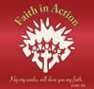
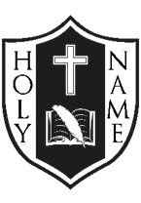
APRIL NEWSLETTER
Greetings:
We rejoice in Jesus’ Resurrection!

Praise and glory to you, O God.
We give you thanks
for all of your wondrous works
and for the joy of this Easter season.
Alleluia! Alleluia!

Amen.

God Bless,
Mrs. McDonald
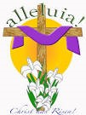

Beacon Of Hope Award
On Tues. April 2, 2019, Triston Vince, a Grade 6 student, was awarded the Beacon of Hope Award for this school year. Triston was chosen by the Holy Name staff for the many ways she demonstrates Faith in Action. Her polite, quiet and humble disposition is always evident. Triston is encouraged to continue to serve as Beacon of Hope to all. Congratulations!

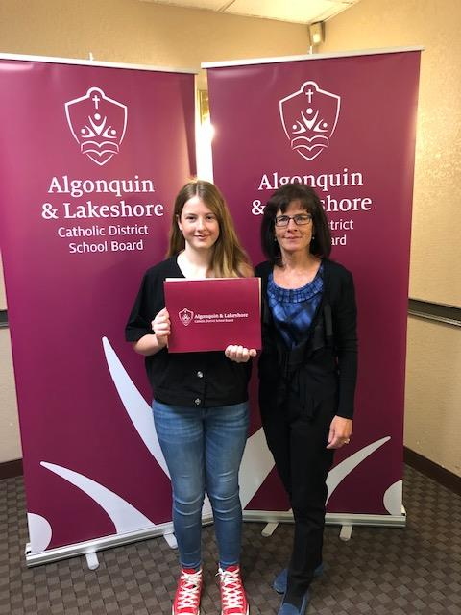
Fr. Wes will offer Lenten Confessions at the school for Gr. 3-8 students on Wed. April 10, 2019.
Stations of the Cross will be visited on Holy Thursday, April 18th. Mrs. MacKler’s Gr. 2/3 class along with Mr. Waller’s Gr. 5/6 students will collaboratively present these reflections for the school community.
Confirmation takes place on Tuesday April 30th at Holy Name of Jesus Church beginning at 6:00 PM. First Reconciliation will take place on Saturday May 04, 2019 at 2:00 PM followed by First Communion on Sunday May 5th at 12:30 PM. Please keep these students in your prayers, as they move forward on their faith journey and prepare for these Sacraments.

Catholic Education Week: Special events will be happening (May 5-10th) and details will follow. SAVE THE DATE! On Thurs. May 9th from 1:15-3:15, there will be a ”Celebration of The Arts”. This event will showcase the many talents of students who have been developing their Arts skills with Ms. Kish this year. Admission tickets will be sold for $2.00 each and proceeds will be donated to the ALCDSB’s Foundation that provides funding for families for emergency situations within our Board.

Congratulations For Community Success!

Colton Irwin, recently advanced to the regional competition in Prescott over the March Break and WON! Congratulations! 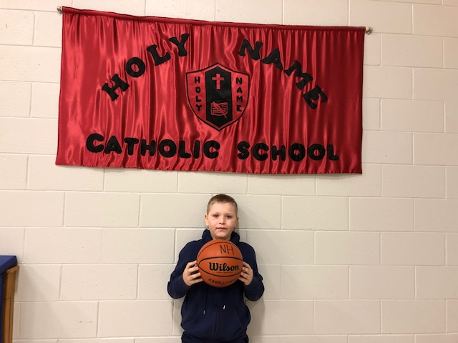
Several students were recognized by the Canadian Legion for their Remembrance Day Art and Literacy success! 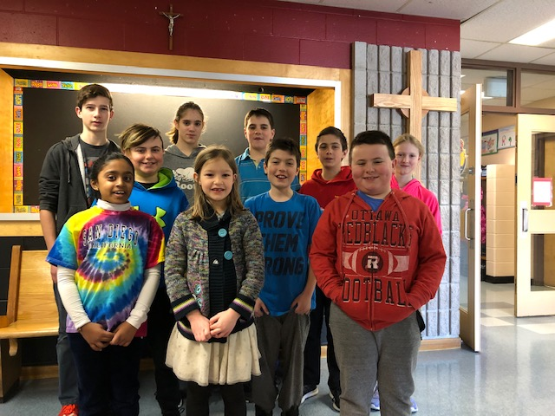
Anthony Kilpatrick and Evangelina Timpson both advanced to the Legion’s Public Speaking!
ECO School Update: Earth Day occurs on the same day as Easter Monday this year. Holy Name will recognize the need to protect God’s world during the week following the Easter Holiday. Watch for details from the ECO Knights!
Continue to follow the great learning happening on Twitter!
alcdsb_name
Full-day Kindergarten Registration – Registrations for the fall of 2019 are being accepted now. New this year is the option to do pre-registration on-line. To register, the following documents are required: the child’s birth certificate, Catholic Baptismal certificate, and record of immunization. Registration packages can be picked up at the Main Office. Information about the full day Kindergarten program can be found at the Ministry of Education’s website at ontario.ca/Kindergarten.
Lost & Found:
Items will be displayed on Thurs. April 18th just before the Easter long weekend. Many winter items need to be claimed! Parents and students are encouraged to look carefully for misplaced clothing.
UPCOMING EVENTS:
Sports: Both Cross Country and Track & Field are coming soon! Details on their way!
Catholic School Council Update:
Holy Name’s Catholic School Council is pleased to announce the success of receiving $10,860.00 from the Pittsburgh Community Benefit Fund to put toward the School Yard Renewal Project! All parents are invited to attend the next School Council meeting scheduled for: Tues. April 22, 2019* (revised date) at 6:30 PM in the Library Learning Commons.

