|  |  |  |  |  |
| --- | --- | --- | --- | --- |
| http://content.mycutegraphics.com/graphics/month/january/january-month-winter-kids.png |  | |  | | --- | | **Welcome Back! We hope you had a restful and joy-filled holiday!**  http://images.clipartpanda.com/counterterrorism-clipart-happy_new_year.gif | |  | |
|  |  |  |
| **we are called to love and be loved** |  | january 2018 newsletter |

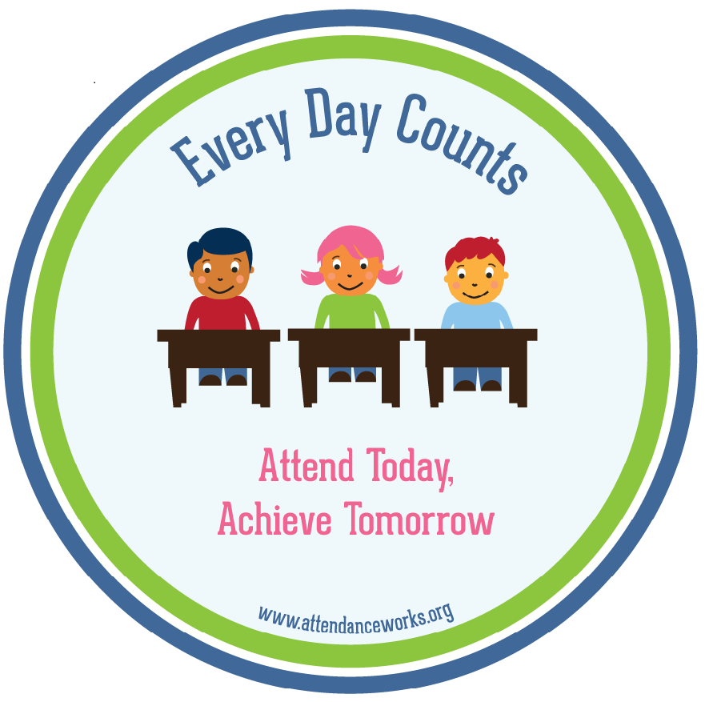

**APPS OF THE MONTH!!**

**Christma Dance a success!**

Senior students organized and assisted in a fun-filled afternoon of dancing on Dec. 22rd. Students from Grade 4 through Grade 8 were able to enjoy celebrating Christmas with music and colourful lighting!

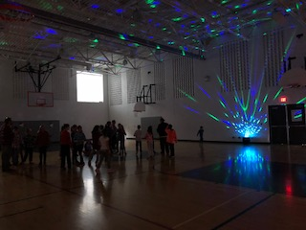

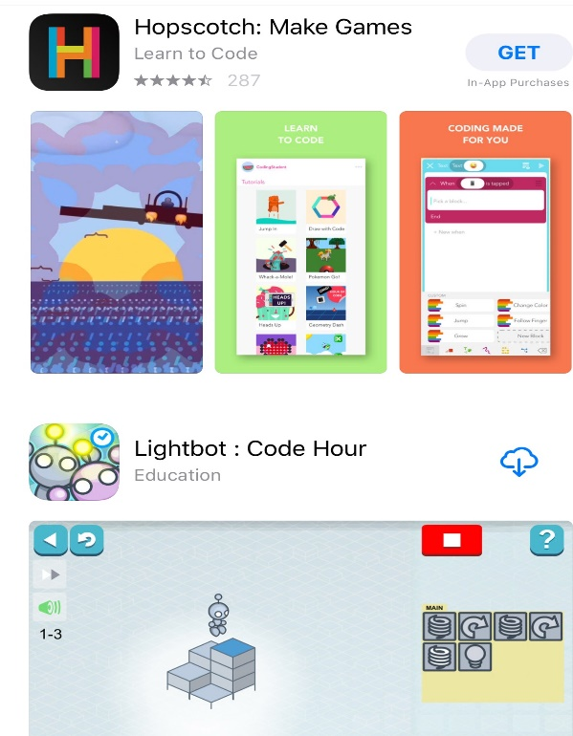

**FRENCH FUN FACT!**

Why learn French? "French is important because it is just another language like English except it has a different culture. It shows that we as people are different and the same." -Michael, ALCDSB Grade 8 Student Encourage your child to be a lifelong learner of French!

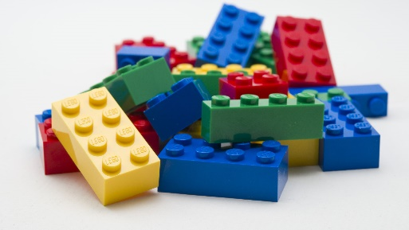

**LEGO Club continues!**



Please remember the following when dressing for our winter weather:

* Wear snowpants
* Wear a hat, scarf and mitts
* Pack extra clothing in case feet or pants become wet

*Indoor clothing*:

* Non-slip footwear
* Shirts must cover shoulders and midriff
* Jeans with holes/rips should still provide modest coverage over legs

|  |
| --- |
| **SCHOOL COUNCIL MEETING** |
| **Wed., Jan., 17th**  **at**  **5:30 pm** |

**Healthy Lunch Idea!**

Whole wheat waffles

Apple slices

Berries

Yogurt

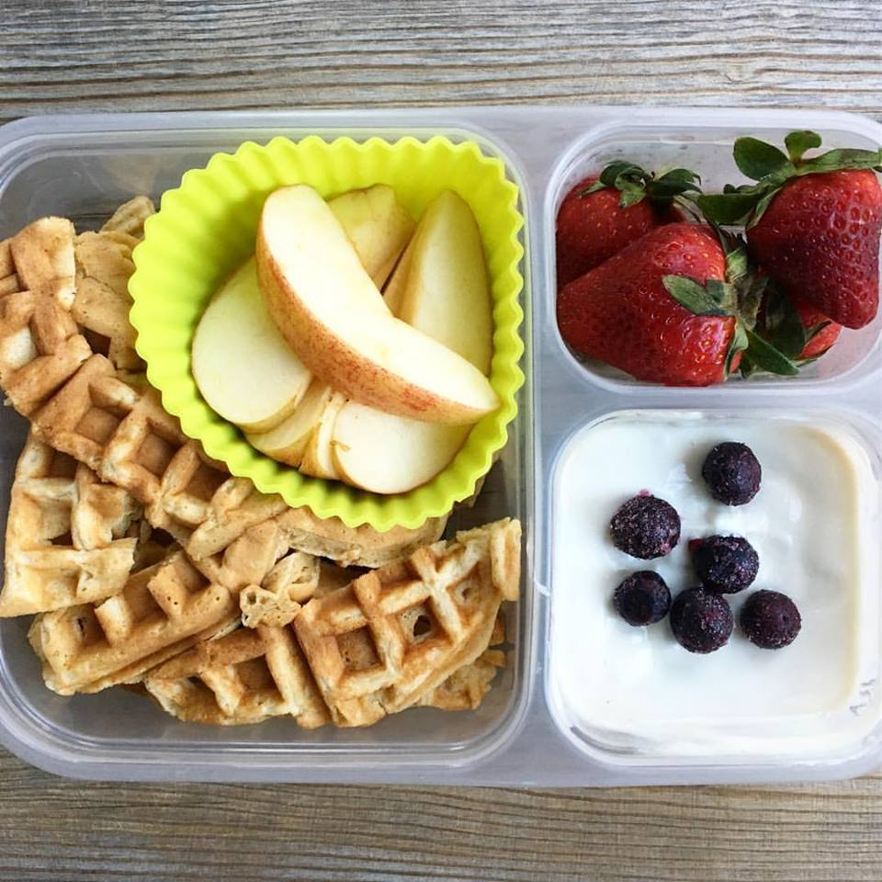

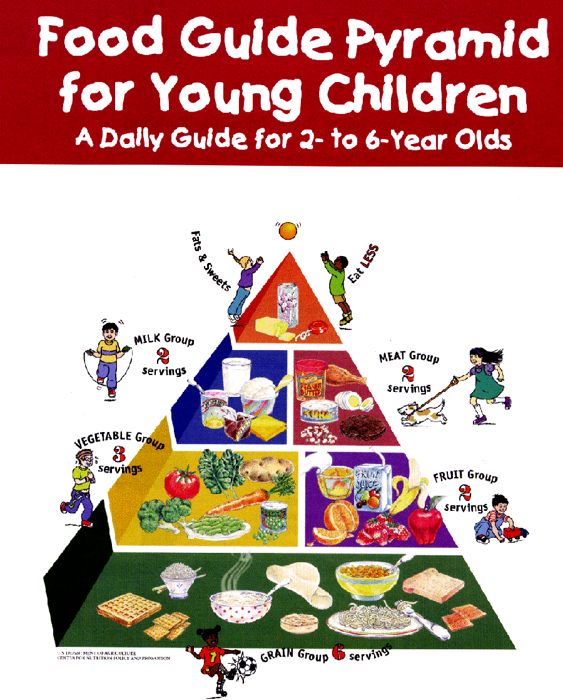

**What’s Your Digital Life?**

Please plan to attend this guest speaker who will be talking about our youth and digital citizenship. Students from Grades 3-8 will have listened to a similar presentation during the day. We invite parents to an informative and interactive discussion and presentation about mental health and digital citizenship.

**Mon., Jan., 22nd @ 6:00 pm**

**In the gym**

**Want to Get Your High School Diploma in the New Year?**

Loyola School of Adult and Continuing Education in Belleville can help!  We will work with you to create an education plan that meets your needs, therefore you may be able to get your high school diploma in as little as 24 weeks.  Loyola also offers a Personal Support Worker Program, ESL classes and academic upgrading for those planning to go to College.  For more information call us at **613-966-9210**  or visit our website at **www.learningatloyola.ca**.

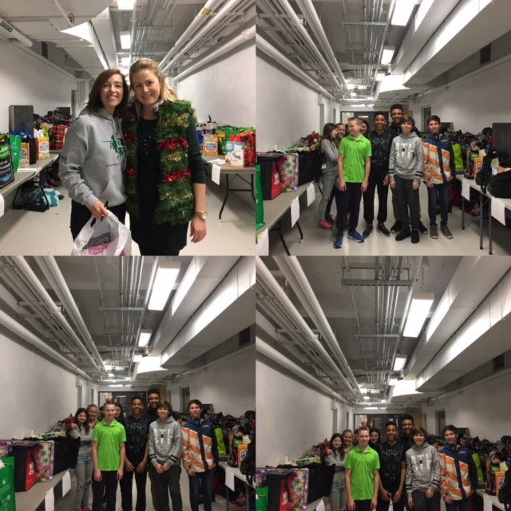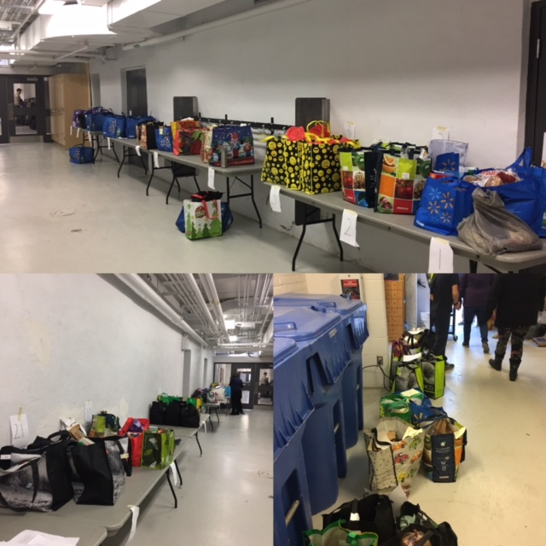

**CHRISTMAS SHARING**

Thank you to the St. Michael Community for supporting our Christmas Sharing program.  Through your generosity, we were able to provide Christmas groceries for many families.  A special thank you to our volunteer drivers for their kindness in delivering the packages.

**Breakfast Club volunteers needed 8:00-8:45 am.**

Please consider joining a team of volunteers that helps to feed dozens of students each morning. rning per week.

|  |
| --- |
|  |

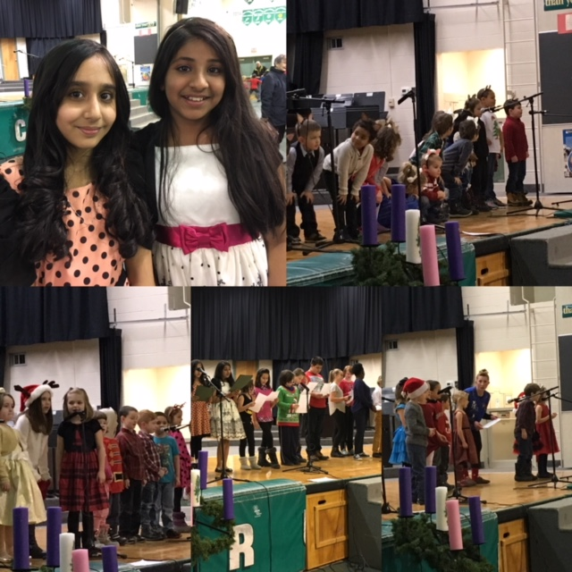

**DECEMBER HAPPENINGS!!**



    
    
    

      
      
      
      