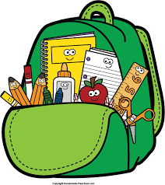
BACK-TO-SCHOOL
STUDENT CONSUMABLE
LIST

Dear Primary Parents:

It is recommended that your child come to school in September equipped with the following school supplies:
A pair of child’s safe scissors
5 Duotangs [yellow, red, blue, orange & green]
30 cm wooden or hard plastic ruler
A protractor
A calculator
A set of computer headphones - (Note that Ear Buds tend to not fit little ears so
please consider headphones.)
A “Courier Bag”
A pencil case
Pencil crayons
Glue sticks
Erasers
Pencils
Washable markers

Primary/Junior Teacher

