Catholic Education Week Mass
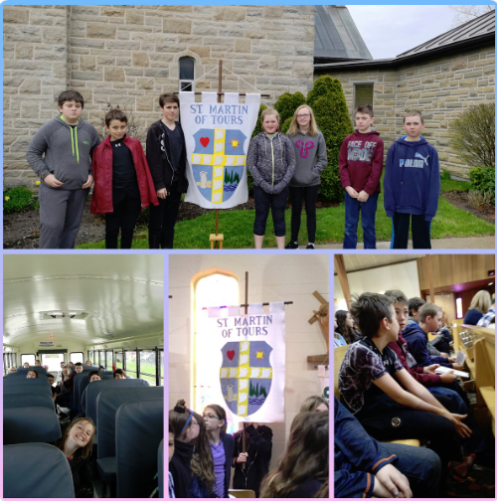

Living in Community & We All Belong. A beautiful celebration of Mass was held on Tuesday, May 7th at St. Joseph Church in Belleville to observe Catholic Education Week.

EQAO

EQAO assessments for Grades 3 and 6 begin TUESDAY, MAY 21st until THURSDAY, MAY 23rd. Please ensure your children in these grades are in full attendance for these three days. Thank you.


P A Day Friday May 17th
Staff will be involved in Professional Development activites both on and off site.


Monday May 20th
Victoria Day Holiday

For 2019-2020 Kindergarten
Program
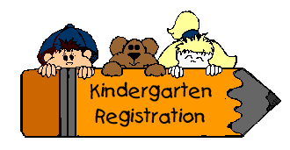
ALCDSB is now able to accept online registration for Kindergarten students for the fall of 2019-2020. To be eligible the child must be 4 years of age on or before December 31st, 2019. Please see our website for more details. Please note that forms for busing are not currently available online. Forms will have to be picked up at the school for submission to Tri-Board.

Catholic Education Week
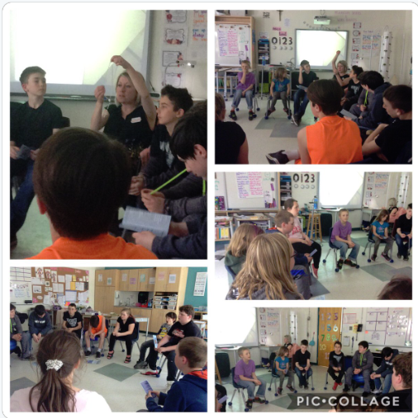

Students and Staff gathered to pray a Rosary during Catholic Education Week.

Track & Field Day

Permission forms will be coming home soon for our Track & Field Meet. We will be competing at York River PS on Tuesday, May 28th (rain date May 29th).
Dental Screening


Due to conflicting time with EQAO dental screening will now be held on May 30th for all students.
Visit with Ms. Kennedy
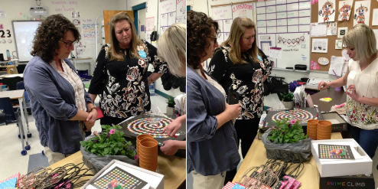

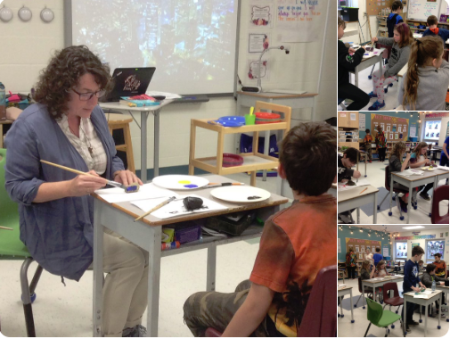

St. Martin of Tours had a visit from our Superintendent Ms. Theresa Kennedy. She joined students in painting faith rocks and learned about a new game called PRIME CLIMB from Mrs. Armstrong.
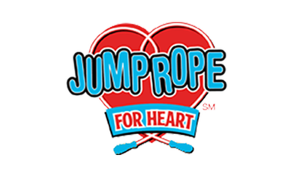
Jump Rope for Heart

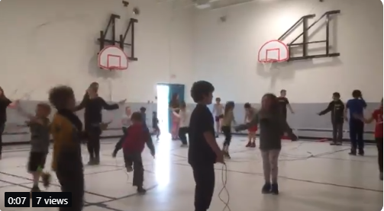
Students and staff from St. Martin of Tours and Whitney Public School participated in Jump Rope for Heart on Friday May 10th. Students raised $365.50! Way to go everyone!

MOVIE NIGHT
Thursday May 16th
The Kid Who Would Be King
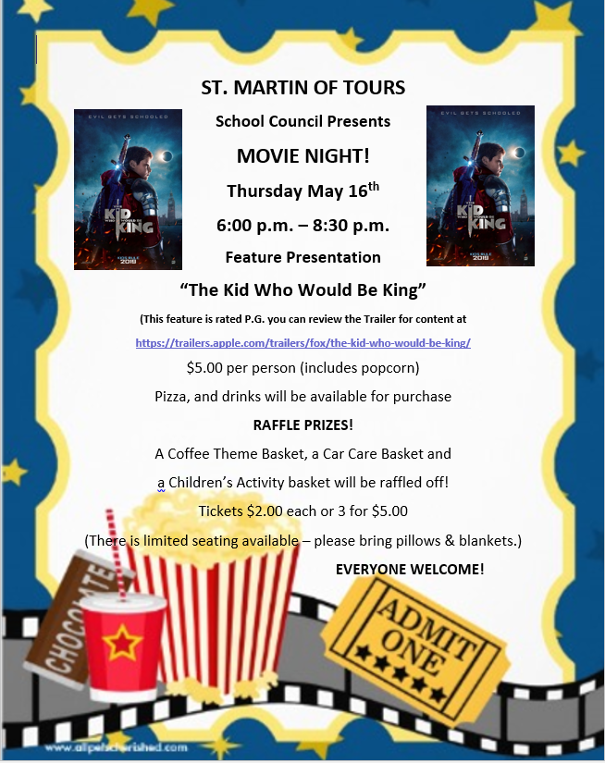
$5.00 per person

Article Bingo


May 30th
6pm – 8pm (approx.)
All ages can play
Looking for donations of prizes. Please have all donations in the office or to Sandra Courneyea by May 24th. All proceeds will go to benefit the Food for Learning Program.



Dreams Take Flight
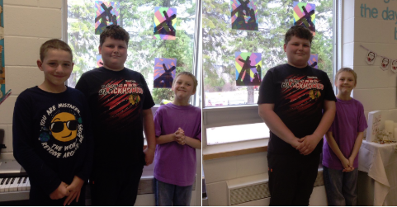

We are so excited for Chris and Zephyr from SMT and Marcus and Kayla from WPS who are our communities Dreams Take Flight kids. They had a great trip to Disney Land and we were so excited for them to return and to hear all about their amazing once in a life time experiences!

Upcoming FEWL Spirit Days

May 23 – Twin/Pajama Day
May 31 – Hawaiian Day


Hawaiian Luau Dance

Staff will be putting on a Hawaiian Luau Dance for the students of both schools on May 31st from 1pm – 2:30pm. Healthy Snacks will be for sale. All Proceeds will go towards FEWL Fundraising.

