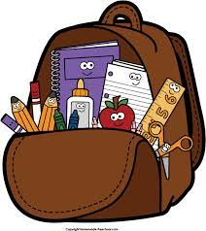
Back-to-School
Student Consumable
List

Dear Junior/Intermediate Parents:

It is recommended that your child come to school in September equipped with the following school supplies:
- pencils (HB)
- pencil sharpener
- blue/black pens
- red pen
- green pen
- pencil case
- plastic ruler (30cm)
- glue stick
- highlighter
- eraser
- a set of pencil crayons
- sheets of lined paper
- graph paper (1/4” grid)
- 1 set of computer headphones
- Calculator
- 1 flash/thumb drive (8 GB is sufficient)

Please note that these supplies should be replenished as needed throughout the school year.

