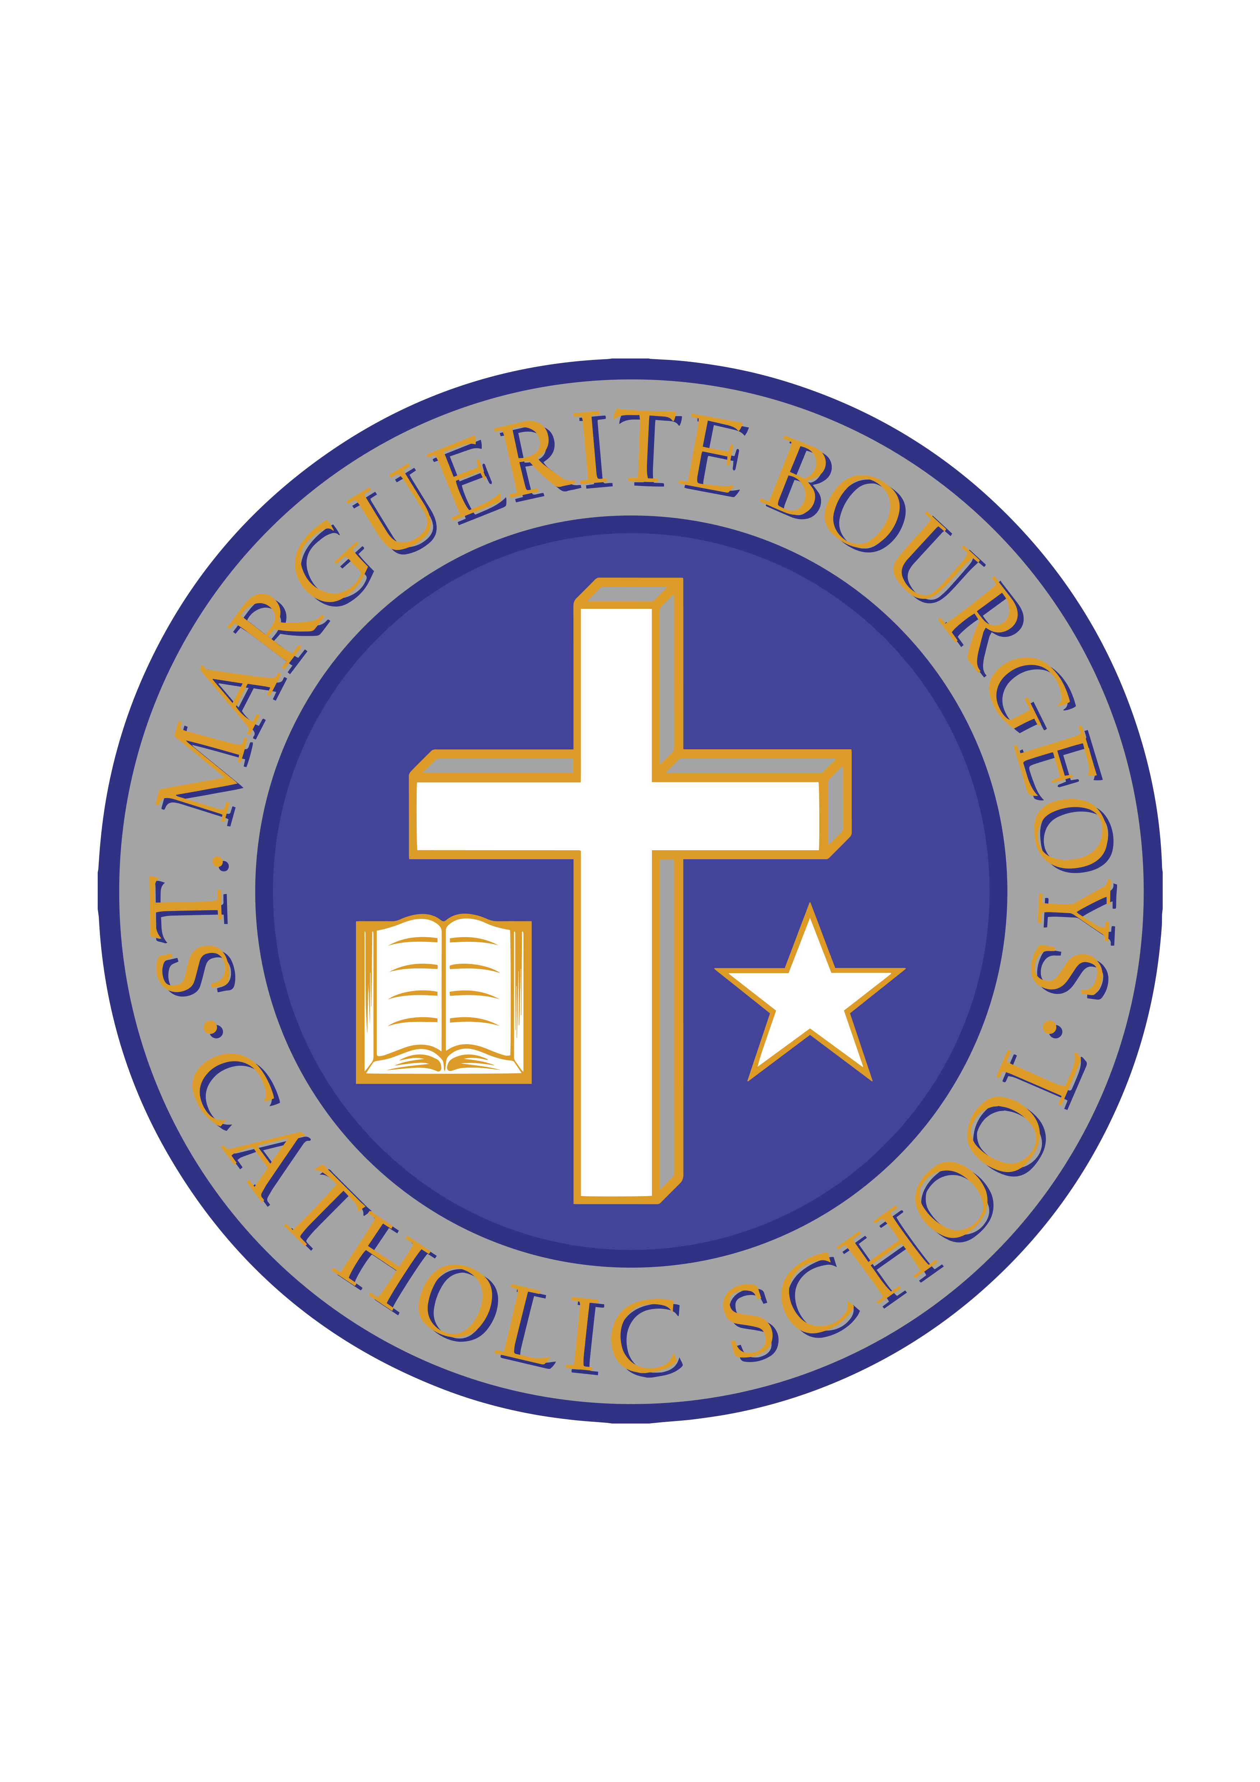

April 3, 2019

Spirit Week Fundraiser/SOCKS for Kingston Campaign

During the week of April 8-12, our School Spirited Support Team will be hosting a Spirit Week to raise funds for Kingston Street Missions Hot Meals Program. This is part of our Lenten activities where we hope to raise $1000. Each day, students are invited to bring in a loonie in exchange for dressing in whatever the theme of the day happens to be. The daily events are:

Monday, April 8th Marvelous Minds Monday (Hat Day)
Tuesday, April 9th Terrific Twin/Triplet Day (wear the same clothes as a friend)
Wed, April 10th Wacky and Wild Hair Day
Thurs, April 11th Thankful Fans Sports Day (Jersey Day)
Friday, April 12th Fabulous Freaky Friday (Pajama Day)

We are also embarking on our annual SOCKS Kingston Campaign during the week of April 15-18th. Details are below:

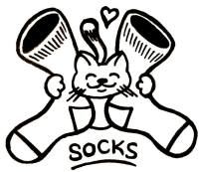
For a third year in a row, SMB will work with SOCKS Kingston to bring in 2000 pairs of new socks! All new socks are welcome! Ms. Lollar’s “Great” 4 class will be organizing a sock drive as part of a Lenten initiative during the week of April 15th-18th. Get ready to SOCK it to us, SMB!

Thank you for all of your support during this Lenten season!

