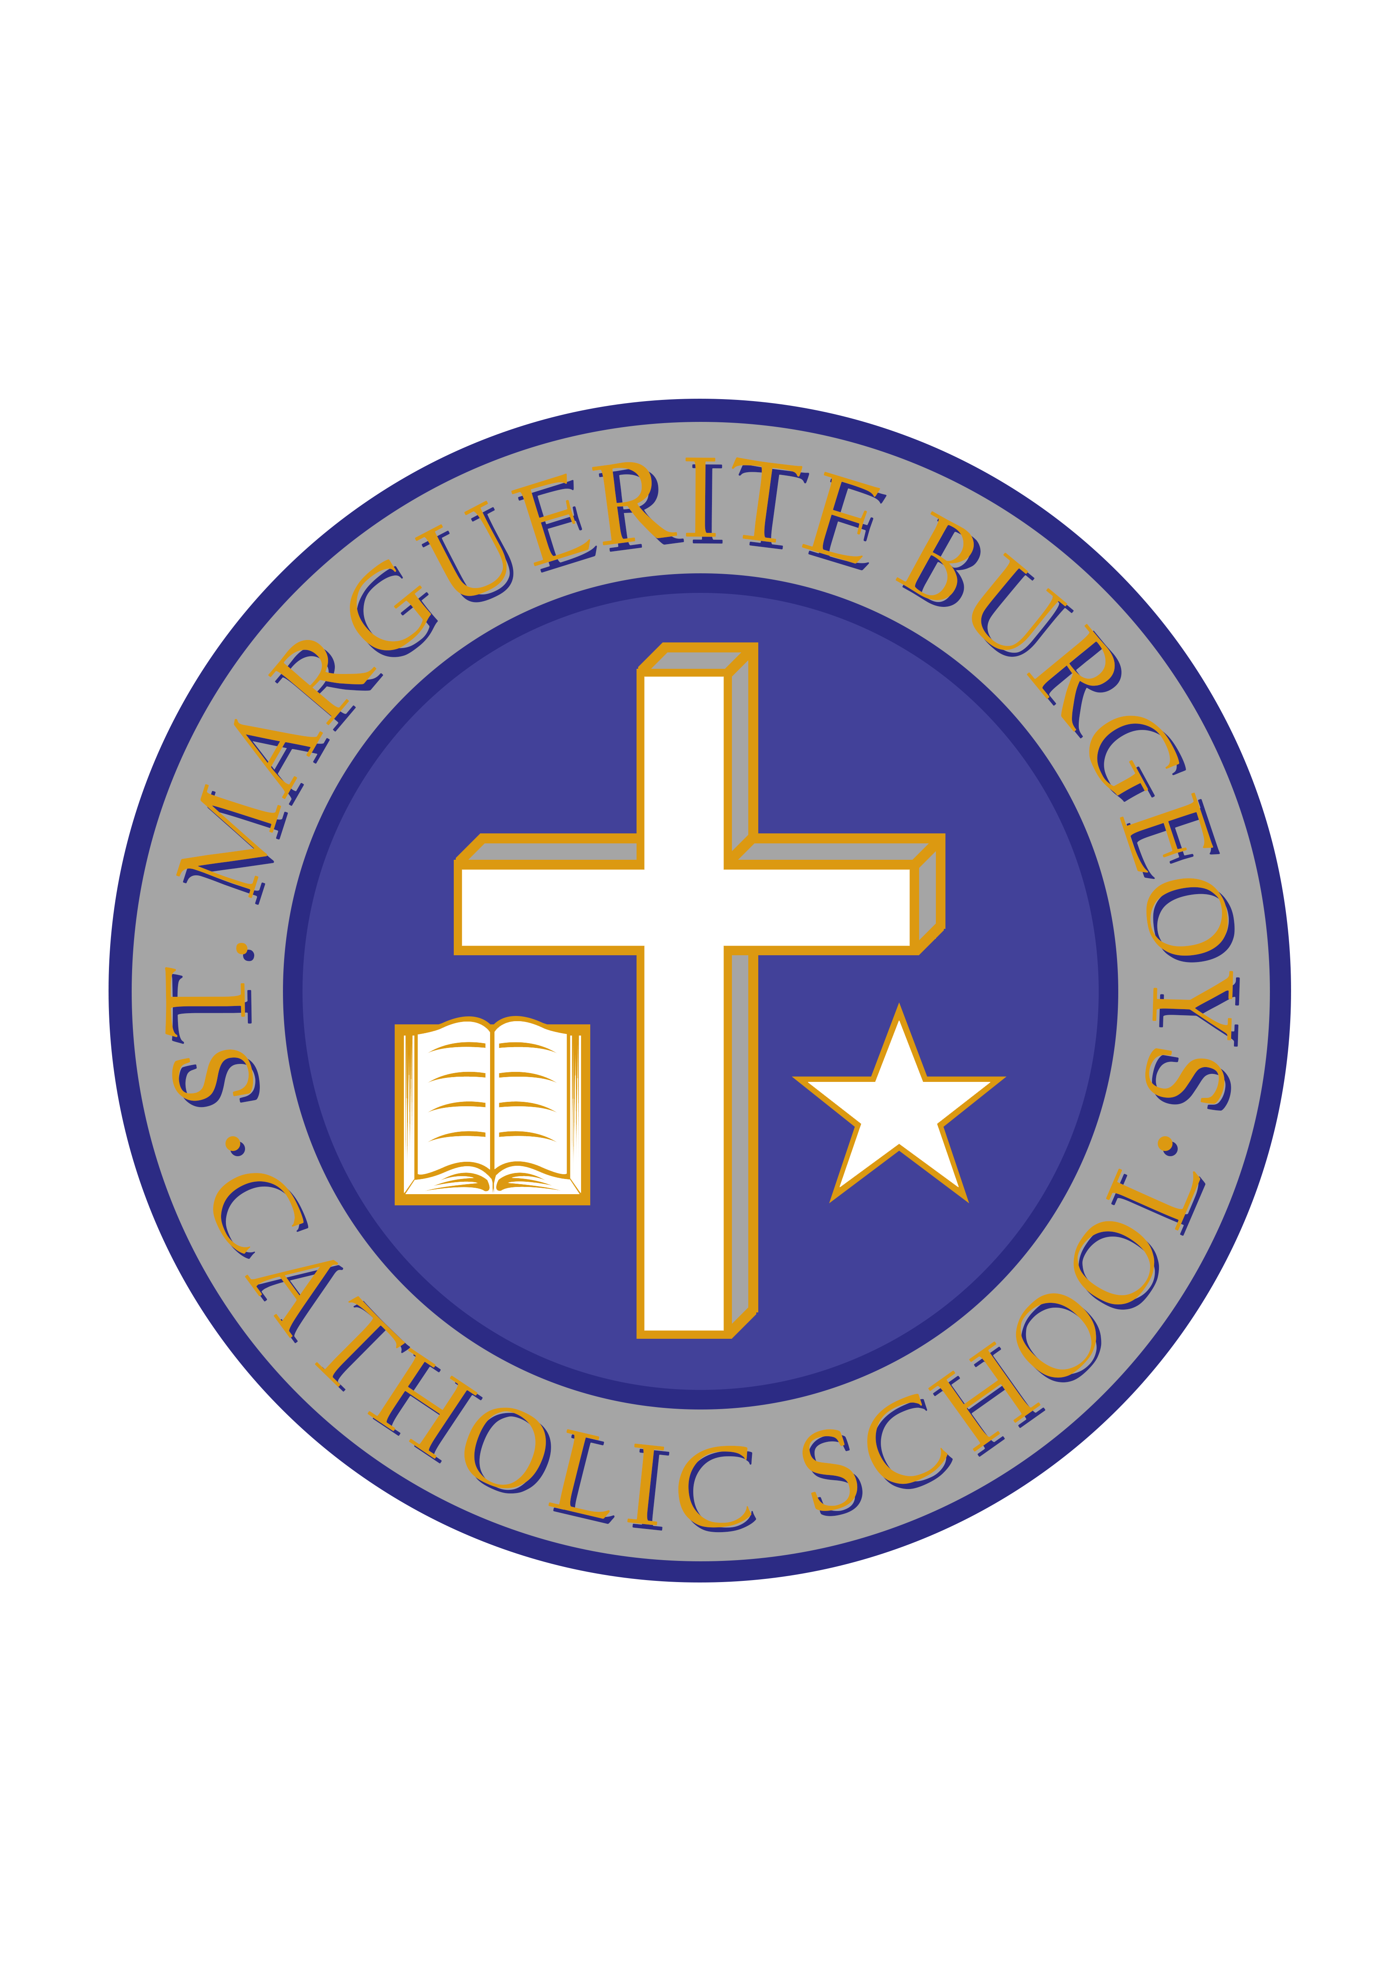

Happy Retirement Ms. Porter!

January 28, 2019

Dear Parents/Guardians,

After many years of working with us here at SMB, Ms. Porter, one of our Educational Assistants, has decided to retire. Although we will certainly miss Ms. Porter’s friendly smile, willingness to help out, and her knowledge of the students in the school, we hope that she now finds more time to enjoy her own personal interests. Ms. Porter’s last day will be Thursday, January 31st. We would also like to welcome Ms. Truscott to SMB who will be replacing Ms. Porter for the remainder of the school year.

Congratulations Ms. Porter. We will miss you!

Sincerely,

Mr. C. Minutillo Ms. L Bryden
Principal Vice-principal

