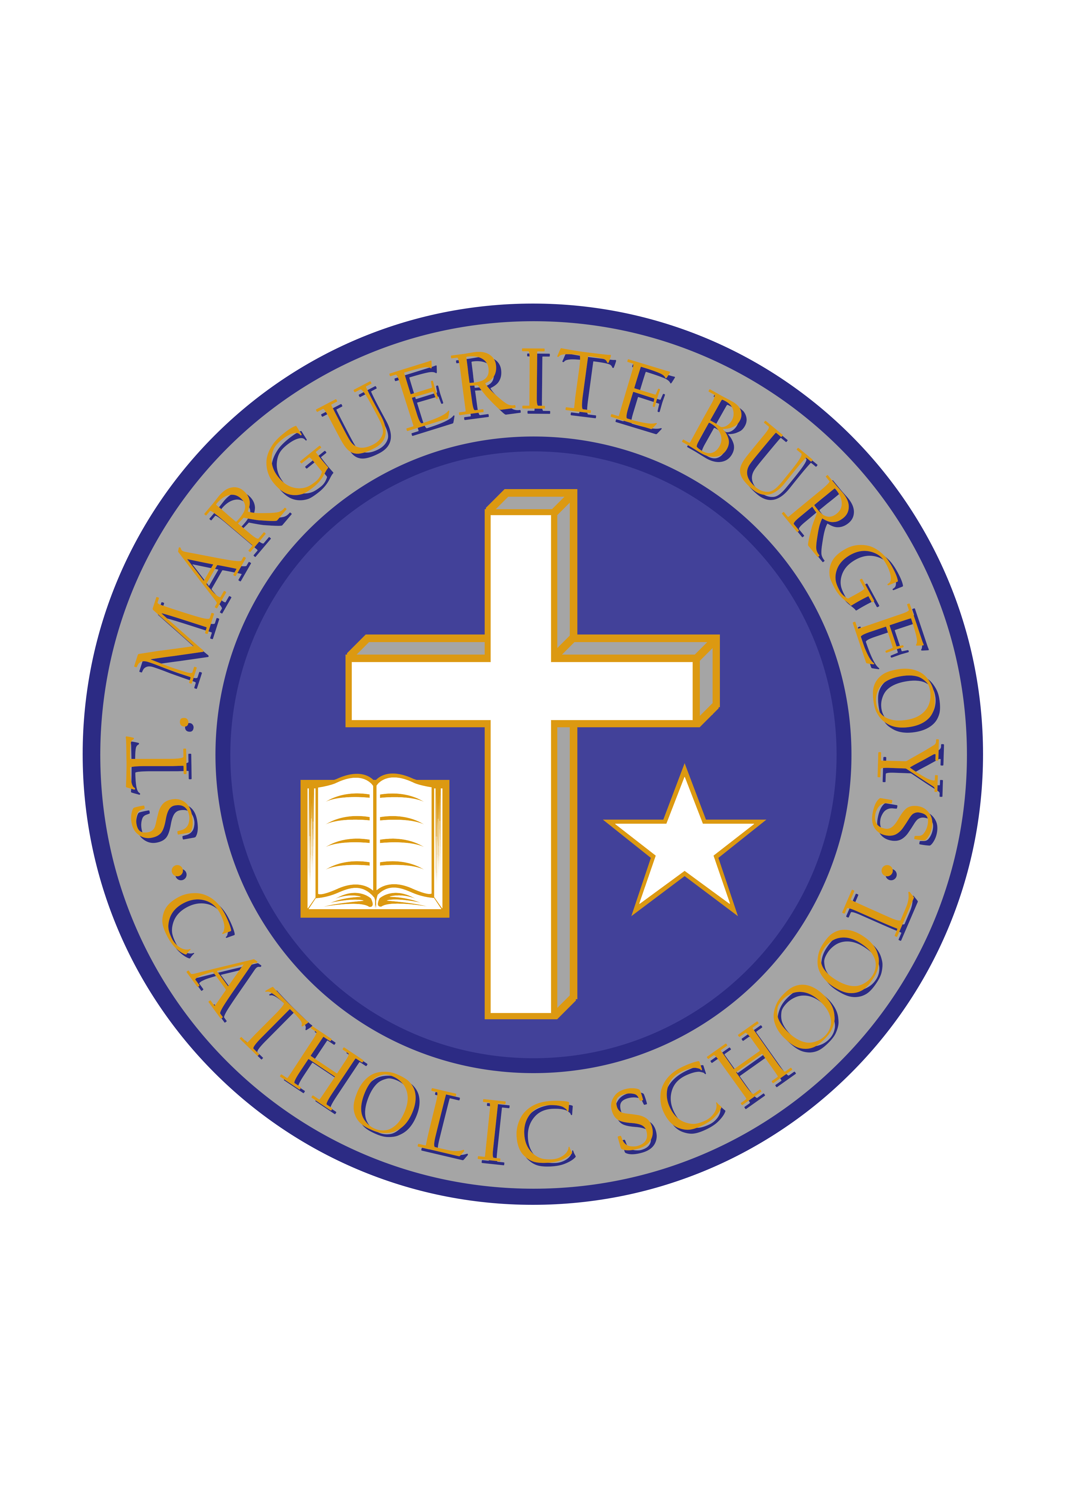

SNOWSUIT DONATION WEEK

At St. Marguerite Bourgeoys Catholic School, we have always demonstrated our willingness to help others in our own community as well as the larger community. Again this year, we are looking to assist families in preparation of the winter season. We are accepting donations of new and used snowsuits, jackets, and pants from our SMB community to be handed back into our SMB community!

Children are welcome to bring their donations to the school during the week of November 12-16, 2018.

On the evening of Thursday, November 22, 2018, between 4:00-7:00, the school will be open to ALL families of the SMB community to come pick up a donated snowsuit.

Every family can benefit from a small act of kindness. Let's bring kindness to our SMB Community!!! Thank you in advance for your generosity.

Mr. C. Minutillo Ms. L. Bryden
Principal Vice-Principal

