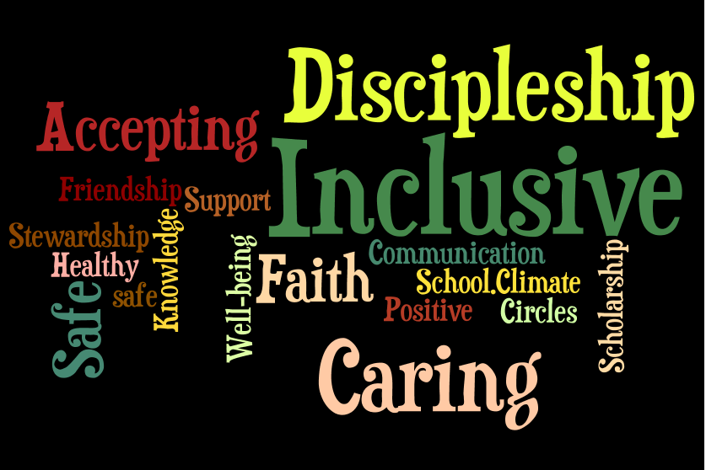
Preamble
Updated: September, 2018
Promoting Positive School Climate and Well-being
The ALCDSB is dedicated to creating and promoting positive school climate and well-being in all of our schools. Respecting the dignity of all persons by fostering trusting relationships through policies and practices that promote equity, inclusion and diversity are at the core of our Catholic values, the Board’s spiritual theme of Faith in Action and our provincial Catholic Graduate Expectations. A positive school climate is directly linked to student success and well-being ensuring students are motivated to do well and will realize their full potential. We are committed to sustaining healthy and nurturing communities of belonging that are safe, caring and respectful and built on the principles of restorative practice and progressive discipline.

The ALCDSB and its school communities engage in a whole school approach in putting prevention and intervention strategies in place to facilitate a positive relationship between students, staff, parents and community partners.

- Education, Awareness, and Outreach
Our Lady of Lourdes Catholic School (the “School”) proclaims that all people are created in the image and likeness of God and, as such, have the right to be treated with dignity, respect and fairness. The school further recognizes that a whole-school approach to engaging the school community will help the School’s efforts to address inappropriate behaviour.

To these ends, the School will utilise the Ministry of Education definition of bullying in communications with the school community:

In its communication efforts, the School will:

- Make known that a positive school climate is essential for student achievement and well-being
- Identify the factors that contribute to a safe, inclusive caring and accepting school climate.
- Support relationship building and focus on promoting healthy relationships using a variety of strategies
- Educate parents and students regarding the differences between bullying, conflict, aggression and teasing
- Explore and identify the underlying factors that contribute to conflict and/or bullying
- Work in partnership with parents and the broader school community to build awareness about the resources and pathways available
- Be responsive to parental concerns and continue to build relationships and resiliency.

Our Lady of Lourdes Catholic School will communicate and share with the school community, policies and procedures including the Board/school Code of Conduct, equity and inclusive education policy and guidelines for religious accommodations, procedures to address incidents of discrimination, progressive discipline approach, and promoting positive school climate and well-being.”

- The School will endeavour to increase education, awareness and outreach by using the following best practices:

- A whole-school approach to creating a safe and caring school;
- Religious and Family Life Education curriculum focused on building relationships; including school masses and liturgies
- Contributions from community partners (i.e. School Resource Officer, Down Syndrome Awareness Day, Epilepsy Awareness Day, LSDC visits to Providence Manor, Children’s Mental Health Presentations (Kids Get Stressed Too!), choir performing for Silver Springs Manor, Mental Health Nurse)
- Messages to families through School Messenger System to inform families of news and events
- Activities planned and organized by the PeaceQuest team (e.g. Bullying Awareness Week, Advent and Lenten Campaign activities, Bell Let’s Talk Day, Pink Shirt Day, etc.)

- The School has identified the following strategies to engage parents in conversations about promoting a positive school climate:
- Parent representation on Caring and Safe Catholic Schools Team - each school has a team;
- Collaborating with to School Council on bullying prevention and positive school climate;
- Post this plan on the school website and share the plan with all parents

- Evaluation of Evidence
Our Lady of Lourdes Catholic School recognizes that effective prevention strategies must be evidence-based.

The School will base its interventions, strategies, practices and programs on evidence from the school climate surveys and other relevant information. The school will take the following steps to assess prevention initiatives and strategies:
- Evaluate the evidence to determine the main areas of concern, and identify issues in the physical environment, determine current procedures, and assess the strategies in place based on results of the school climate surveys and other relevant information.
- Identify children and youth involved in bullying (including the bully, the person being bullied, and those who may have witnessed or been affected by the bullying). The School will consider using a risk assessment approach in this process.

- Review and update the School’s strategies as a result of gathering new information.

- Share the updated strategies with the school community.

Pre-evaluation strategy
- The School’s main issues of concern raised by students, staff and parents in the school climate surveys and based on other relevant information are the following:
- Ensuring that students can report incidents of bullying safely and in a way that minimizes the possibility of reprisal;

- Identifying and supporting students who are experiencing anxiety at school.

- Providing early intervention and support for students with respect to verbal and social bullying.

- Youth Worker helps to address the behavioural, emotional and social needs of children through behavioural problem solving and programming, and social support.

- The School’s areas of focus with respect to the physical environment are:
- Ensuring supervision of students inside the school and on school property; (e.g. yard slips, vests for supervisors)
- Monitoring of bathrooms and change rooms by staff;

- Communicating regularly with bus drivers and bus patrollers.

- The School’s current processes for reporting on, responding to, supporting, and following up on issues are as follows:
- Use of the Board’s Caring and Safe Catholic School Administrative Procedures;

- yard slips provided for all supervisors to report concerns with follow up by school administrator as necessary;

- Restorative conflict resolution with all parties involved in issues and follow up reporting to parents as necessary.

- Based on a review of the school climate survey results and other relevant information, the following areas have shown success/improvement:
- Most students expressed that they had a positive sense of belonging and that they valued schooling outcomes. Most students felt like they had positive peer relationships and friends at school they can trust and who encourage them to make positive choices.
- Most students reported feeling safe in all areas of the school.

- Based on the school climate survey and other relevant data, the School proposes the following action plan to address areas requiring improvement:
Our students, especially in senior grades, report a high level of anxiety (38% vs. Canadian Norm of 18%). We will turn our attention to strategies to teach and practise with our students to help them cope. We will focus our attention on positive mental health and wellness strategies by explicitly teaching and reviewing coping strategies and self-advocacy skills. Our Child and Youth Worker will focus on Teir 1 supports within the classroom (e.g. Roots of Empathy, Kids get Stressed Too!, etc.) We will engage community partners such as KFL&A Health Unit, Children and Youth Mental Health, ALCDSB Mental Health Nurse, Pathways, and our Community Police Officer.

Post-evaluation Strategy

The School will reassess the results of subsequent school climate surveys to verify the efficacy of the positive initiatives implemented. The “post-evaluation phase gathers evidence to test the efficacy of the prevention, responses, interventions or supports provided in order for changes to be made, where necessary.”

Upon re-evaluation, the School will update the information in this template to reflect the effectiveness of its bullying prevention initiatives.

- Policies and Procedures
The School recognizes that a whole school approach and the policies and procedures of ALCDSB are important for promoting positive school climate and well-being.
The School also recognizes that the goals of policy initiatives must address the areas of challenge identified in school/Board climate surveys and other relevant data.

- The School will actively communicate its policies, procedures and guidelines to the school community (including involving the school community in the review and/or development of policies, procedures and guidelines relating to Caring and Safe Catholic Schools, by taking the following steps:
- Link to school Code of Conduct: https://drive.google.com/file/d/1LSxXC6dkP9bLyusQ4hgeTLMgTEansCxT/view?usp=sharing

- Ministry of Education Provincial Parent Guide;

- School Code of Conduct is inserted in all student agendas (parents are asked to review the code with their children);

- Catholic School Council will continue to be consulted in the review and development of our school policies related to Caring and Safe Schools.

- The roles/responsibilities of the school community (students, staff, parents, and community members) are as follows:
- To follow the standards of behaviour as outlined in the Code of Conduct: https://drive.google.com/file/d/1LSxXC6dkP9bLyusQ4hgeTLMgTEansCxT/view?usp=sharing

- To participate in a whole-school approach to positive school climate in order to ensure that schools are safe, inclusive, and accepting. The Ministry of Education Provincial Parent Guide link: http://www.edu.gov.on.ca/eng/safeschools/code.pdf.

- Prevention
The School recognizes that fostering a positive learning environment will help to reduce possible bullying, harassment, and discrimination incidents. The School is committed to taking steps to strengthen prevention measures.

- The roles and responsibilities of the Caring and Safe Catholic Schools Team (which will be communicated to the school community) are as follows:
- Team members are responsible for addressing issues identified in the School Climate Surveys and other related data;
- meet to discuss progress of initiatives in the school;

- continue to re-evaluate this plan based on new school climate survey data as well as information from all stakeholders.

- From its evidence-based analysis, the School has identified the following practices and initiatives for promoting positive school climate and well-being:
- Bullying prevention and intervention programs or activities that are evidence-informed and that address the needs identified by the Board or the School:
- Restorative Practices including mending sessions and class circles, In-School Discipline;
- Fun Friends and Friends for Life programs;
- Roots of Empathy program.
- Programs to increase self-esteem (e.g. Kids Get Stressed Too!, PeaceQuest Initiatives).
- Every School Day Counts Philosophy: Helps us to keep kids safe and helps us, through investigation, learn what barriers might keep some of our students from attending school on a regular basis.

- Relationship-building and community-building resources that are present in the school, classroom and in the larger community:
- Promoting connections to caring adults who are involved in the school community;
- Religious Education and Family Life curriculum and sacramental preparation;
- Pastoral ministry;
- Youth Worker;
- Mental Health and Addictions Nurse.
- Activities that promote a positive school climate:
- School-wide focus on gospel values and Catholic Graduate Expectations
- School-wide social justice and charity initiatives
- PeaceQuest Team
- ECO School initiative
- Positive relationship with parish priest and the parish; priest visits classrooms regularly
- Reading Buddy Program
- Awareness-raising strategies for students, e.g. social-emotional learning, empathy, developing self-regulation skills:
- Roots of Empathy
- FRIENDS and Fun FRIENDS
- Zones of Regulation
- Growth Mindset philosophy

- Awareness-raising strategies to engage community partners and parents in early and ongoing dialogue:
- Presentation to Caring and Safe Catholic Schools Team and School Council on results from School Climate Surveys;
- Communication with parents about all initiatives mentioned above

- Strategies for linking curriculum and daily learning for promoting positive school climate and well-being:
- School-wide focus on restorative practice as a whole-school approach;
- Religious and Family Life Education programs.

- Strategies to support and encourage role modeling by caring adults and student leaders within the School and school community:
- Catholic Student Council;
- Buddy Program;
- Whole-school restorative practice.
- Every School Day Counts

- The School has identified the following learning and training opportunities for school staff and the school community that are needed:
- Annual training promoting positive school climate and well-being:
- Promoting Positive School Climate and Well-being pamphlet for parents (available at the Board’s website www.alcdsb.on.ca);
- Zones of Regulation
- Interventions and Support Strategies
The School recognizes the importance of using timely interventions and supports with a school-wide approach.
- To this end, the School will:
- Use teachable moments within a progressive discipline approach to address inappropriate behaviour, and consider mitigating and other factors;
- Have in place processes and strategies to identify and respond to bullying when it happens;
- Restorative Practices are in place to support prevention and intervention practices;
- Communicate the progressive discipline approach to the school community and the procedures in place to support the student.

- The School supports the use, in a timely manner and using a whole school approach, of the following evidence-informed interventions and support strategies:
- Restorative practices;
- Referral of students to school Youth Worker or out to Mental Health Counsellor (secondary);
- Discussion with Board Social Worker (Mental Health Leader).

Bullying - means aggressive and typically repeated behaviour by a pupil where,
- the behaviour is intended by the pupil to have the effect of, or the pupil ought to know that the behaviour would be likely to have the effect of,
  - causing harm, fear or distress to another individual, including physical, psychological, social or academic harm, harm to the individual’s reputation or harm to the individual’s property, or
  - creating a negative environment at a school for another individual, and
- the behaviour occurs in a context where there is a real or perceived power imbalance between the pupil and the individual based on factors such as size, strength, age, intelligence, peer group power, economic status, social status, religion, ethnic origin, sexual orientation, family circumstances, gender, gender identity, gender expression, race, disability or the receipt of special education (“intimidation”)
For the purposes of the definition of “bullying” above, behaviour includes the use of any physical, verbal, electronic, written or other means.
Cyber-bullying
For the purposes of the definition of “bullying” above, bullying includes bullying by electronic means (commonly known as cyber-bullying), including,
- creating a web page or a blog in which the creator assumes the identity of another person;
- impersonating another person as the author of content or messages posted on the internet; and
- communicating material electronically to more than one individual or posting material on a website that may be accessed by one or more individuals.

