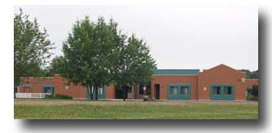February 2017

J.J. O’Neill Catholic School
240 Marilyn Avenue, Napanee, Ontario. K7R 2L4

613-354-9500 http://schools.alcdsb.on.ca/jjon

Principal: Tammy Hulton Vice-Principal: Gloria Hackett Superintendent of School Effectiveness: David Giroux Trustee: Greg Speagle

Especially on Valentine’s Day may God’s blessing from above fill your hearts with special joy and
bring you a day that’s filled with love.
May you find His presence near you, may He answer every prayer
and
may each day be just like
Valentine’s Day
for you throughout the year.

Upcoming Events
Family Day Statutory Holiday- All Catholic schools and board sites in the ALCDSB will be closed on Monday Feb. 20th. for Family day. Have a great day!
Next School Council Meeting – Thursday, February 9 at 5:30 p.m. Parents are most welcome to join us.
P.A. Days -Thursday, February
3rd is a P.A. Day.

BASKETBALL TOURNAMENTS

The tournaments will be held as follows:
Jr. Boys– Feb 27
(Coach – Mr. Kennedy)

Jr. Girls – Feb. 28
(Coach – Mr. Borges)
To be held at MacArthur College

Sr. Boys –Mar. 2
(Coach- Mr. Sheahan)

LITURGICAL UPDATE
Father Marek will celebrate our February Mass at
J.J. O’Neill on Friday, February 17th at 11:00 a.m. at the school. Parents and parishioners
are welcome to join us!
Sr. Girls – Mar. 3
(Coach – Mr. Watt)
To be held at Holy Cross
Secondary School

ge 1 of 3

Pa

MARCH BREAK
For all you lucky people planning a “get away” for March break –we will be off for the week of March 13 to 17. We will return to school on Monday, March 20th.

KINDERGARTEN REGISTRATION
We encourage parents to register for Junior and Senior Kindergarten as soon as possible. Please bring a copy of your child’s:
✓ Baptismal Certificate
✓ Birth Certificate
✓ Immunization Record
Early registration helps us to determine staff requirements. NOTE: If your child is already attending the Junior Program, he/she will automatically be enrolled in the Senior Program next year.

FUN FRENCH FACTS
DID YOU KNOW…
… more than a third of all English words are derived directly or indirectly from French, and it's estimated that English speakers who have never studied French already know 15,000 French words. http://tinyurl.com/28hpyue
Encourage your child to be a lifelong learner of French!

If your child is away for any reason, (ill, appointment, tournament, etc.) please send a note or call the school
number at 613-354-9500 – there is an answering machine available before and
after school hours so that you can leave a message. Also, you are welcome to send an email to Mrs. Craigen at craigen@alcdsb.on.ca. This will help alleviate the phone calls to parents at
home and work.
Thank you ☺

Lennox & Addington County General Hospital Student Art Exhibition

Congratulations to all of our students who submitted their artwork for the contest. We are thrilled to announce the following names of our students
whose artwork will be displayed at the Hospital. Invitations have been sent home with the students to attend the opening on Wednesday, Feb. 15 at 7:00 p.m.
in the Airhart Room at the hospital.

Congrats to:
Theresa Kerr, Ben Kerr, Natalee Snider, Heidi Rogers,
Pareza Tahamtan, Clara Jolicoeur, Rachel Clair
Jake Vanberkel, Cindi Powell
Blythe Forestell.

Cake Walk
Our Grade 7/8 students will be hosting a cake walk on February 14th. Tickets will be sold for 25 cents each or 5 for $1.00. All proceeds are in support of the SEVEC student exchange trip to Alberta.

Knights of Columbus
Free Throw Competitions

J.J. Winners
The following students will be competing at the District Competition
Saturday, Feb. 18th
1:00 registration
At
Archbishop O’Sullivan School, Kingston

Sam McCaw Isabelle McGinnis Jacob Nibourg Faith Beland Conor Maloney Taylor Gilmour Nathan Crosby MaKenna Marlow Tylar McDonald Taylor Hinch

Grade 3 & 6 EQAO
The Grade 3 & 6 testing will be taking place
This year during the weeks of May 22 to
June 4, 2017. Just a reminder to please
Keep this in mind when booking appointments. More information will follow to the students’
Involved.

February 2017

Sun | Mon | Tue | Wed | Thu | Fri | Sat
 |  |  | 1 | 2 | 3  P.A. DAY | 4
5 | 6 | 7 | 8 | 9  School Council  Meeting 5:30 p.m. | 10 | 11
12 | 13 | 14  Happy Valentine's Day CAKE WALK for SEVEC | 15 | 16 | 17  Mass in the school gym at 11:00 a.m. | 18
19 | 20  Family Day | 21 | 22 | 23 | 24 | 25
26 | 27  Jr. Boys at  MacArthur College | 28  Jr. Girls at  MacArthur College

Serve Well Bring Hope Celebrate All

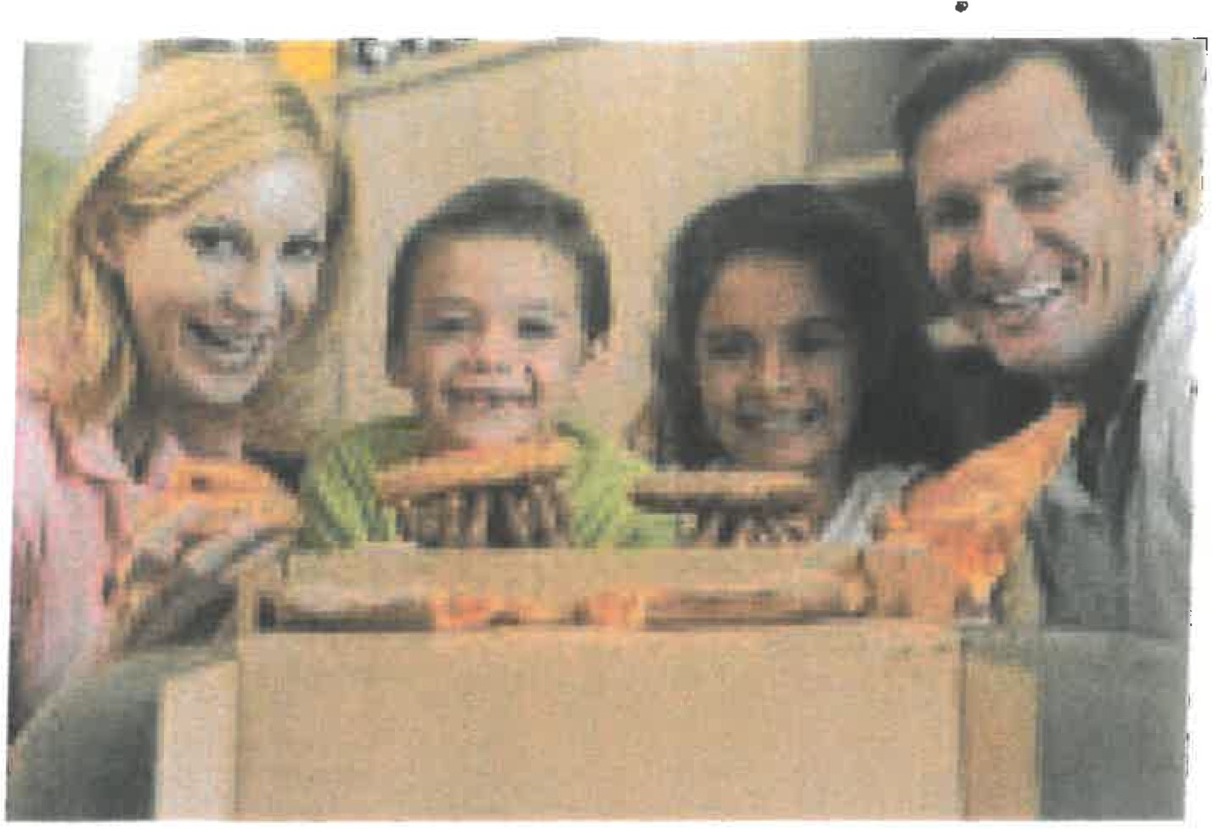

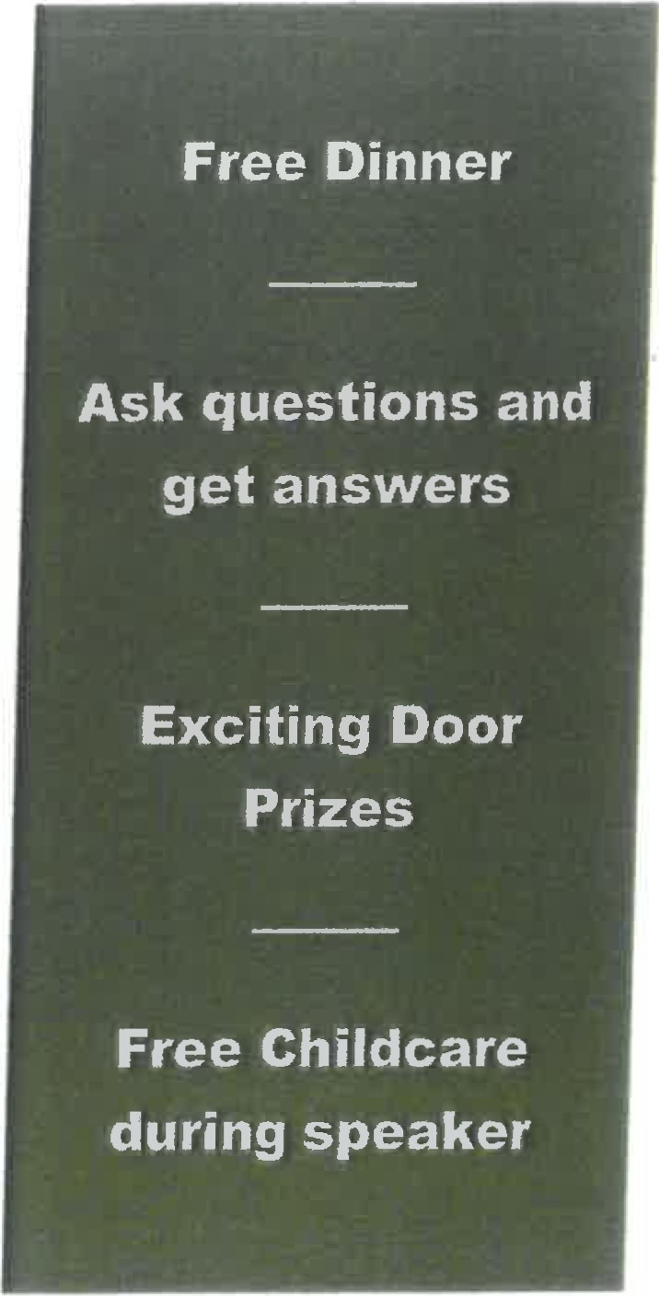FA LY G T

Join us at J.J. O'Neill for a free pizza dinner at
5:30 PM, followed by a guest speaker at 6:oo PM
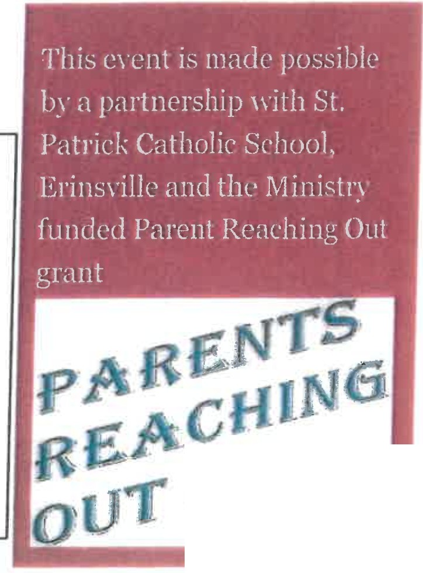for parents. Dr.Julie Gowthorpe will share some ideas about helping our children deal with conflict and how we can support positive
resolutions.

Please RVSP on or before Thursday February 16th.

Family Name: # attending: _ Child care needed: Yes or No
Dietary restrictions: ---------------

RSVP will be used for door prize ballot- must be in attendance to win!

· ••

,..

