Good morning,
This year Parent-Teacher Interviews will be held on Thursday, March 23rd from 3:00 to 5:30 and 6:30 to 8:00 PM. Staff will be in the learning commons and the cafeteria alphabetically.
Please click on the link below to book your interview times.

SECOND SEMESTER PARENT TEACHER INTERVIEWS
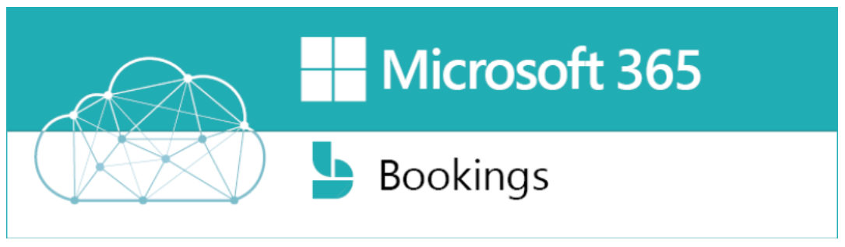

Parent-teacher interviews have been scheduled for Thursday, March 23rd from 3:00 to 5:30 and 6:30 to 8:00 PM. This year, parents will book teacher appointments using the on-line booking system, Microsoft Bookings. Instructions for completing appointments are below. Please click the link (CTRL and Click) for the website to book appointments.

Microsoft 365 Bookings - Parent Instructions
- The appointment link will be open from March 20th to March 23rd at 8:30 a.m.
Select your student’s teacher from the drop down AND March 23 on the calendar with a time slot
**NOTE: Please DO NOT select ‘ANYONE’ as the teacher. If your student’s teacher does not have any remaining time slots please contact the teacher via email or phone.
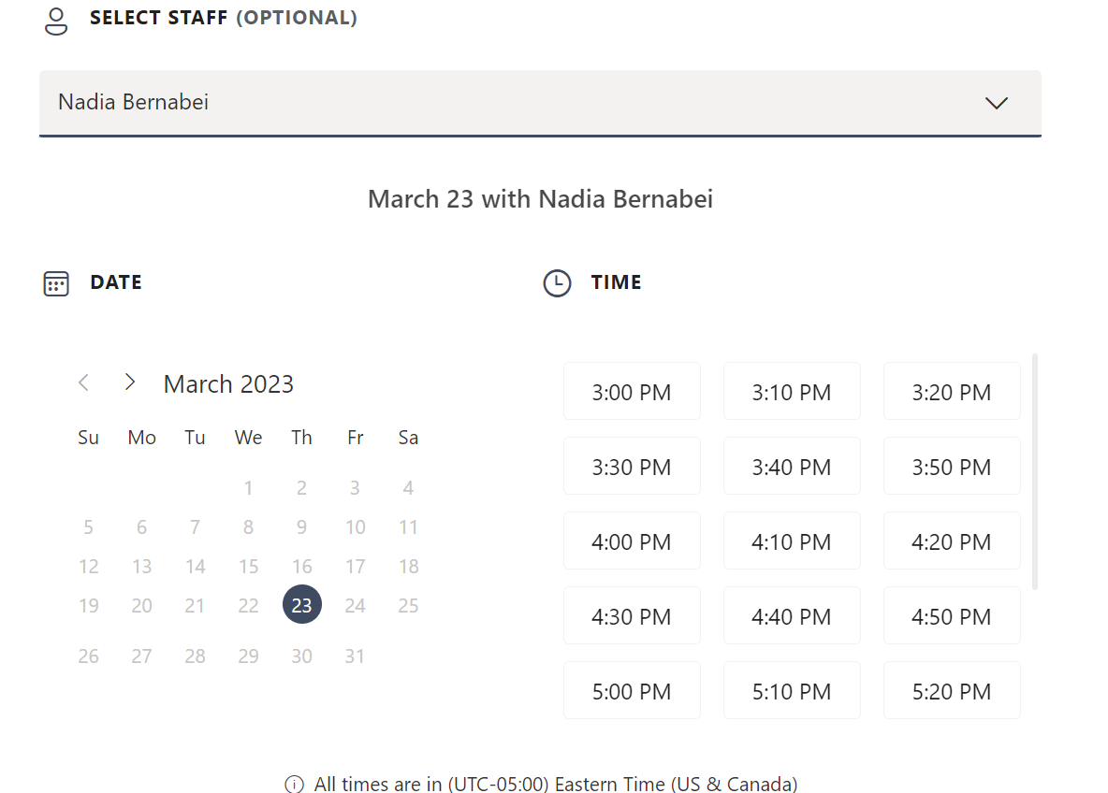
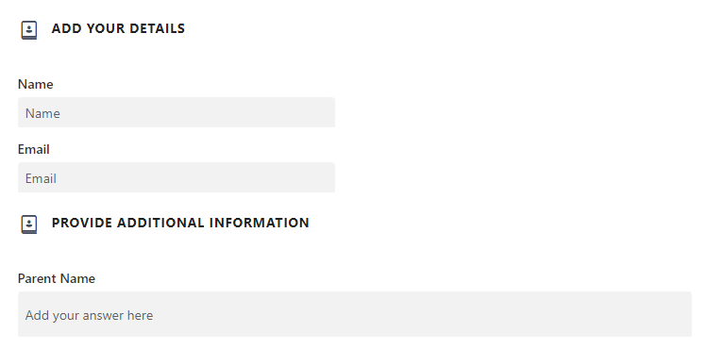
- Complete all fields in order to submit the appointment. Please put your student’s name in the Name field.
PARENT EMAIL
**All fields are required
STUDENT NAME
- Click to submit the appointment time.
- You will need to complete the process for each of your student’s teachers.

